

**Food Allergen Information and Controls for Caterers**

     

Originally written and designed by Lancashire County Council, Burnley Borough Council & Hyndburn Borough Council.

**Food Allergen Information and Controls for Caterers**

People with food allergies have to take great care when eating out to avoid certain foods that could cause them harm. As a business you have a legal obligation to ensure that any food you produce or prepare is **safe**. This is so they can make an informed choice about what to eat.

**You have a legal obligation to provide information to consumers on the allergens that are in the food that you supply.**

**These are the 14 allergens that you need to find out whether they are in the food that you make. Consumers may ask about other ingredients, but these are the ones you must know whether or not they are in the foods that you provide, by law.**

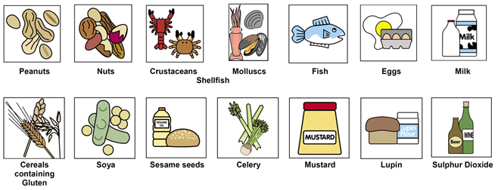

Thus information must be made clear on the menu, on chalk boards, tickets or provided verbally by an appropriate member of staff. It must be clear and conspicuous, not hidden away, easily visible, and legible.

If thus information is to be provided verbally by a member of staff then it is necessary to make it clear that the information can be obtained by asking a member of staff by means of a notice, menu, ticket or label that can easily be seen by customers. **You must then still be able to clearly advise of all 14 allergens present in all your menu items.**

**An example of suitable wording:**

*Food Allergies and Food intolerances: Please ask a member of staff if you require information on the ingredients in the food we serve.*

It is no longer enough for businesses to say that they do not know whether or not a food contains an allergen and nor is it enough to say that all their foods may contain allergens. Allergen information must be specific to the food, complete and accurate.

**As a food business operator you cannot refuse to provide specific allergen information on foods served. You also cannot give incorrect or misleading information on a menu or through verbal communication. This is a criminal offence under the Food Information Regulations 2014, punishable by an unlimited fine.**

**How to do this: What food allergens are contained in what dishes?**

**Information about allergens in the food you serve must be available and easily accessible.** You need to know what allergens are in all of your dishes/ open food you sell, to do this you must find the ingredients list on all packets of food, including ingredients used in dishes. If you buy in open food from a supplier e.g. bread, cakes, pies etc., you must ask the supplier to provide you with the allergenic information for these products, if they haven't done so already.

You can save the labels from the packets of food, which contain the allergen information and or transfer this information on to an allergen matrix. If you are saving labels, you must ensure they are easily retrievable and up-to-date, it is good practice to keep the most recent label, and discard any old ones. It is also good practice to check on a regular basis for recipe/product changes.

If you are making meals or other food products e.g. sandwiches, cakes etc., you can complete the allergen matrix or use a recipe card to record the allergens they contain. Examples of both are shown below. A recipe card may be easier if you are using lots of ingredients. **Remember to check all ingredients used, including those used for compound ingredients e.g Worcester sauce, condiments, stock, thickeners or garnishes.**

|  |  |  |
| --- | --- | --- |
| **Allergen Matrix** | **Recipe Card** | **Recipe Card** |
| [Image result for allergen matrices](https://www.google.co.uk/url?sa=i&rct=j&q=&esrc=s&source=images&cd=&cad=rja&uact=8&ved=0ahUKEwjEytma9_DQAhVrBcAKHS2gB9sQjRwIBw&url=https://www.allergyuk.org/blog/blog/post/179-changes-to-food-labelling-regulations-for-top-14allergens&psig=AFQjCNHPP-k_0wQ5HWs9XkBcphLqIGDrWQ&ust=1481710201760244)**https://www.food.gov.uk/sites/default/files/allergen-chart.pdf** | **[Image result for allergens recipe card](https://www.google.co.uk/url?sa=i&rct=j&q=&esrc=s&source=images&cd=&cad=rja&uact=8&ved=0ahUKEwip9aHEgfHQAhXMlxoKHa33B9gQjRwIBw&url=http://harlech.co.uk/29/en-GB/Food-Allergens---Are-you-compliant-&bvm=bv.141320020,d.eWE&psig=AFQjCNE0IqcRU4-CZBMQiTHBoGTRbXf5dA&ust=1481713080247194)https://www.food.gov.uk/sites/default/files/recipe-sheet.pdf** | |  |  | | --- | --- | | **Menu Item:** | | | Ingredients | Contains | |  | http://totalfoodservice.co.uk/data/ckeditor/article_images/FSA-Recipe-Sheet.jpg | |  | |  | |  | |  | |  | |  | |  | |  | |  | **Notes/Special Requirements:** | |  | | **Date Completed** | | **Name** | | **Date(s) reviewed** | | **Name** | |

**Once you have identified what foods/dishes contain what allergens, you must keep this information up to date. For example, if you change products, suppliers or your menu. All staff must know where the information is kept in case they need to answer a query about allergens in your products.**

**Service of food to persons with a food allergy**

If you serve customers with a food allergy, you must do more than simply identify what allergens are present in the food provided, you must have appropriate hygiene controls in place to ensure the food served to them is safe. To do this, first it is necessary to ensure foods with allergens have been correctly identified, as described in the previous part of this guide. Then it is necessary to decide how best to prevent any cross contamination from allergenic foods/ingredients to non-allergenic foods/ingredients during storage, preparation and service. The guidance that follows will help you to assess whether the controls you have in place are sufficient to provide food that is safe for a customer with a specific food allergy and to identify if improvements are needed. **A safe working procedure should normally be written down**.

**If you are not completely certain that you can provide food that is suitable for someone with a food allergy, then you must tell them, so that they can then decide if they want to eat the foods you provide.**

**How do you do this? Control of allergens in the kitchen - Management**

|  |  |
| --- | --- |
| **Control** | **What do you do?** |
| You need to know if any of the 14 specified allergens are in any of the dishes/ open food you sell. | Check ingredient labels and information?  Record details of allergens for your dishes and or ingredients on an allergen matrix? |
| Any foods/dishes with any of these 14 allergens in must be carefully stored and handled in your kitchen, so to prevent the risks of cross contamination. See storage and handling section. | Write down how you do this. |
| All staff, including managers, food handlers, service staff and staff taking orders in person or over the phone etc., must be aware of the risks posed by allergens and of providing wrong information to customers. | Who has overall responsibility for allergens and food safety?  Display notices reminding staff of the risk |
| Display notices advising customers to ask for information on allergens or signpost them to where this information is displayed.  If your menu doesn’t change often and you use the same recipes and suppliers all the time, allergen information could be contained in menus, to assist customers choosing meals.  You could also place allergen information on your website.  The information must be kept up to date. | Display advisory signs where they will be seen by customers looking at the menu and ordering.  http://www.londonbiopackaging.com/wp-content/uploads/2014/08/allergens_labelling_02.jpg |
| Do/can kitchen staff make recipe changes without informing front of house staff?  Front of house staff must be advised of any recipe changes. | What is your procedure for dealing with this?  What happens to allergen information in this instance? |
| Could recipes and menus be revised to exclude allergic ingredients and so possibly completely removing them from the kitchen? | Identify the changes that can be made. |
| Could some recipes be revised to provide allergen free food alternatives, which could be made in advance, covered and stored safely. This would remove the need to prepare allergenic free meals during a busy kitchen service period. | Do you do this? If so:  When do you prepare them?  How do you identify them? |
| Do you employ different Chef’s?  Do they follow the same recipes or have their own recipes?  If chefs use different recipes make sure all ingredients for all recipes are recorded. | Do you do this?  How have you ensured that all chefs follow the same recipes. |

**How do you do this? Control of allergens in the kitchen- Front of House**

**Space for your notes and actions taken below:**

|  |  |
| --- | --- |
| **Control** | **What do you do** |
| When a request is received about an allergy, you must have procedures in place to meet this requirement.   * Who is trained to answer this query?  1. Where is the information stored on allergen content in your meals? 2. Consider providing a checklist or guidance that staff can refer to whilst taking orders that highlights which dishes contain what type of allergic ingredients 3. How is the kitchen alerted that the food they are about to prepare is for somebody who is allergic to an ingredient? | Name/s:  What training have they had:  Location of information:  You could use an Allergen Matrix  How do you do this?  For example: It is written on the order and the chef is told directly. |
| To assist with planning in the kitchen, for group and advanced bookings, you could ask your customers if they suffer from any food allergies, and identify any dishes that they will not be able to eat. | Do you do this? |
| Dealing responsibly with a customer complaint over concerns that their food may be contaminated with an allergenic ingredient. Staff should not just remove the ‘offending’ allergen from a prepared dish and send it back on the same plate, because traces of the allergen will remain which could cause a reaction. | What do you do? |

**Management**

**Space for your notes and action taken below:**

**How do you do this: Control of allergens in the kitchen - Training**

|  |  |  |
| --- | --- | --- |
| **Allergen Control** | | **Tick** |
| Train **all** your staff in allergy awareness. | |  |
| Make sure that **all staff** understand that they should never guess whether or not an allergen is present in food. **Always be honest** with the customer. If you do not know, admit it and go and find out or ask. | |  |
| Allergen training is freely available online at:  <http://allergytraining.food.gov.uk/english/>  It is good practice that this is undertaken by **all staff**, but any food handlers in particular. | |  |
| Staff should receive general allergen awareness training and training in your own allergen control procedures. | |  |
| Have all **kitchen staff** received food allergen awareness training?  Yes/No | |  |
| Have **front of house staff** (bar staff, service staff, staff taking order over the phone, in person etc.) received food allergen awareness training?  Yes/ No | |  |
| It is good practice to ensure all training given to staff is recorded and kept on file and that refresher training is given on a regular basis.  This can be recorded in the table below and/or in your training records. There are extra blank copies at the back of this guidance for you to copy. | |  |
| Training should include the following:   1. Allergens and anaphylactic shock. Staff to know the effect of providing the wrong information or serving food containing an ingredient that a customer is allergic to. 2. Kitchen procedures to prevent cross-contamination during storage, preparation and serving of food. 3. How you identify customers with food allergies, when they book a table, or when staff take orders (e.g. menu reminders, in person and over the phone or online). 4. Your system for alerting kitchen staff that the food they are to prepare is for somebody who is allergic to certain ingredients. 5. Your procedure for dealing with a customer complaint over concerns that their food may be contaminated with an allergenic ingredient.   Staff must not simply remove the ‘offending’ food from a prepared dish and send the meal back on the same plate, because traces of the allergen will remain which could cause a reaction. Managers must then investigate the complaint fully to isolate where the contamination with the allergen occurred. | |  |
| **Allergen Training Record** | | |
| **Staff Member** | **Position** | |
|  |  | |
|  |  | |
|  |  | |
|  |  | |
|  |  | |
|  |  | |
|  |  | |
|  |  | |
|  |  | |
|  |  | |
|  |  | |
|  |  | |
|  |  | |
|  |  | |
|  |  | |
|  |  | |
|  |  | |
|  |  | |
|  |  | |
|  |  | |
|  |  | |
|  |  | |
|  |  | |
|  |  | |
|  |  | |
|  |  | |
|  |  | |
|  |  | |
|  |  | |
|  |  | |
|  |  | |
|  |  | |

**Space for your notes and action taken below:**

**How do you do this? Control of allergens in the kitchen - Suppliers**

|  |  |
| --- | --- |
| **Control** | **What do you do** |
| Collect allergen information from all your suppliers, this may be data sheets or labels from pre packed foods or on a sheet for loose/open foods. E.g. if you get open pies/pasties, sausages etc. from a butchers.  Once done, record these checks with your suppliers’ records or in the table below, there are blank copies at the back of this document for you to photocopy. | Check that all food you receive is supplied with allergen information?  Obtain any missing information so that you can comply with your relevant duties. |
| You must check for any changes on the products you buy in on a regular basis. It is recommended that this is done each time you buy a product. At the very least it must be checked on a routine basis, and when products state 'new recipe' on the label.  If this information is changed, you must record this and advise staff members. | Where do you record it? And how do you advise staff members? |
| Do you often choose or are given substituted items, to those assessed on your allergen chart, if the item you want is not in stock or another product is cheaper etc.?  If Yes**, you must check the allergen information on this product**, to see if it is different from your regular product  If this information is changed, you must record this and advise staff members. | Do you accept substituted items from your suppliers?  Do you check the allergens present and if they differ from your regular item?  Where do you record it?  And how do you advise staff members? |
| [Image result for new allergen food labels](http://www.google.co.uk/url?sa=i&rct=j&q=&esrc=s&source=images&cd=&cad=rja&uact=8&ved=0ahUKEwjso-X92u7RAhXHnRoKHRcYCiMQjRwIBw&url=http://www.londonbiopackaging.com/allergen-labelling-regulations/&psig=AFQjCNH_yRkEaQWS9hcyFh0zAkIAcBPfnw&ust=1486032064067285)Ensure all food labels have the ingredients listed in English. |  |

|  |  |  |
| --- | --- | --- |
| **Allergen Information Received from Suppliers** | | |
| **Supplier** | **Food Supplied** | **Allergen information supplied: Yes/No** |
|  |  |  |
|  |  |  |
|  |  |  |
|  |  |  |
|  |  |  |
|  |  |  |
|  |  |  |
|  |  |  |
|  |  |  |
|  |  |  |
|  |  |  |
|  |  |  |
|  |  |  |
|  |  |  |
|  |  |  |
|  |  |  |
|  |  |  |
|  |  |  |
|  |  |  |
|  |  |  |
|  |  |  |
|  |  |  |
|  |  |  |
|  |  |  |
|  |  |  |
|  |  |  |
|  |  |  |
|  |  |  |
|  |  |  |
|  |  |  |
|  |  |  |
|  |  |  |
|  |  |  |
|  |  |  |
|  |  |  |

Copy this page as many times as you need to

**Space for your notes and action taken below:**

**How do you do this: Control of allergens in the kitchen - Storage**

|  |  |
| --- | --- |
| **Control** | **What do you do** |
| A storage system should be in place to prevent cross contamination of ingredients with other ingredients containing allergens.  Do you store food and ingredients containing allergens in a designated area or if this isn't possible, store on lower shelving, in dedicated sealed, labelled containers. | What is your storage system? |
| Is allergen labelling information kept with each product, or are they labelled with allergen information by you? |  |
| Do you have a spillage plan in place to clean up allergenic ingredients: You should use disposable clothes / towels / blue roll, so preventing cross contamination. | What is your spillage plan? |
| It is best to keep food in its original container. But if food is decanted into another container (for dry, frozen or chilled storage), **all the ingredient and allergen information** must be kept with it.  If decanting products:   * Always clean and dry any re-used containers first. * Use the same container for the same food type – e.g. ground nuts always go in the same container when decanted.   Do not put an allergen free food in to a container that may have previously held food that included that allergen as an ingredient. | Do you keep food in its original container, or decant? |
| Are all ingredients stored in lidded containers, or suitably enclosed to prevent cross contamination between products e.g. powders, grains etc. |  |
| Are desserts or other foods e.g. cakes, tarts, gateaux’s, ice creams and toppings containing allergenic ingredient’s e.g. nuts, milk, stored separately in both storage and chilled/ frozen display units? Ensure they do not touch and have separate service utensils. |  |

**Space for your notes and action taken below:**

**How do you do this: Control of allergens in the kitchen - Preparation, Handling and Service**

|  |  |
| --- | --- |
| **Control** | **What do you do** |
| Procedures should be in place to prevent cross contamination when preparing food for a customer with a food allergy, which should include:  Check ingredient labels for allergenic ingredients – marked in **bold**.  Always read the labels! Remember that manufacturers will change recipes from time to time and may introduce other allergens | Do you write your procedures down for preparing food for a customer with an allergy?  Where is it kept?  Who knows about it? |
| When preparing all foods, care must be taken to ensure that no cross contamination can occur between foods containing allergens and foods which are allergen free. Some allergenic ingredients e.g. sesame seeds, nut powders, flour are easily spread around the kitchen and need extra care. It is best to use these in a separate preparation area where no other food is handled or handle these at a time when all other food is away. | Potential contamination via work surfaces, equipment, cloths, clothing and hands must all be controlled.  Identify allergic ingredients you handle that can easily be spread and how you control them? |
| Where possible use separate pots, pans, chopping boards, knives and spoons and separate preparation areas for allergen and allergen free foods.  If not possible, thoroughly clean equipment/ utensils/ surfaces between uses. | Do you have separate equipment?  What equipment and what for? |
| Some pieces of equipment are inherently difficult to clean properly e.g. Woks, griddles, tandoors, microwaves, pizza ovens, vacuum packer, blenders and mixers and other pieces of complex equipment.  Do you have equipment like this? Can you clean it fully in between customers? Do you use the same piece of equipment for allergy containing and allergy free meals?  It mustn't be assumed that residues can ever be removed from equipment with uneven, porous cooking surfaces or intricate parts. | Do you have separate equipment?  What equipment and what for? |
| Make sure that thorough cleaning takes place before and after handling and preparing different foods.  Two stage cleaning must take place to remove allergenic residues from equipment and surfaces. | What cleaning products and/or equipment do you use? |
| Verify that all food handlers follow adequate hand-washing procedures. **Hands play a major role in allergen cross contamination so hand washing is very important.**  Soap provides better allergen removal than gel. Gels do not remove allergens!  [Image result for hand washing poster](http://www.google.co.uk/url?sa=i&rct=j&q=&esrc=s&source=images&cd=&cad=rja&uact=8&ved=0ahUKEwjTy43H2u7RAhWPJhoKHfRPCcgQjRwIBw&url=http://sct.poumon.ca/protect-protegez/germs-microbes_e.php&psig=AFQjCNFosJsdwYsbQvBVtPtWrZf8Fdp19w&ust=1486031920197797) | Do all food handlers follow adequate hand washing procedures? How do you check? |
| Cross contamination can occur via use of reusable cloths. Use single use/disposable cloths wherever possible. | Do you re-use cloths?  How do you clean them? |
| Don’t re-use cooking oil, if there is a possibility that nut proteins/fish  proteins/gluten/sesame will still be present. If possible have a separate pan or fryer for allergen and allergen free foods. | Do you use a dedicated fryer for allergen free foods, or always use fresh oil? |
| If foods such as casseroles, pies, fruit tarts, scones etc. containing allergens are batch cooked, cooled and/or stored with ones not containing allergens, how are the different varieties identified? | How do you do this? |
| Consider the allergens that you are handling e.g. high risk allergens - those easily spread or those that can cause a severe allergic reaction ( shellfish, nuts, powdered ingredients), and the way you are handling them. Think about the distribution of the allergens when handling them, and wear appropriate protective clothing to prevent cross- contamination. | Are disposable or separate aprons used for handling allergenic products, if so which are worn for what? |
| Garnishes, drizzling oils, dessert toppings etc. can also contain allergenic ingredients. Staff must be aware of their contents. | Are these covered in your allergen matrix?  Are serving staff aware of them? |
| The preparation and service of cakes and desserts may not be done by kitchen staff, but by service staff, therefore ensure all staff are fully aware of allergen controls. Use separate equipment and utensils for service. | Are these covered in your allergen matrix?  Who serves these, what controls are in place? |
| At self-service counters e.g. salad bars, buffets, carveries etc.:   1. There must be adequate signage providing customers with details of the foods and their allergenic contents. 2. Foods containing no allergenic ingredients must be sufficiently separated and easily distinguishable from food containing allergenic ingredient and displayed in a way to prevent any falling food contaminating it. 3. Provide sufficient utensils to prevent cross contamination. Are they easily distinguishable? | Do you have a self-service counter?  How do you do this?  How do you do this?  How do you do this? |

**More Advice**

**Space for your notes and action taken below:**

Once you have completed this assessment and feel that your business needs more advice, please contact your local Environmental Health or Trading Standards Service.

**Now you have considered the controls required, if you are not completely certain that you can provide food that is suitable for someone with a food allergy, then you must tell them, so that they can then decide if they want to eat the foods you provide. You can display a sign saying this.**

|  |
| --- |
| **Some of our menu items contain nuts, gluten, and other allergens. Due to our cooking environment there is a risk that traces of these may be in any other dish or food that we serve. We understand the dangers to those with severe allergies, so advise you to please speak to a member of staff who may be able to help you to make an alternative choice.** |

**USEFUL LINKS TO RESOURCES AND INFORMATION**

|  |  |
| --- | --- |
| Food Standards Agency | <https://www.food.gov.uk/business-guidance/allergen-guidance-for-food-businesses> |

**Recipe card**

|  |  |
| --- | --- |
| **Menu Item:** | |
| Ingredients | Contains |
|  | http://totalfoodservice.co.uk/data/ckeditor/article_images/FSA-Recipe-Sheet.jpg |
|  |
|  |
|  |
|  |
|  |
|  |
|  |
|  |
|  |
|  |
|  |
|  |
|  |  |
|  |  |
|  | **Notes/Special Requirements:** |
|  |
| **Date Completed** |
| **Name** |
| **Date(s) reviewed** |
| **Name** |

**Recipe card**

|  |  |
| --- | --- |
| **Menu Item:** | |
| Ingredients | Contains |
|  | http://totalfoodservice.co.uk/data/ckeditor/article_images/FSA-Recipe-Sheet.jpg |
|  |
|  |
|  |
|  |
|  |
|  |
|  |
|  |
|  |
|  |
|  |
|  |
|  | **Notes/Special Requirements:** |
|  |
| **Date Completed** |
| **Name** |
| **Date(s) reviewed** |
| **Name** |
|  |  |

**Allergen Matrix**

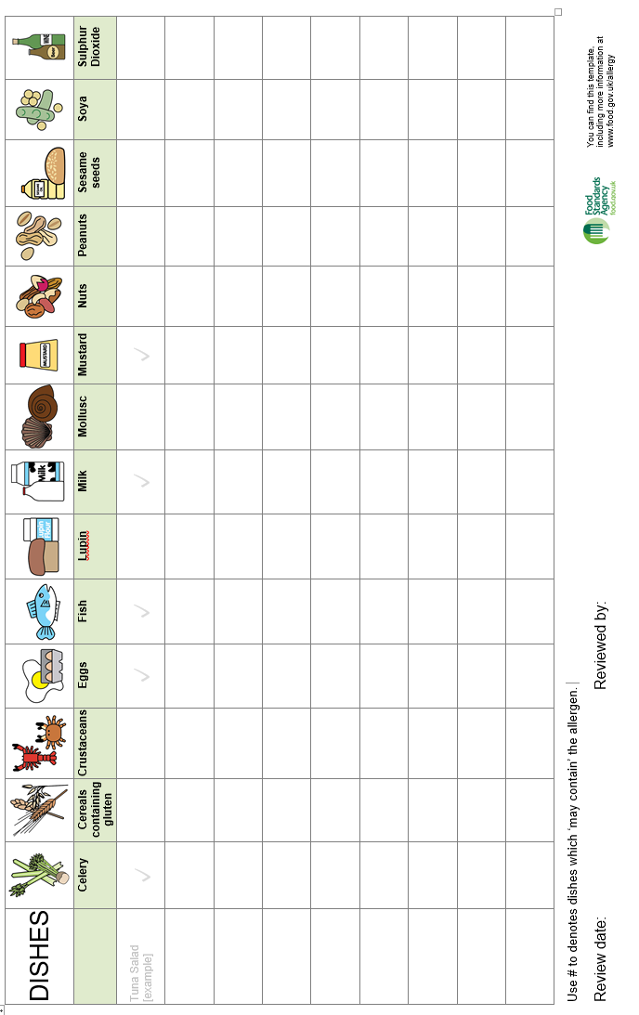

**Available also in Urdu, Punjabi, Bengali, Turkish,** **Kurdish, Cantonese, Mandarin**