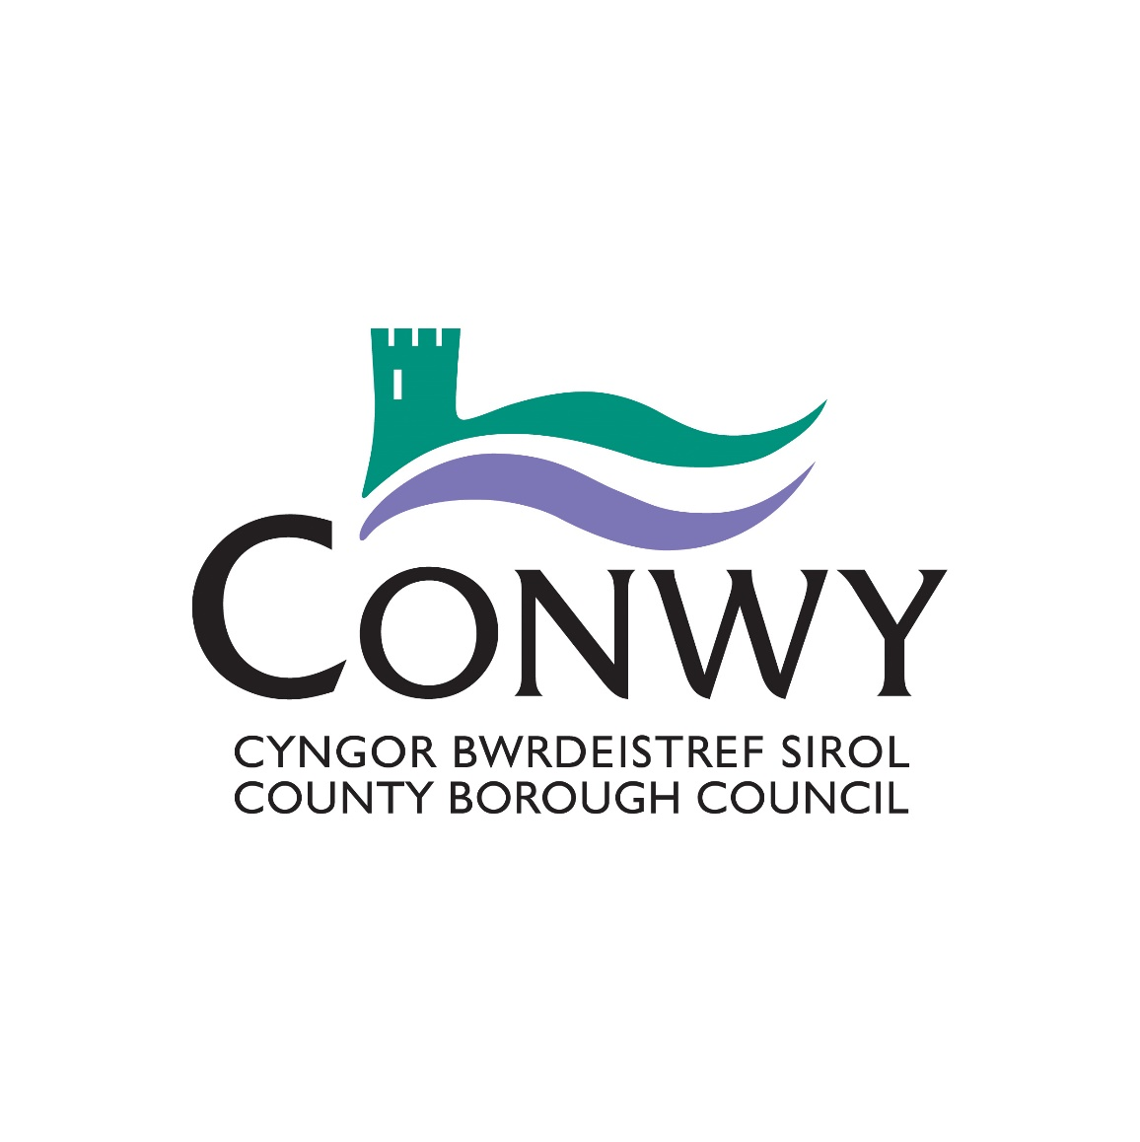

**Conwy County Borough Council**

**Draft Summary Annual Report**

**2017/2018**

**Contents**

1 Introduction 3

2 What the Authority does – a snap shot in numbers 4

3 Summary of Corporate Plan progress 5

3.1 Summary of the highlights achieved in 2017/18 8

3.2 Where we need to improve/ develop 12

4 How do we compare? 13

5 Financial Summary 16

6 Get Involved 20

7 Where to Get More Information About Your Council 21

# 

# **1 Introduction**

W

elcome to Conwy County Borough Council’s Summary Annual Report. The aim of this report is to give a brief overview of what the Council has achieved in the last financial year (1st April 2017 to 31st March 2018). It is essential to look back on the Council’s performance and make sure that the services provided are making a difference. This is particularly important given the challenging goal of millions of pounds of efficiencies to be delivered year on year. The Corporate Plan embraces the Well-being of Future Generations (Wales) Act 2015 which came into force on 1st April 2016 ([www.thewaleswewant.co.uk](http://www.thewaleswewant.co.uk)).

We have written a more detailed report which you can read if you want further details about our performance. The detailed report is called the Annual Report 2017 –2018. A copy of the Annual Report and all performance measures can be obtained on our website [**www.conwy.gov.uk/accountability.**](http://www.conwy.gov.uk/accountability)

Although the Corporate Plan covers a five year period, we will report on the progress we have made every year. Each year we review the priorities to make sure they are still relevant to communities. .These priorities are reviewed in partnership with the public.

The Corporate Plan 2017-2022 is not a ‘wish list’ however; rather it serves to focus and prioritise the most important actions communities think we need to focus on. It includes ‘get involved’ sections with ideas on what communities can do to help themselves.

We also have an ongoing conversation - The County conversation, so you can take part at any time to share your views and ideas about the County or your local area.

[www.conwy.gov.uk/countyconversation](http://www.conwy.gov.uk/countyconversation)

[www.conwy.gov.uk/sgwrsysir](http://www.conwy.gov.uk/sgwrsysir)

[www.facebook.com/sgwrsconwyconvo/](http://www.facebook.com/sgwrsconwyconvo/)

[@sgwrsconwyconvo](https://twitter.com/sgwrsconwyconvo)

We hope that you will find this summary report an informative and balanced overview of some of the achievements we made in the last year. We have also noted areas we need to improve.

# **2 What the Authority does – a snap shot in numbers**

T

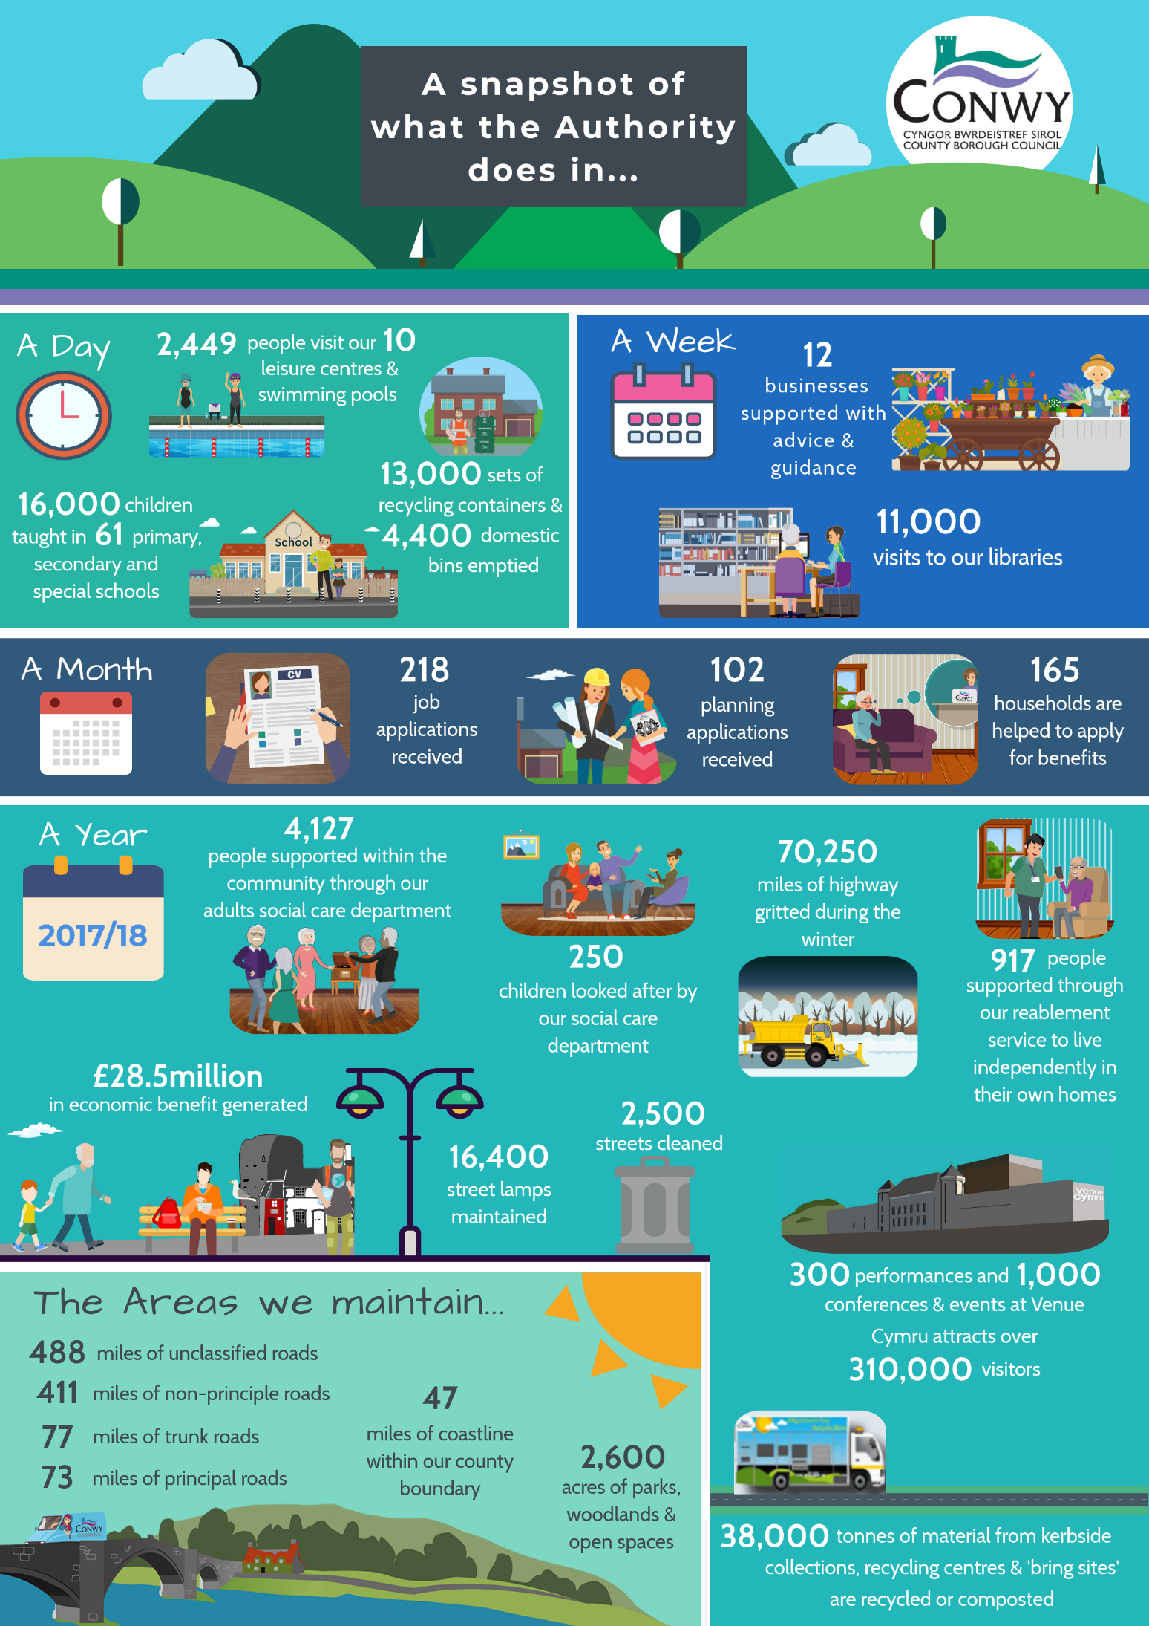he Council is responsible for a wide range of public services which aim to support the everyday lives of the citizens of, and visitors to, the County Borough. The next page is a snap shot of the various services and the average level of demand we have to meet:

4

4

**3 Summary of Corporate Plan progress**

This table provides an overview of the progress made to deliver the Corporate Plan Actions and Measures. For more detailed information please refer to the full Annual report.

The following keys define the red/ amber/ green (RAG) status of each action and measure.

|  |  |  |  |  |  |  |  |  |  |  |  |  |  |  |  |  |  |  |  |  |  |  |  |  |  |  |  |
| --- | --- | --- | --- | --- | --- | --- | --- | --- | --- | --- | --- | --- | --- | --- | --- | --- | --- | --- | --- | --- | --- | --- | --- | --- | --- | --- | --- |
|  | |  |  |  |  |  |  |  |  |  |  |  |  |  |  |  |  |  |  |  |  |  |  |  |  |  |  | | --- | --- | --- | --- | --- | --- | --- | --- | --- | --- | --- | --- | --- | --- | --- | --- | --- | --- | --- | --- | --- | --- | --- | --- | --- | --- | | **RAG Actions Key: RAG Performance Measure Key:**   |  |  |  |  |  | | --- | --- | --- | --- | --- | |  |  |  | **Compared to target set:** |  | | Action not progressing / areas of concern have been raised | **Red** |  | Measure not meeting target and below tolerance level | **Red** | | Action progressing and no concerns raised | **Amber** |  | Measure within tolerance to progress work to meet target | **Amber** | | Action complete | **Green** |  | Target for the measure has been met | **Green** | |  |  |  | Not applicable ( no target set) | **N/A** | | |

|  |  |  |  |  |  |  |  |  |  |  |  |  |  |  |  |  |  |  |  |  |  |  |  |  |  |  |  |  |  |  |  |  |  |  |  |  |  |  |  |  |  |  |  |  |  |  |  |  |  |  |  |  |  |  |  |  |  |  |  |  |  |  |  |  |  |  |  |  |  |  |  |  |  |  |  |  |  |  |  |
| --- | --- | --- | --- | --- | --- | --- | --- | --- | --- | --- | --- | --- | --- | --- | --- | --- | --- | --- | --- | --- | --- | --- | --- | --- | --- | --- | --- | --- | --- | --- | --- | --- | --- | --- | --- | --- | --- | --- | --- | --- | --- | --- | --- | --- | --- | --- | --- | --- | --- | --- | --- | --- | --- | --- | --- | --- | --- | --- | --- | --- | --- | --- | --- | --- | --- | --- | --- | --- | --- | --- | --- | --- | --- | --- | --- | --- | --- | --- | --- |
| |  |  |  |  |  |  |  |  |  |  |  |  |  |  |  |  |  |  |  |  |  |  |  |  |  |  |  |  |  |  |  |  |  |  |  |  |  |  |  |  |  |  |  |  |  |  |  |  |  |  |  |  |  |  |  |  |  |  |  |  |  |  |  |  |  |  |  |  |  |  |  |  |  |  |  |  |  |  |  | | --- | --- | --- | --- | --- | --- | --- | --- | --- | --- | --- | --- | --- | --- | --- | --- | --- | --- | --- | --- | --- | --- | --- | --- | --- | --- | --- | --- | --- | --- | --- | --- | --- | --- | --- | --- | --- | --- | --- | --- | --- | --- | --- | --- | --- | --- | --- | --- | --- | --- | --- | --- | --- | --- | --- | --- | --- | --- | --- | --- | --- | --- | --- | --- | --- | --- | --- | --- | --- | --- | --- | --- | --- | --- | --- | --- | --- | --- | --- | |  | |  |  |  |  | | --- | --- | --- | --- | | **Outcome 1 -** People in Conwy are educated and skilled | | **Outcome 2 -** People in Conwy are safe and feel safe | | | |  |  |  |  |  |  |  |  |  | | --- | --- | --- | --- | --- | --- | --- | --- | --- | | |  |  | | --- | --- | | **A1.1** | **Amber** | | **A1.2** | **Green** | | **A1.3** | **Green** | | **A1.4** | **Green** | | |  | | |  |  |  |  |  |  |  |  |  |  |  |  |  |  |  |  |  |  |  |  |  |  |  |  |  |  |  |  |  |  |  | | --- | --- | --- | --- | --- | --- | --- | --- | --- | --- | --- | --- | --- | --- | --- | --- | --- | --- | --- | --- | --- | --- | --- | --- | --- | --- | --- | --- | --- | --- | --- | | |  |  | | --- | --- | | **M1.1a** | **Red** | | **M1.1b** | **Green** | | **M1.1c** | **Amber** | | **M1.1d** | **Red** | | **M1.1e** | **Red** | | **M1.1f** | **Green** | | **M1.2a** | **Red** | | **M1.2b** | **Red** | | **M1.3** | **Green** | | **M1.4a** | **Amber** | | **M1.4b** | **N/A** | | **M1.4c** | **N/A** | | **M1.4d** | **Red** | | **M1.4e** | **N/A** | | **M1.4f** | **Green** | | | |  |  |  |  |  |  |  |  |  | | --- | --- | --- | --- | --- | --- | --- | --- | --- | | |  |  | | --- | --- | | **A2.1** | **Green** | | **A2.2** | **Green** | | **A2.3** | **Green** | | **A2.4** | **Green** | | |  | | |  |  |  |  |  |  |  |  |  |  |  |  |  |  |  |  |  | | --- | --- | --- | --- | --- | --- | --- | --- | --- | --- | --- | --- | --- | --- | --- | --- | --- | | |  |  | | --- | --- | | **M2.1** | **Red** | | **M2.2a** | **Green** | | **M2.2b** | **Green** | | **M2.2c** | **Red** | | **M2.2d** | **Green** | | **M2.3** | **N/A** | | **M2.4 (i)** | **N/A** | | **M2.4 (ii)** | **N/A** | | |  | | | |

|  |  |  |  |  |  |  |  |  |  |  |  |  |  |  |  |  |  |  |  |  |  |  |  |  |  |  |  |  |  |  |  |  |  |  |  |  |  |  |  |  |  |  |  |  |  |  |  |  |  |  |  |  |  |  |  |  |  |  |  |  |  |  |  |  |  |  |  |  |  |  |  |  |  |  |  |  |  |  |  |  |  |
| --- | --- | --- | --- | --- | --- | --- | --- | --- | --- | --- | --- | --- | --- | --- | --- | --- | --- | --- | --- | --- | --- | --- | --- | --- | --- | --- | --- | --- | --- | --- | --- | --- | --- | --- | --- | --- | --- | --- | --- | --- | --- | --- | --- | --- | --- | --- | --- | --- | --- | --- | --- | --- | --- | --- | --- | --- | --- | --- | --- | --- | --- | --- | --- | --- | --- | --- | --- | --- | --- | --- | --- | --- | --- | --- | --- | --- | --- | --- | --- | --- | --- |
| |  |  |  |  |  |  |  |  |  |  |  |  |  |  |  |  |  |  |  |  |  |  |  |  |  |  |  |  |  |  |  |  |  |  |  |  |  |  |  |  |  |  |  |  |  |  |  |  |  |  |  |  |  |  |  |  |  |  |  |  |  |  |  |  |  |  |  |  |  |  |  |  |  |  |  |  |  |  |  |  |  | | --- | --- | --- | --- | --- | --- | --- | --- | --- | --- | --- | --- | --- | --- | --- | --- | --- | --- | --- | --- | --- | --- | --- | --- | --- | --- | --- | --- | --- | --- | --- | --- | --- | --- | --- | --- | --- | --- | --- | --- | --- | --- | --- | --- | --- | --- | --- | --- | --- | --- | --- | --- | --- | --- | --- | --- | --- | --- | --- | --- | --- | --- | --- | --- | --- | --- | --- | --- | --- | --- | --- | --- | --- | --- | --- | --- | --- | --- | --- | --- | --- | |  | |  |  |  |  | | --- | --- | --- | --- | | **Outcome 3 -** People in Conwy have access  to affordable, appropriate, good quality accommodation that enhances the quality  of their lives | | **Outcome 4 -** People in Conwy are healthy and active | | | |  |  |  |  |  |  |  |  |  | | --- | --- | --- | --- | --- | --- | --- | --- | --- | | |  |  | | --- | --- | | **A3.1** | **Amber** | | **A3.2** | **Green** | | **A3.3** | **Amber** | | **A3.4** | **Green** | | |  | | |  |  |  |  |  |  |  |  |  |  |  |  |  |  |  |  |  |  |  |  |  |  |  |  |  |  |  |  |  |  |  |  |  |  |  |  |  | | --- | --- | --- | --- | --- | --- | --- | --- | --- | --- | --- | --- | --- | --- | --- | --- | --- | --- | --- | --- | --- | --- | --- | --- | --- | --- | --- | --- | --- | --- | --- | --- | --- | --- | --- | --- | --- | | |  |  | | --- | --- | | **M3.1a (i)** | **Red** | | **M3.1a (ii)** | **Red** | | **M3.1b** | **Green** | | **M3.1c** | **Red** | | **M3.1d** | **Red** | | **M3.2** | **Red** | | **M3.2a** | **N/A** | | **M3.3a** | **Amber** | | **M3.3b** | **Green** | | **M3.3c** | **Amber** | | **M3.4a** | **Amber** | | **M3.4b** | **Red** | | **M3.4c** | **Green** | | **M3.4d** | **Red** | | **M3.4e** | **Green** | | **M3.4f** | **Green** | | **M3.4g** | **Green** | | **M3.4h** | **Green** | | | |  |  |  |  |  |  |  |  |  |  |  | | --- | --- | --- | --- | --- | --- | --- | --- | --- | --- | --- | | |  |  | | --- | --- | | **A4.1** | **Green** | | **A4.2** | **Green** | | **A4.3** | **Green** | | **A4.4** | **Green** | | **A4.5** | **Green** | | |  | | |  |  |  |  |  |  |  |  |  |  |  | | --- | --- | --- | --- | --- | --- | --- | --- | --- | --- | --- | | |  |  | | --- | --- | | **M4.1a** | **Green** | | **M4.1b** | **Red** | | **M4.1c** | **N/A** | | **M4.2** | **N/A** | | **M4.3** | **Green** | | |  | | | |
| |  |  |  |  |  |  |  |  |  |  |  |  |  |  |  |  |  |  |  |  |  |  |  |  |  |  |  |  |  |  |  |  |  |  |  |  |  |  |  |  |  |  |  |  |  |  |  |  |  |  |  |  |  |  |  |  |  |  |  |  |  |  |  |  |  |  |  |  |  |  |  |  |  |  |  |  |  | | --- | --- | --- | --- | --- | --- | --- | --- | --- | --- | --- | --- | --- | --- | --- | --- | --- | --- | --- | --- | --- | --- | --- | --- | --- | --- | --- | --- | --- | --- | --- | --- | --- | --- | --- | --- | --- | --- | --- | --- | --- | --- | --- | --- | --- | --- | --- | --- | --- | --- | --- | --- | --- | --- | --- | --- | --- | --- | --- | --- | --- | --- | --- | --- | --- | --- | --- | --- | --- | --- | --- | --- | --- | --- | --- | --- | --- | |  | |  |  |  |  | | --- | --- | --- | --- | |  | |  | | |  | |  | | | **Outcome 5 -** People in Conwy live in a county which has a prosperous economy | | **Outcome 6 -** People in Conwy value and look after the environment | | | |  |  |  |  |  |  |  |  |  |  |  |  |  | | --- | --- | --- | --- | --- | --- | --- | --- | --- | --- | --- | --- | --- | | |  |  | | --- | --- | | **A5.1** | **Green** | | **A5.2** | **Green** | | **A5.3** | **Green** | | **A5.4** | **Green** | | **A5.5** | **Green** | | **A5.6** | **Red** | | |  | | |  |  |  |  |  |  |  |  |  |  |  |  |  |  |  | | --- | --- | --- | --- | --- | --- | --- | --- | --- | --- | --- | --- | --- | --- | --- | | |  |  | | --- | --- | | **M5.1** | **Red** | | **M5.2a** | **Green** | | **M5.2b** | **Red** | | **M5.3** | **Green** | | **M5.4** | **N/A** | | **M5.5a** | **N/A** | | **M5.5b** | **N/A** | | | |  |  |  |  |  |  |  |  |  |  |  |  |  |  |  | | --- | --- | --- | --- | --- | --- | --- | --- | --- | --- | --- | --- | --- | --- | --- | | |  |  | | --- | --- | | **A6.1** | **Green** | | **A6.2** | **Green** | | **A6.3** | **Amber** | | **A6.4** | **Green** | | **A6.5** | **Green** | | **A6.5a** | **Amber** | | **A6.6** | **Amber** | | | |  |  |  |  |  |  |  |  |  |  |  |  |  |  |  | | --- | --- | --- | --- | --- | --- | --- | --- | --- | --- | --- | --- | --- | --- | --- | | |  |  | | --- | --- | | **M6.1a** | **Green** | | **M6.1b** | **Amber** | | **M6.2** | **Green** | | **M6.3a** | **Amber** | | **M6.3b** | **Green** | | **M6.4** | **N/A** | | **M6.5** | **N/A** | | | | |

|  |  |  |  |  |  |  |  |  |  |  |  |  |  |  |  |  |  |  |  |  |  |  |  |  |  |  |  |  |  |  |  |  |  |  |  |  |  |  |  |  |  |  |  |  |  |  |  |  |  |  |  |  |  |  |  |  |  |  |  |  |  |  |  |  |  |  |  |  |  |  |  |  |  |  |  |  |  |  |  |  |  |
| --- | --- | --- | --- | --- | --- | --- | --- | --- | --- | --- | --- | --- | --- | --- | --- | --- | --- | --- | --- | --- | --- | --- | --- | --- | --- | --- | --- | --- | --- | --- | --- | --- | --- | --- | --- | --- | --- | --- | --- | --- | --- | --- | --- | --- | --- | --- | --- | --- | --- | --- | --- | --- | --- | --- | --- | --- | --- | --- | --- | --- | --- | --- | --- | --- | --- | --- | --- | --- | --- | --- | --- | --- | --- | --- | --- | --- | --- | --- | --- | --- | --- |
| |  |  |  |  |  |  |  |  |  |  |  |  |  |  |  |  |  |  |  |  |  |  |  |  |  |  |  |  |  |  |  |  |  |  |  |  |  |  |  |  |  |  |  |  |  |  |  |  |  |  |  |  |  |  |  |  |  |  |  |  |  |  |  |  |  |  |  |  |  |  |  |  |  |  |  |  |  |  |  |  |  | | --- | --- | --- | --- | --- | --- | --- | --- | --- | --- | --- | --- | --- | --- | --- | --- | --- | --- | --- | --- | --- | --- | --- | --- | --- | --- | --- | --- | --- | --- | --- | --- | --- | --- | --- | --- | --- | --- | --- | --- | --- | --- | --- | --- | --- | --- | --- | --- | --- | --- | --- | --- | --- | --- | --- | --- | --- | --- | --- | --- | --- | --- | --- | --- | --- | --- | --- | --- | --- | --- | --- | --- | --- | --- | --- | --- | --- | --- | --- | --- | --- | |  | |  |  |  |  | | --- | --- | --- | --- | | **Outcome 7 -** People in Conwy live in a county where heritage, culture and the Welsh language thrive | | **Outcome 8 -** People in Conwy contribute to their community. They are informed, included and listened to | | | |  |  |  |  |  |  |  |  |  |  |  | | --- | --- | --- | --- | --- | --- | --- | --- | --- | --- | --- | | |  |  | | --- | --- | | **A7.1** | **Green** | | **A7.2** | **Green** | | **A7.3** | **Green** | | **A7.4** | **N/A** | | **A7.5** | **Green** | | |  | | |  |  |  |  |  |  |  |  |  |  |  |  |  |  |  |  |  |  |  |  |  | | --- | --- | --- | --- | --- | --- | --- | --- | --- | --- | --- | --- | --- | --- | --- | --- | --- | --- | --- | --- | --- | | |  |  | | --- | --- | | **M7.1a** | **Red** | | **M7.1b** | **Green** | | **M7.1c** | **Green** | | **M7.1d** | **N/A** | | **M7.2** | **Green** | | **M7.3** | **Green** | | **M7.3a** | **Green** | | **M7.4** | **Green** | | **M7.5a** | **Green** | | **M7.5b** | **Red** | | |  | | |  |  |  |  |  |  |  |  |  |  |  | | --- | --- | --- | --- | --- | --- | --- | --- | --- | --- | --- | | |  |  | | --- | --- | | **A8.1** | **Amber** | | **A8.2** | **Amber** | | **A8.3** | **Amber** | | **A8.4** | **Green** | | **A8.5** | **Amber** | | |  | | |  |  |  |  |  |  |  |  |  |  |  |  |  |  |  |  |  |  |  |  |  |  |  |  |  | | --- | --- | --- | --- | --- | --- | --- | --- | --- | --- | --- | --- | --- | --- | --- | --- | --- | --- | --- | --- | --- | --- | --- | --- | --- | | |  |  | | --- | --- | | **M8.1** | **N/A** | | **M8.2** | **N/A** | | **M8.2a** | **N/A** | | **M8.2b** | **Amber** | | **M8.2c** | **N/A** | | **M8.3** | **N/A** | | **M8.4** | **Amber** | | **M8.4a** | **Green** | | **M8.4a** | **Green** | | **M8.4a** | **Green** | | **M8.4b** | **Green** | | **M8.5** | **N/A** | | | | |
| |  |  |  |  |  |  |  |  |  |  |  |  |  |  |  |  |  |  |  |  |  |  |  |  |  | | --- | --- | --- | --- | --- | --- | --- | --- | --- | --- | --- | --- | --- | --- | --- | --- | --- | --- | --- | --- | --- | --- | --- | --- | --- | |  | |  |  | | --- | --- | | **Outcome 9 -** CCBC is resilient (Efficient) | | | |  |  |  |  |  |  |  |  |  | | --- | --- | --- | --- | --- | --- | --- | --- | --- | | |  |  | | --- | --- | | **A9.1** | **Green** | | **A9.2** | **N/A** | | **A9.3** | **Green** | | **A9.4** | **Green** | | | |  |  |  |  |  |  |  |  |  | | --- | --- | --- | --- | --- | --- | --- | --- | --- | | |  |  | | --- | --- | | **M9.4a** | **Green** | | **M9.4b** | **Green** | | **M9.4c** | **Green** | | **M9.4d** | **Green** | | | |  | |

**Your**

**Feedback**



We are proud that the [**National Survey for Wales**](https://gov.wales/statistics-and-research/national-survey/?lang=en) November 2017 bulletin stated

61% of people rated Conwy as the top performing authority in Wales for the provision of high quality services!

# **3.1 Summary of the highlights achieved in 2017/18**



**317**

art events held to support well-being



**Culture**

Construction started on the new

Culture Centre

in Conwy



well-being activities

promoted through

Community venues

**603**



**1 million** (approx.) visits to our leisure centres

**Social**



**54%** of people who received social care reported they can do what matters

to them

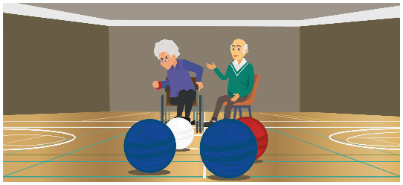

**190**

different type of

activities provided across Conwy - keeping the older

population

fit & active



**198**

Welsh Language promotion events held



**93%**

of Welsh medium primary

pupils went onto Welsh

medium secondary

education

**71%**

of people who had a re-enablement

package no longer

needed care after

6 months



**48**

heritage events held



Provided **68**

apprenticeships



Contributed by Venue Cymru towards local economic impact

**£33Million**

**£3.5million**

gained for citizens through welfare

benefits



**Economy**



**594**

businesses

supported to gain high street rate relief

worth of

grants allocated

to businesses



**£94k**

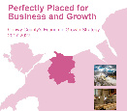

Approval of the

[Conwy Economic](http://conwybusinesscentre.com/conwys-economic-growth-strategy-2017-2027/)

[Growth Strategy 2017-2027](http://conwybusinesscentre.com/conwys-economic-growth-strategy-2017-2027/)



Environmental ‘hotspots’

reduced from **12 to 9**

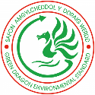

Awarded the **Green Dragon Environmental Standard**

for the 5th year

in a row



**99%**

Street cleanliness

rating achieved



Timeliness of

planning decisions

has improved -

Conwy is now

ranked the

best in

Wales

**7th**



Installed solar panels on to

**8** council sites

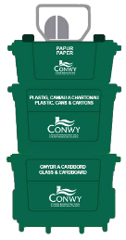

Achieved the best

ever

recycling rate of

**63%**



**11** flooding awareness events

held

**21**

Awards were

achieved for our

parks and

green spaces



**Environment**



**27%**

reduction in

carbon emissions

achieved



Roll

out of [Parent](http://www.conwy.gov.uk/en/Resident/Education-and-Families/Schools/Parent-Pay-Overview.aspx)

[Pay](http://www.conwy.gov.uk/en/Resident/Education-and-Families/Schools/Parent-Pay-Overview.aspx) to all

schools,

for online

payments



Restarted [**webcasting**](https://conwy.public-i.tv/core/portal/home)of democratic meetings &

launched [**e-petitions**](http://www.conwy.gov.uk/en/Council/ePetitions/ePetitions-home.aspx)



**Modernisation**



Launched [**‘Report, Pay, Apply’**](http://www.conwy.gov.uk/en/Resident/Report-Pay-Apply/Report-Pay-Apply.aspx)

**105**,**257**



staff in 17/18 -

claimed by

fewer miles

This is the equivalent of **23 ½**

whole trips around the world!



We achieved the Silver Corporate Health Standard

Our Environment, Roads & Facilities and Revenue & Benefit Service won the Customer Excellence award

for the 7th year in a

row!



Car Park

machines now

chip & Pin enabled



**59**

Sustainability is fundamental to the future of Wales, and it is vital that in all the we do, we consider how we work to prevent a problem occurring, avoid silos, involve people in developing solutions which look to the longer term, and work collaboratively with key partners. Below are some of the highlights achieved in 2017/18.

**Environment**

1. The county achieved the best ever performance in recycling with a rate of 63%.
2. The Council has achieved a 27% reduction in carbon emissions.
3. The Green Dragon Environmental Standard has been awarded for the 5thconsecutive year.
4. The renewable energy improvement programme to install photo-voltaic panels has commenced on 8 council sites.
5. The number of environmental ‘hotspots’ has reduced overall from 12 down to 9.
6. A 99% street cleanliness rating has been achieved.
7. The Parks & Green spaces team have won the APSE Best Performer Award for the 5th consecutive year.
8. Llandudno was awarded Gold and 1st place for Britain in Bloom and a Silver gilt and 1st Place Wales in Bloom were awarded to Colwyn Bay.
9. Overall Twenty one awards were achieved for parks and green spaces.
10. The timeliness of planning decisions has improved considerably – Conwy is now ranked 7th in Wales.

**Social well-being**

1. We were early adopters of ['Making Every Contact Count'](http://www.wales.nhs.uk/sitesplus/888/page/65550) (to support healthy lifestyles).
2. There are excellent examples of the arts at venue Cymru supporting the well-being of people with dementia and providing therapy for people with mental health support needs. A Children in Need Link officer can now refer people to the arts project ['creu-create'](https://venuecymru.co.uk/creu-create).
3. In the Social Care Wales 2018 Accolades –the council’s Reducing Childhood Sexual Exploitation project, was selected as a finalist in the ‘Better outcomes by learning and working together’ category.
4. The Conwy Governors Association has been set up and a programme of mandatory and voluntary training is in place.
5. The [Social Care Commissioning Strategy](http://www.conwy.gov.uk/en/Resident/Social-Care-and-Wellbeing/Policies-Plans-and-Reports/assets/assets/documents/Social-Care-Commissioning-Strategy.pdf) has been launched.
6. There has been a significant improvement in Carers assessments.
7. The shift in focus for social care support to consider ‘what matters’ is achieving excellent feedback.
8. The intensive swimming lessons school pilot has had positive results.
9. The North Wales Obesity service is about to open and is based in Parc Eirias.
10. The food safety team came 9th in the UK on a ‘Which’ survey of planned interventions in failing premises.

**Culture**

1. The Welsh Language Standards have been achieved and the Welsh Language in Education Strategy has been reviewed and updated.
2. Staff are taking up the offer free Welsh Government funded training on workplace Welsh.
3. Social Services are working to support residential homes where there are not many Welsh speaking staff.
4. The Tri Partnership Agreement with Bangor University MA Programme has been revalidated. The 2018 students undertaking placements within local authorities will be bilingual and it is anticipated, upon qualifying, they will be recruited by partners and so increase the number of welsh speaking social workers within the workforce.
5. The Communication team has been restructured to improve communication capacity.
6. Teams are looking at ways to support/ get involved in the Eisteddfod 2019 which will be hosted in Llanrwst.
7. Venue Cymru has been helping schools with orchestra provision and through the Conwy Arts Trust, a wind ensemble has been set up.
8. There has been an excellent response to the Dementia friendly screenings in Theatre Colwyn and capital works to improve the theatre have been completed.
9. Heritage Lottery Funding of over £1.1million has been secured for Llandudno and Penmaenmawr museums.
10. The refurbishment of Venue Cymru will start in 2018.
11. The Culture centre is on track to open in Autumn 2019.

**Economic**

1. The regional growth bid is progressing and is hoped that this can be broadened to include adventure tourism.
2. The [Conwy Economic Growth Strategy 2017-2027](http://conwybusinesscentre.com/conwys-economic-growth-strategy-2017-2027/) has been approved.
3. The Council target for the number of apprenticeships has been achieved and many have gone on to gain permanent employment on complete of the scheme.
4. The Environment Roads and Facilities Service have been shortlisted for the Constructing Excellence in Wales 2018 for commitment to employee training (relating to the career grade apprenticeship scheme they have developed).
5. The use of volunteers to support events has gone well, and has resulted in a number of volunteers going on to gain employment.
6. £3.5 million has been gained for citizens through welfare benefits.
7. 594 businesses have been supported to gain High Street rate relief.
8. £94,000 worth of grants were allocated to businesses in 2017/18.
9. The Skills Board has been revised and ‘Communities for Work Plus’ starts in September.
10. It has been another year of successful events. The authority hosted the Armed Forces Day. This was the biggest event the authority has ever undertaken, resulting in significant visitor numbers, positive feedback and extensive media coverage. Other events included sporting events, the choral festival (which is pulling in interest from across the world), and the GB Rally. Next year the GB Rally will be going through the streets of Llandudno.
11. The new [Tourist Information Centre](http://www.visitllandudno.org.uk/visitor-info/tourist-information-centres) has opened in Llandudno Victoria Centre and now includes local produce for sale and can now sell theatre tickets.
12. The Tram now sells bespoke tram gifts to generate income.
13. Llandudno Library is now offering Visa Support.

**Modernisation**

1. The formal handover of our new offices in Colwyn Bay, Coed Pella, has been brought forward a month to September 2018. Services will move into the building in October 2018.
2. Coed Pella has an interim award for BREAM excellence.
3. The building project for Coed Pella has exceeded all social value targets (use of local business and apprenticeships).
4. The Customer Excellence Award has been gained for 7th consecutive year for Environment Roads and Facilities and Revenue and Benefits Services, with 8th year pending for 2019.
5. [Webcasting](https://conwy.public-i.tv/core/portal/home) of democratic meetings has restarted and [e-petitions](http://www.conwy.gov.uk/en/Council/ePetitions/ePetitions-home.aspx) have been launched.
6. We have launched the ‘Report, Pay, Apply’ [online tool](http://www.conwy.gov.uk/en/Resident/Report-Pay-Apply/Report-Pay-Apply.aspx) .
7. Chip & pin has been rolled out to 59 carpark machines
8. Parent Pay has been rolled out to all schools to allow online payments and there has been positive feedback.
9. Finances’ review of MRP (Minimum Revenue Provision) policy has saved £2 million a year.
10. There has been an improvement in attendance management & approx. 1400 staff achieved 100% attendance in 2017/18.
11. The authority achieved the Silver Corporate Health Standard.
12. The downward trend for business miles claimed is continuing, with 105,257 fewer miles claimed in 2017/18 than 2016/17 and £52,049 less reimbursed in 2017/18 than 2016/17. This is the equivalent to 23 ½ complete journeys around the world.
13. The new corporate branding and style guide has been launched.

# **3.2 Where we need to improve/ develop**

W

e are delighted with these achievements, but self-evaluation also means reflecting where there are pressures in service delivery. We are therefore monitoring the following areas:

1. The demand for housing support and preventing homelessness is increasing. We will continue to monitor levels of homelessness. There is a national increasing trend, and the team is being restructured to adapt to the demand and to prevent homelessness occurring.
2. Universal Credit commenced in Conwy in February 2018 and we are monitoring the impact on 6459 working age households which are affected.
3. We will continue to focus on our corporate approach to safeguarding.
4. We continue to focus on educational attainment and to adapt to the changes in Welsh Government education performance measures.

# **4 How do we compare?**

In order to assess and compare how well we are doing across Wales, the WLGA has a number of all Wales performance measures covering key policy areas. Public Accountability Measures consist of a small set of “outcome focused” indicators. They reflect those aspects of local authority work which local authorities agree are considered to be important in terms of public accountability. For example, recycling, educational attainment, sustainable development, etc. This information is collected and reported nationally, validated, and published annually. This section provides an overview of our performance against these national measures.

The following tables report the actual out turn performance figure against target for the Public Accountability Measures (PAMs). A detailed report was presented to Finance & Resources Overview and Scrutiny Committee on 2nd July 2018, which can be accessed here: [Year End Performance Indicator Report](http://modgoveng.conwy.gov.uk/documents/g7088/Public%20reports%20pack%20Monday%2002-Jul-2018%2010.00%20Finance%20and%20Resources%20Overview%20and%20Scrutiny%20Committe.pdf?T=10)

Where the target has not been achieved the service has put actions in place to address the issues. These actions are monitored as part of the 6 monthly Service Performance Reviews to ensure we manage the performance during the year.

The key used in the Performance column is explained below:

|  |  |
| --- | --- |
| ***Compared to target set:*** |  |
| Target met | bl |
| Within tolerance to progress work to meet target | bl |
| Not Meeting target and below tolerance level | bl |
| No target set | bl |

Conwy features in the top quartile in Wales for the following:

* The number of working days/shifts per full-time equivalent (FTE) local authority employee lost due to sickness absence during the year
* % of highways inspected of a high or acceptable standard of cleanliness
* The average number of calendar days taken to deliver a Disabled Facilities Grant (DFG)
* The number of visits to local authority sport and leisure facilities during the year where the visitor will be participating in physical activity per 1,000 population

And the bottom quartile for the following:

* % of empty private sector properties brought back into use during the year through direct action by the local authority.
* % of appeals against planning application decisions dismissed.
* % of C roads that are in overall poor condition.

|  |  |  |  |  |  |  |
| --- | --- | --- | --- | --- | --- | --- |
| **Measures Title** | **Actual 16/17** | **Actual 17/18** | **Target 17/18** | **Wales Benchmark** | **Rank in Wales**  **(out of 22)** | **Analysis of Performance** |
| (PAM/001) - Number of working days/shifts per FTE lost due to sickness absence | 3.35 | 2.83 | 10.50 | 10.1 | 6 | |  |  |  |  |  | | --- | --- | --- | --- | --- | |  |  |  |  |  | |  | bl | | |  | |  |  | |  | | --- | | Green | |  |  | |  |  |  |  |  | |
| (PAM/006) - % of Year 11 pupils achieving the Level 2 threshold including a GCSE grade A*-C in English or Welsh first language and Mathematics | 55.9 | 53.8 | 60.0 | 54.6 | 12 | |  |  |  |  |  | | --- | --- | --- | --- | --- | |  |  |  |  |  | |  | bl | | |  | |  |  | |  | | --- | | Red | |  |  | |  |  |  |  |  | |
| (PAM/007) - % of pupil attendance in primary schools | 94.92 | 94.84 | 95.00 | 94.8 | 11 | |  |  |  |  |  | | --- | --- | --- | --- | --- | |  |  |  |  |  | |  | bl | | |  | |  |  | |  | | --- | | Amber | |  |  | |  |  |  |  |  | |
| (PAM/008) - % of pupil attendance in secondary schools | 94.44 | 94.36 | 94.50 | 94.1 | 8 | |  |  |  |  |  | | --- | --- | --- | --- | --- | |  |  |  |  |  | |  | bl | | |  | |  |  | |  | | --- | | Amber | |  |  | |  |  |  |  |  | |
| (PAM/009) - % of Year 11 leavers not in education, employment or training (Destination Survey). | 1.78 | 1.30 | 1.80 | 1.30 | 9 | |  |  |  |  |  | | --- | --- | --- | --- | --- | |  |  |  |  |  | |  | bl | | |  | |  |  | |  | | --- | | Green | |  |  | |  |  |  |  |  | |
| (PAM/010) - % of streets that are clean | 98.95 | 98.67 | 95.00 | 95.8 | 5 | |  |  |  |  |  | | --- | --- | --- | --- | --- | |  |  |  |  |  | |  | bl | | |  | |  |  | |  | | --- | | Green | |  |  | |  |  |  |  |  | |
| (PAM/011) - % of reported fly-tipping incidents cleared within 5 working days of the incident being reported | 98.22 | 96.31 | 95.00 | 96.62 | 12 | |  |  |  |  |  | | --- | --- | --- | --- | --- | |  |  |  |  |  | |  | bl | | |  | |  |  | |  | | --- | | Green | |  |  | |  |  |  |  |  | |
| (PAM/012) - % of households threatened with homelessness successfully prevented from becoming homeless | No data | 58.43 | 65.00 | 65.1 | 16 | |  |  |  |  |  | | --- | --- | --- | --- | --- | |  |  |  |  |  | |  | bl | | |  | |  |  | |  | | --- | | Red | |  |  | |  |  |  |  |  | |
| (PAM/013) - % of private sector dwellings that had been vacant for more than 6 months that were returned to occupation during the year through direct action by the local authority | 4.75 | 1.76 | None set | 4.5 | 18 |  |
| (PAM/014) - Number of additional dwellings created as a result of bringing empty properties back into use | No data | 1.00 | None set | None published | N/A |  |
| (PAM/015) - Days taken to deliver a Disabled Facilities Grant | 176.11 | 163.78 | 170.00 | 223 | 3 | |  |  |  |  |  | | --- | --- | --- | --- | --- | |  |  |  |  |  | |  | bl | | |  | |  |  | |  | | --- | | Green | |  |  | |  |  |  |  |  | |
| (PAM/016) - Number of visits to public libraries during the year per 1,000 population | 4,770 | 4,540 | 4,775 | 4,666 | 13 | |  |  |  |  |  | | --- | --- | --- | --- | --- | |  |  |  |  |  | |  | bl | | |  | |  |  | |  | | --- | | Red | |  |  | |  |  |  |  |  | |
| (PAM/017) - Number of visits to local authority sport and leisure centres during the year where the visitor will be participating in physical activity, per 1,000 population | 8,459 | 10,008 | 8,500 | 8,496 | 4 | |  |  |  |  |  | | --- | --- | --- | --- | --- | |  |  |  |  |  | |  | bl | | |  | |  |  | |  | | --- | | Green | |  |  | |  |  |  |  |  | |
| (PAM/018) - % of all planning applications determined in time | No data | 90.3 | None set | 89.8 | 10 |  |
| (PAM/019) - % of appeals determined that upheld the authority's decision in relation to planning application decisions and enforcement notices | 57.9 | 47.4 | None set | 60.5 | 20 |  |
| (PAM/020) - % of A roads in poor condition | 3.08 | 3.47 | 4.00 | 3.3 | 13 | |  |  |  |  |  | | --- | --- | --- | --- | --- | |  |  |  |  |  | |  | bl | | |  | |  |  | |  | | --- | | Green | |  |  | |  |  |  |  |  | |
| (PAM/021) - % of B roads in poor condition | 4.26 | 4.26 | 7.50 | 4.4 | 10 | |  |  |  |  |  | | --- | --- | --- | --- | --- | |  |  |  |  |  | |  | bl | | |  | |  |  | |  | | --- | | Green | |  |  | |  |  |  |  |  | |
| (PAM/022) - % of C roads in poor condition | 15.67 | 14.45 | 17.00 | 7.5 | 19 | |  |  |  |  |  | | --- | --- | --- | --- | --- | |  |  |  |  |  | |  | bl | | |  | |  |  | |  | | --- | | Green | |  |  | |  |  |  |  |  | |
| (PAM/023) - % of food establishments which are 'broadly compliant' with food hygiene standards | 95.39 | 96.60 | None set | 95.2 | 9 |  |
| (PAM/024) - People who are satisfied with the care and support they received | 86.00 | 83.26 | None set | Data not yet available | |  |
| (PAM/025) - The rate of delayed transfers of care for social care reasons per 1,000 population aged 75 or over | 1.01 | 0.33 | 0.00 | Data not yet available | | |  |  |  |  |  | | --- | --- | --- | --- | --- | |  |  |  |  |  | |  | bl | | |  | |  |  | |  | | --- | | Green | |  |  | |  |  |  |  |  | |
| (PAM/026) - Carers reporting they feel supported to continue their caring role | 68.00 | 69.57 | None set | Data not yet available | |  |
| (PAM/027) - % of children who are satisfied with the care and support that they received | Data not yet available | | | Data not yet available | |  |
| (PAM/028) - % of assessments completed for children within statutory timescales | 95.34 | 100.00 | 95.00 | Data not yet available | | |  |  |  |  |  | | --- | --- | --- | --- | --- | |  |  |  |  |  | |  | bl | | |  | |  |  | |  | | --- | | Green | |  |  | |  |  |  |  |  | |
| (PAM/029) - % of looked after children on 31 March who have had 3 or more placements during the year | 12.92 | 7.73 | 10.00 | Data not yet available | | |  |  |  |  |  | | --- | --- | --- | --- | --- | |  |  |  |  |  | |  | bl | | |  | |  |  | |  | | --- | | Green | |  |  | |  |  |  |  |  | |
| (PAM/030) - % of municipal waste reused, recycled or composted | 62.63 | 63.37 | 65.00 | Data not yet available | | |  |  |  |  |  | | --- | --- | --- | --- | --- | |  |  |  |  |  | |  | bl | | |  | |  |  | |  | | --- | | Amber | |  |  | |  |  |  |  |  | |
| (PAM/031) - % of municipal waste sent to landfill | 28.47 | 25.87 | 35.00 | Data not yet available | | |  |  |  |  |  | | --- | --- | --- | --- | --- | |  |  |  |  |  | |  | bl | | |  | |  |  | |  | | --- | | Green | |  |  | |  |  |  |  |  | |

# 

# **5 Financial Summary**

As a public accountable body, Conwy County Borough Council must provide value for money in the services it provides to the community. The Authority charged the ninth lowest Council Tax at Band D in Wales for 2017/2018.  A large part of the funding for Local Authorities in Wales is from the Welsh Government through a revenue support grant (RSG).   For 2017/2018 the Aggregate External Finance (AEF), which includes the RSG and a proportion of the National Non Domestic Rates collected, increased by 0.5% which in cash terms equated to an additional £764,000.  However, due to demand led pressures on services and UK Government policy changes the resource shortfall was £14,282million.  In order to meet the resource shortfall a number of measures were implemented;

1. All departments were required to make savings through various means. Initiatives were put forward by the services and approved by Members such as the introduction of preventative initiatives in Social Services, additional income generation, service re-modelling etc.
2. Council tax was increased by 4.6%.
3. A number of corporate initiatives were implemented including changes to the way the capital programme was financed.

The diagrams below shows where the money (income) came from and how we spent our budget in 2017/2018.

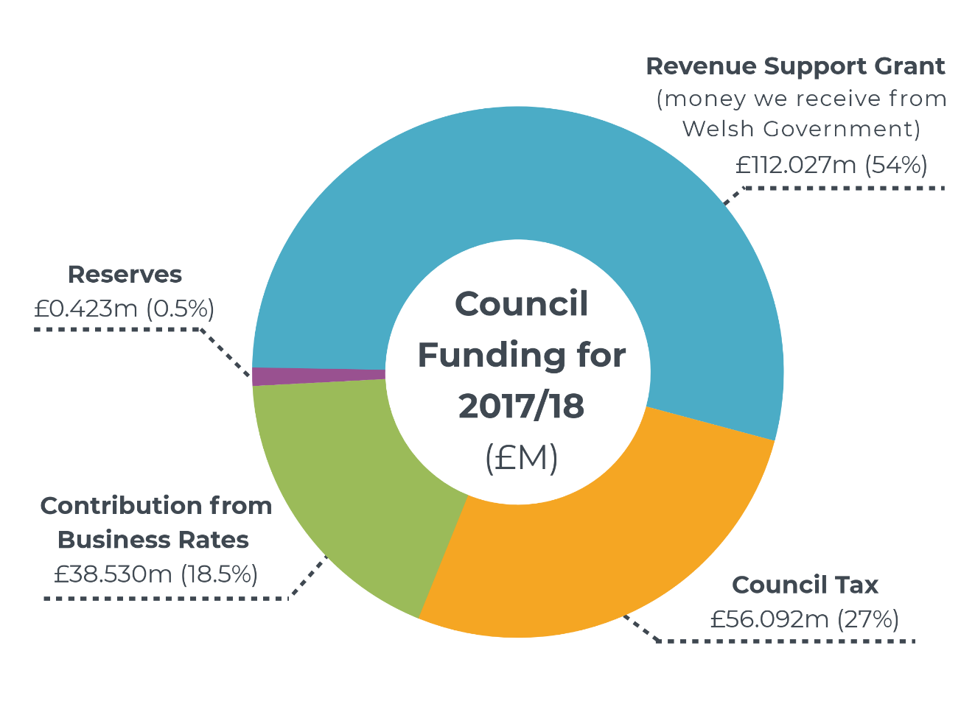

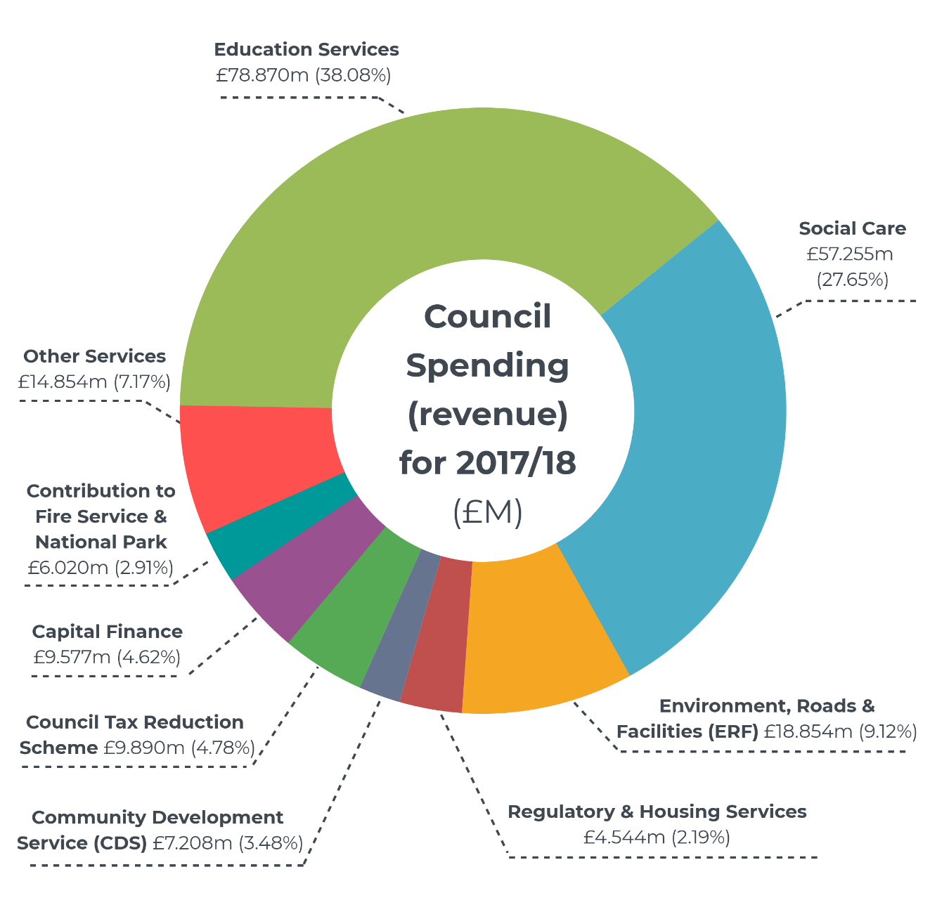

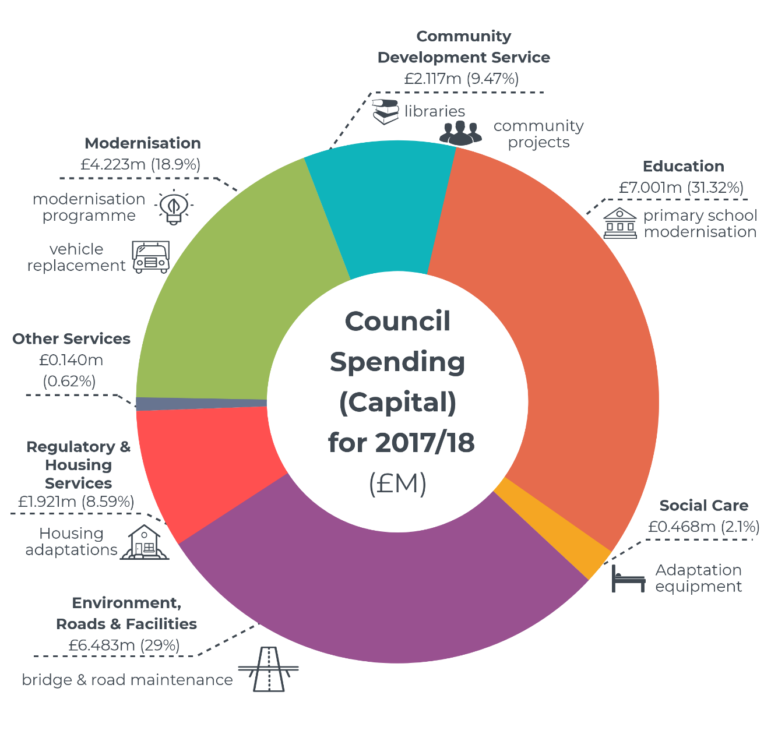

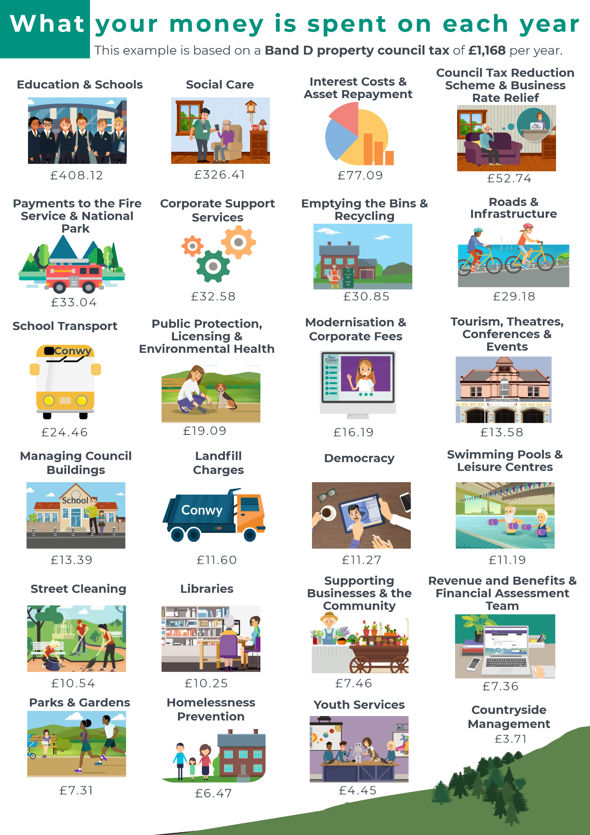

More detailed information on our budgets can be found in the Statement of Accounts which is presented to Audit & Governance Committee every September.

Since 2013 we have delivered £42,109m of savings.  We achieved £9,405 million savings during 2017/18. We are now at a point where the options left to us are very difficult because they involve a further reduction in staff numbers and cutting service provision. We are trying to avoid such difficult decisions where we can, by working collaboratively and thinking more laterally about how we commission services. We are also looking longer term, to review where future demands will be, so that we can adapt to meet the needs of future generations. We are actively planning to deliver further savings to address a shortfall of £11,326m in 2018/19. We are also preparing for a potential shortfall of £14,856million for 2019/20 and £12million for 2020/21.

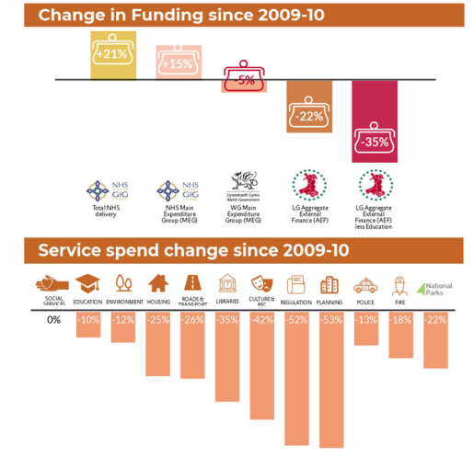

Source WLGA “*Fair and Sustainable Funding for Essential Local Services*”

# **6 Get Involved**

Conwy County Borough Council is committed to improving our services and it is important that we listen to what you, the community, say. We welcome your comments or suggestions for improvements for the Council to consider at any time of the year, so please let us know. You can join **The County Conversation** to share your views and ideas about the County or your local area.

|  |  |  |
| --- | --- | --- |
|  | | [www.conwy.gov.uk/The-County-Conversation](http://www.conwy.gov.uk/en/Council/Have-your-say/The-County-Conversation.aspx)  [www.conwy.gov.uk/Sgwrs-y-Sir](http://www.conwy.gov.uk/cy/Council/Have-your-say/The-County-Conversation.aspx)  [www.facebook.com/sgwrsconwyconvo/](http://www.facebook.com/sgwrsconwyconvo/)  [@sgwrsconwyconvo](https://twitter.com/sgwrsconwyconvo) |
| [Image result for symbol pen](http://www.google.co.uk/url?sa=i&rct=j&q=&esrc=s&source=images&cd=&cad=rja&uact=8&ved=0ahUKEwjXxJSsva3RAhXB6xoKHY7TBwUQjRwIBw&url=http://downloadicons.net/pen-symbol-icon-2488&bvm=bv.142059868,d.d2s&psig=AFQjCNE0IRo4HRemLV6Py2N0JYnew3Jzzw&ust=1483790723068244) | Corporate Improvement & Development Team  Conwy County Borough Council  Bodlondeb  Conwy  LL32 8DU | |
| [Image result for email icon transparent background](http://www.google.co.uk/url?sa=i&rct=j&q=&esrc=s&source=images&cd=&cad=rja&uact=8&ved=0ahUKEwi80d2HjK3RAhUJOhoKHZvxCPUQjRwIBw&url=http://www.pngall.com/email-marketing-png&bvm=bv.142059868,d.d2s&psig=AFQjCNE7pjBdAT_GBuC75Q5EX5dIMVCD0Q&ust=1483777426053392) | cidt@conwy.gov.uk | |
| [Image result for phone icon transparent background](http://www.google.co.uk/url?sa=i&rct=j&q=&esrc=s&source=images&cd=&cad=rja&uact=8&ved=0ahUKEwiou-agjK3RAhXFSxoKHVCYCVIQjRwIBw&url=http://www.clipartbest.com/clipart-RTGnBLbTL&bvm=bv.142059868,d.d2s&psig=AFQjCNEB9SLPieRBRMIj1KJh73TA2zKYdw&ust=1483777546155262) | 01492 574000  BT Relay Service Customers with hearing or speech impairments can contact any Council service by dialling **18001** before the number they require. | |

**We want to hear Young People’s views**

Having a say isn’t just for adults.  Our young people are the future generation and we want to hear your views too!  There are lots of ways you can have your say in Conwy, all of the services working with children and young people in Conwy give opportunities for you to have your say. In particular, Conwy Youth Council are about you having a voice and having a choice in decisions that affect you. They are your representatives, and work on projects, and have a say on things that can make a difference to children and young people in Conwy.

If you want to get involved: <https://www.facebook.com/CyngorIeuenctidConwyYouthCouncil>

This Annual Report, the Corporate Plan, the Annual Governance Statement and the Wales Audit Office Annual Improvement Report are all published on our website in English and Welsh. [www.conwy.gov.uk/corporateplan](http://www.conwy.gov.uk/corporateplan) or [www.conwy.gov.uk/accountability](http://www.conwy.gov.uk/accountability).

You can also access the Reports on our free public access computers which are in all Council Libraries and Bodlondeb and Civic Office Receptions.

In order to be sustainable and to reduce printing costs, a limited number of paper copies of the Annual Report are available at these locations:

|  |  |
| --- | --- |
| **All Council Libraries** | **Bodlondeb Council Office, Conwy** |
| **Mobile Library** | **Mochdre Council Office** |
| **Housebound Service** | **Coed Pella Council office, Colwyn Bay ( Opening in 2018)** |

A paper copy can be requested by calling 01492 574000.

**We are happy to provide this document in large print, audio CD, braille and British Sign Language.**

**Please call 01492 574000 to arrange a copy.**





# 

# C:\Users\Lewisfm\AppData\Local\Microsoft\Windows\Temporary Internet Files\Content.Outlook\D97PPVEB\app.png**7 Where to Get More Information About Your Council**

* Be Digital – [AppConwy](http://www.conwy.gov.uk/en/Council/Apps/AppConwy.aspx) provides the latest news updates from the Council and features local service information such as school announcements, job vacancies and waste collection days. To try out our app simply download AppConwy from the AppStore, PlayStore or Windows Store.
* Our Website [www.conwy.gov.uk](http://www.conwy.gov.uk)
* Social Networks - You can follow us on Twitter and Face book
* Conwy County Borough Council’s **Corporate Plan 2017 - 2022** and 6 monthly Performance Reports [www.conwy.gov.uk/corporateplan](http://www.conwy.gov.uk/corporateplan)
* The **Local Government Data Unit** collect, present and compare the National Performance Measurement Framework data for all councils in Wales. A performance measurement report detailing Conwy’s progress over a period of years is available on our website:

[www.dataunitwales.gov.uk](http://www.dataunitwales.gov.uk/)

[www.mylocalcouncil.info](http://www.mylocalcouncil.info)

* **Wales Audit Office** inspect all Welsh Local Authorities’ performance. National and council specific audit reports can be found at: [www.wao.gov.uk](http://www.wao.gov.uk)
* **Estyn** inspect all primary & secondary schools and Local Education Authorities across Wales. All inspection reports can be accessed at: [www.estyn.co.uk](http://www.estyn.co.uk)
* The **Care Inspectorate Wales (CIW)** inspect the quality of social care establishments and some early years provision across the County. All inspection reports can be accessed at: [www.careinspectorate.wales](http://www.careinspectorate.wales)