**Strategic Equality Plan 2020-2024**

**Treating People Fairly**

**Conwy County Borough Council**

**Easy Read version of**

**Equality Objectives**

**2020-2024**

**Easy Read**

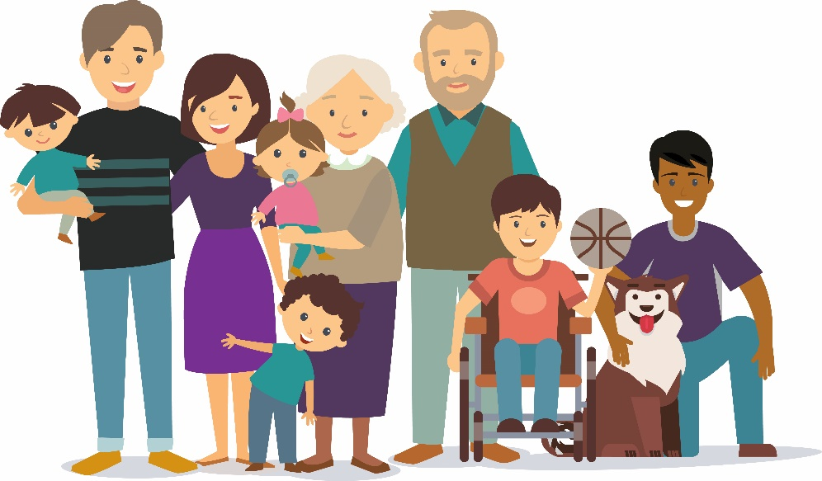

The Organisations below are working together to help people from different protected groups. They have been talking with people to find out what they may need.

|  |  |
| --- | --- |
|  | **Anglesey County Council** |
|  | **Betsi Cadwaladr University Health Board** |
|  | **Conwy County Borough Council** |
|  | **Denbighshire County Council** |
|  | **Flintshire County Council** |
|  | **Gwynedd County Council** |
|  | **North Wales Fire & Rescue Service** |
|  | **North Wales Police** |
| N:\Administration of the OPCC\Templates\Branding\OPCC.Logo.jpg | **North Wales Police & Crime Commissioner** |
| http://www.eryri-npa.gov.uk/__data/assets/image/0004/23971/snpa_col_1b.jpg | **Snowdonia National Park Authority** |
|  | **Welsh Ambulance Service** |
| Wrexham Council homepage | **Wrexham County Borough Council** |

|  |  |
| --- | --- |
| **H:\NWPSEN\Easy Read Objectives 2016-20\Equality.PNG** | **What is this document?**  This document tells you about the things we think are most important for us to concentrate on to give you services that are right and fair.  **How to use this document**  This is an Easy Read version. The words and their meaning are easy to read and understand.  You may need help and support to read and understand this document. Ask someone you know to help you.  Some words may be difficult to understand. These are in **bold blue writing** and have been explained in a box beneath the word.  If any of the words are used later in the booklet they are shown in normal blue writing. If you see words in normal blue writing, you can look up what they mean in a list of the hard words on page 10  Where the document says ‘we’, this means all the organisations listed on page 2. |

|  |  |
| --- | --- |
| **H:\NWPSEN\Easy Read Objectives 2016-20\Equality.PNG** | **What is Equality and what does the law says about it?** |

|  |
| --- |
| **Equality** means treating people fairly and making sure they have the same chances. |

|  |  |
| --- | --- |
| **H:\NWPSEN\Easy Read Objectives 2016-20\Images\law.PNG** | The **Equality Act (2010)** is a law to make sure everyone has the same chances.  The **Equality Act** says everyone has the right to:  ▪ be treated fairly  ▪ have the same opportunities as others  ▪ be free from **discrimination** |

|  |
| --- |
| **Discrimination** is when you are treated badly or unfairly because of your sex, race, religion, disability or sexual identity. |

**Protected groups of people**

The Equality Act protects people from discrimination.

Discrimination is against the law.

There are many people who can be discriminated against. This can include:

|  |  |  |
| --- | --- | --- |
| \\corp.conwy.gov.uk\data\DocStore_Departmental\CommsMarketing\Graphics\Com Characters-02.png | \\corp.conwy.gov.uk\data\DocStore_Departmental\CommsMarketing\Graphics\FamilyHubs-Park.png | men and women |
| \\corp.conwy.gov.uk\data\DocStore_Departmental\CommsMarketing\Graphics\Disability Group-01.png | | disabled people |
| [Image result for people who need support with their emotions](https://www.google.co.uk/url?sa=i&rct=j&q=&esrc=s&source=images&cd=&ved=&url=https://www.psychologynoteshq.com/jameslangetheoryofemotion/&psig=AOvVaw086vvK9gVMOxKRK37IeE8C&ust=1574241572701543) | | people who need support with their thoughts or emotions |
| \\corp.conwy.gov.uk\data\DocStore_Departmental\CommsMarketing\Graphics\Activity Icons\ComArtboard 43@4x.png | \\corp.conwy.gov.uk\data\DocStore_Departmental\CommsMarketing\Graphics\Elderly Chess-01.png | people of different ages - young people or older people |
| \\corp.conwy.gov.uk\data\DocStore_Departmental\CommsMarketing\Graphics\Wellbeing–Be Active-01.png | | people who come from other countries or cultures - who may live in a different way or have a different skin colour |
| \\corp.conwy.gov.uk\data\DocStore_Departmental\CommsMarketing\Graphics\Com Characters-05.png | [Image result for images for religion](https://www.google.co.uk/url?sa=i&rct=j&q=&esrc=s&source=images&cd=&ved=&url=https://making-the-web.com/clipart-9237043&psig=AOvVaw2ew6lHhQB4UhWI0iAKbRSL&ust=1574241100806890) | people of different religions - or who have no religious beliefs |
| \\corp.conwy.gov.uk\data\DocStore_Departmental\CommsMarketing\Graphics\Activity Icons\ComArtboard 59@4x.png | \\corp.conwy.gov.uk\data\DocStore_Departmental\CommsMarketing\Graphics\Activity Icons\ComArtboard 45@4x.png | women who are pregnant or breastfeeding |
| \\corp.conwy.gov.uk\data\DocStore_Departmental\CommsMarketing\Graphics\Group Alternatives-01.png | | lesbian women - women who are attracted to other women |
| \\corp.conwy.gov.uk\data\DocStore_Departmental\CommsMarketing\Graphics\Activity Icons\ComArtboard 40@4x.png | | gay men - men who are attracted to other men |
| \\corp.conwy.gov.uk\data\DocStore_Departmental\CommsMarketing\Graphics\Group Alternatives-01.png | | bisexual men and women - people who are attracted to both men and women |
| [Image result for signage for transgender](https://significon.com/transgender-restroom-signs/) | | transgender people - people who are born as one sex and want to live as the other sex. For example a person who looks like a man may feel inside like a woman |

All these things listed in the box above are known as **protected characteristics**

People can be discriminated against for more than one reason.

|  |
| --- |
| **Protected Characteristics** are features which make up your personal identity for example your sex, race, religion, disability or sexual identity. |

After speaking to lots of people in our communities including

* The public
* People from protected groups
* People from community groups
* People from the voluntary sector
* People from our organisations

we chose **7 areas** to concentrate on to make sure the services you get are fair. These are

|  |  |
| --- | --- |
| \\corp.conwy.gov.uk\data\DocStore_Departmental\CommsMarketing\Graphics\Disability Child School-01.png | **1 Education**  We will do our best to make sure everyone has the same chances in Education.  We will look at   * **Attainment** gaps * **Exclusions** * Bullying * Subject choice |
| \\corp.conwy.gov.uk\data\DocStore_Departmental\CommsMarketing\Graphics\CV-01.png  H:\NWPSEN\Easy Read Objectives 2016-20\Images\education.PNG | **2 Employment and Pay**  We will do our best to make sure everyone has a fair chance to get a job and be paid and treated fairly.  We will look at:   * **Pay gaps** * **Flexible working** * Maternity/paternity * Sexual harassment * Employing disabled people * **Positive action** * **Apprenticeships** |
| [Image result for images living standards](http://www.google.co.uk/url?sa=i&rct=j&q=&esrc=s&source=images&cd=&cad=rja&uact=8&ved=&url=http://www.google.co.uk/url?sa%3Di%26rct%3Dj%26q%3D%26esrc%3Ds%26source%3Dimages%26cd%3D%26ved%3D%26url%3Dhttp://coriolis.co.uk/can-better-living-standards-turned-improved-supplier-profitability/living-standards/%26psig%3DAOvVaw0SGkujNpOCrQKGVfijQ0Pi%26ust%3D1574242038118136&psig=AOvVaw0SGkujNpOCrQKGVfijQ0Pi&ust=1574242038118136) | **3 Living Standards**  We will do our best to improve living standards where possible. We will look at   * Unequal impact * **Independent living** for disabled people * Accessible buildings |
| H:\NWPSEN\Easy Read Objectives 2016-20\Images\health.PNG | **4 Health, Wellbeing and Social Care**  We will do our best to improve health and wellbeing for everyone. We will look at   * Carers * Gypsy/Traveller support * Suicide Prevention * Mental Health * Understanding the social model of disability * Support for neurological conditions |
|  | **5 Personal Security**  We will do our best to make sure everyone has the same chances to be safe from crime and bullying. We will look at   * Hate crime * Violence against women * Personal safety and safeguarding |
|  | **6 Participation**  We will do our best to make sure everyone has the same chances to be heard. We will look at   * Representation at meetings * Disability Training to transport providers * Improving the ways we talk to people |
|  | **7 Socio-Economic Duty**  We will do our best to understand what we need to do and take action |

**Hard Words**

|  |  |  |
| --- | --- | --- |
| 1 | **Equality** | Treating people fairly and making sure they have the same chances |
| 2 | **Discrimination** | When you are treated badly or unfairly because of your sex, race, religion, disability or sexual identity |
| 3 | **Protected Characteristics** | Features which make up your personal identity for example your sex, race, religion, disability or sexual identity. |
| 4 | **Attainment gaps** | The difference in school grades achieved |
| 5 | **Exclusions** | Pupils who are stopped from attending school due to their behaviour |
| 6 | **Pay gaps** | Difference in pay between different protected groups – most commonly there is a pay gap between men and women’s pay |
| 7 | **Flexible working** | Where work is structured less formally and staff can more easily fit their work around their life |
| 8 | **Positive Action** | Where training and other support is given to help people do better to get a job |
| 9 | **Apprenticeships** | A person learning the skills of a job while working |
| 10 | **Independent living** | To help people achieve their goals and have the lives they want |
| 11 | **Accessible** | Easy to find, easy to get to, easy to use |
| 12 | **Well-being** | Anything to do with your health and happiness |
| 13 | **Hate crime** | Where you are bullied or attacked because of your protected characteristic |