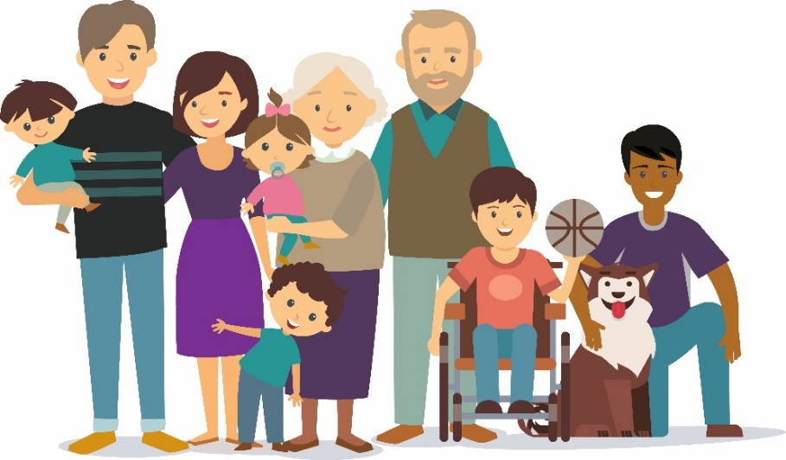
Strategic Equality Plan
2020-2024

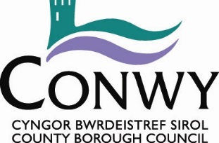

Have your say on the Council’s

Draft Strategic Equality Plan and Equality Objectives for 2020-2024

See the Draft Strategic Equality Plan and Objectives:
(LINK to Draft SEP, SEP Action Plan and Easy Read SEP)

We'd like you to get involved and share your views by answering the following questions:

- Are our Equality Objectives the right things we should be focusing on to improve Equalities within Conwy for the next 4 years?
Yes

No

- If no, what other objectives would you suggest?

- What should we do more of?

- What should we do less of?

- Have you any further comments about our plan or the progress we've made so far which can be seen within our Annual Reports?

Equality Questionnaire
In order to monitor the effectiveness of our engagement activity and to ensure it is delivered in a way that is fair to all and free from bias, we would appreciate your cooperation in providing on an entirely voluntary basis, the information as requested below.
The information is confidential and anonymous, and will be used solely for statistical monitoring purposes.

Age:
Please indicate your age by ticking the appropriate box: | 0 – 15 years |  | 16 – 24 years |  | 25 – 34 years
 | 35 – 44 years |  | 45 – 54 years |  | 55 – 64 years
 | 65 – 74 years |  | 75 and above

Sex:
Male |  | Other
Female |  | Prefer Not To Say

National identity:
How would you describe your national identity?
Welsh |  | British
English |  | Irish
Scottish |  | Other (please describe) ____________________________________
Northern Irish |  | Prefer Not To Say

Ethnic Group:
What is your ethnic group? Choose one option that best describes your ethnic group or background.
White |  | Black/Black British |  | Asian/Asian British
British |  | Caribbean |  | Indian
English |  | African |  | Bangladeshi
Northern Irish |  | Any other Black  Background |  | Pakistani
Scottish |  |  |  | Chinese
Welsh |  |  |  | Asian other
Irish
Gypsy or Irish
Traveller
Other
Mixed/Mixed British |  | Other / Other British
White / Black Caribbean |  | Arab |  | Prefer not to say
White / Black African |  | Other (state if required) |  | _______________
White / Asian
Any other Mixed background

Sexual Orientation:
Which of the following options best describes how you think of yourself?
Heterosexual/Straight |  | Bisexual
Gay Man |  | Other (state if desired) _______________________________
Gay Woman/Lesbian |  | Prefer not to say

Gender Reassignment:
Since birth has your gender identity changed? (please tick one option) | Yes
 | No
 | Prefer not to say

Religion or Belief:
What is your religion?
Christian (all denominations) |  |  |  |  |  | No religion
Buddhist |  | Muslim |  | Jewish |  | Other (State) ___________________
Hindu |  | Sikh |  | Atheist |  | Prefer not to say

Marital Status:
Are you married or in a same-sex civil partnership? | Yes
 | No
 | Prefer not to say

Disability:
Section 6(1) of the Equality Act 2010 states that a person has a disability if:
- That person has a physical or mental impairment, and
- The impairment has a substantial and long-term adverse effect on that person’s ability to carry out normal day-to-day activities.
Using this definition do you consider yourself to be disabled? | Yes  No  Prefer not to say

Pregnancy and Maternity:
Are you currently pregnant or have you been pregnant or taken maternity leave in the last year?
Yes |  | Does not apply to me
No |  | Prefer Not To Say
Other please specify:

Thank you for taking the time to give us feedback. Your comments will be taken into account in the final version of our plan.
If you would like to contact us to discuss the Strategic Equality Plan further, please contact equalities@conwy.gov.uk

