**Equality in North Wales: Data and evidence report**

**Executive Summary**

This report was commissioned by the North Wales Public Services Board Officers Network in order to gain a deeper understanding of equality at local level – in particular on the issues covered in the “Is Wales Fairer?” report (Equality and Human Rights Commission, 2018). It is intended as a supplement to, rather than a duplication of, that report concentrating on more detailed information, either at overall north Wales level or more locally if available. The report contains a comprehensive list of the data sources used, which could be used as a basis for updating and reviewing progress in delivering the objectives over time.

In general the main findings amplify those in “Is Wales Fairer?” and show that the effects of poverty, inequality and exclusion, which were highlighted at Wales level in that report, are also very much in evidence in local communities across north Wales. The main themes which become evident are:

* **Socio-economic disadvantage:** the impact of poverty and deprivation on peoples’ lives is very apparent; a particularly striking example is educational attainment: 28% of pupils claiming free school meals achieve the Level 2 Inclusive Threshold at school-leaving age, compared with 58% of other pupils. Households in lower socio-economic groups are also much less likely to have access to a car – which will have a particularly significant impact on people living in rural areas.
* **Disabled people:** although the additional evidence available locally is patchy, the data for employment in particular suggest that opportunities for disabled people are limited; for example in one local authority area (Conwy) disabled people are five times more likely than non-disabled people to be unemployed.
* **Outcomes for women / girls:** the data suggests a mixed picture:
  + girls achieve higher educational attainment than boys in schools, and among the working-age population there are more females than males with degree-level qualifications;
  + unemployment is generally lower amongst females than males, and more females than males participate in job-related training and apprenticeships;
  + female life expectancy is higher (in line with the national pattern). However:
* women generally earn less than men, with the pay gap reaching up to 17% in some areas;
* females are more likely to provide unpaid care, to be in households threatened with homelessness, and to live with a limiting long-term health condition;
* less than a quarter of elected councillors in north Wales are female.
* **Race inequality:** the data available is patchy, but show for example that people from ethnic minority groups are more likely than the White Welsh / British population to have a degree-level qualification; however in Gwynedd, Flintshire and Wrexham the employment rate amongst ethnic minorities is lower than amongst the White Welsh / British population (the opposite is true in the other three local authority areas). In 2017/18 64% of hate offences across North Wales related to race.

It should be emphasised that these conclusions are based on the information available for each protected characteristic; the “Is Wales Fairer?” report notes that *“there are serious gaps in data for Wales that make it very difficult to make a full assessment of equality in Wales”*. This is even truer at North Wales and lower geographical levels, and the absence of evidence should not be taken to imply that inequalities for other protected groups do not exist or are somehow less important.

The 2021 Census (additional questions, and greater availability / flexibility of the results) will help fill some of the gaps but a more systematic and robust approach to data collection and dissemination is needed to enable a comprehensive assessment of equality at local level. In particular, some of the questions already included in the National Survey for Wales could be a very useful source of information particularly on issues such as health, lifestyles and participation. The results however are generally published by area, or by protected characteristic, but not both. Pressing the Welsh Government to publish these results in more detail (or to boost the sample size, if this is the reason they are not published) would be a useful first step towards improving the data available.

1. **Purpose of report**

This report has been commissioned by the North Wales Public Services Board Officers Network in order to gain a deeper understanding of equality data at local level – in particular on the issues covered in the “Is Wales Fairer?” report (Equality and Human Rights Commission, 2018).

This document is intended as a supplement to, rather than a duplication of, the data and findings contained in “Is Wales Fairer?” concentrating on the more detailed information which is available at overall north Wales level, the 6 local authority areas and more locally if available. It is based on the latest available data at time of writing (September 2019).

It also draws attention to the gaps in data and information at local levels and suggests some priorities for improvement.

**Appendix 1** of the report contains a comprehensive list of the data sources used with hyperlinks. These could be used to update and review progress in delivering the objectives over time.

1. **Introduction / approach used**

The report uses the same headings and structure as the “Is Wales Fairer?” report, in order to emphasise the intention for it to be used as a supplement to that report and to facilitate comparisons with Wales as a whole.

The starting point for the report was to investigate all the data sources referenced in “Is Wales Fairer?” to check whether they were available at north Wales, local authority or lower level.

This information was then supplemented with data from the Wales Public Health Observatory and other databases such as InfoBaseCymru, StatsWales and Nomis. In some cases more detailed data was requested from organisations such as the Welsh Government.

We discussed the findings, and specifically the information gaps which became evident, with North Wales Public Sector Equality Network members as the report was developed. They provided us with useful links to other data and more locally available evidence.

The final report is therefore comprehensive in terms of the information available to us, but a number of data gaps still exist as highlighted in the report. In particular, the report contains more analysis of some protected characteristics (such as gender and age) than others. This reflects the data available for each topic and should not be taken to imply that inequalities for the other protected groups do not exist or are somehow less important.

By highlighting the information gaps which exist at local level this report will hopefully play a small part in addressing them for the future. The output from the 2021 Census will allow for somewhat more flexible, detailed analysis of local area characteristics; there will also be additional / fuller information on gender identity, sexual orientation and civil partnerships.

1. **Key statistics for North Wales**

Where data on protected and other key characteristics is available from the 2011 Census, the proportions by local authority are shown in the charts below.

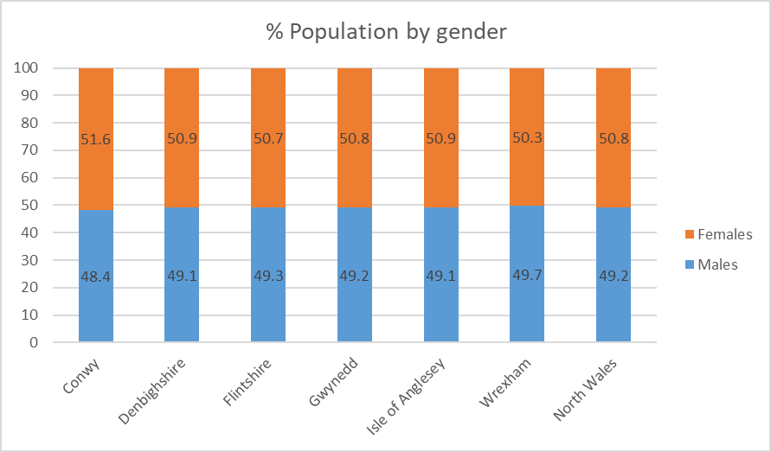

**Data from sources other than the Census**

***Sexual orientation***

Data on sexual orientation is not currently estimated below UK region / country level. Data from the Annual Population Survey for 2017[1] estimates that across Wales as a whole, 94.9% of the population aged 16 and over identify as heterosexual / straight, 1.3% as gay or lesbian, 0.7% as bisexual, 0.5% other, and 2.5% refuse to answer / don’t know.

***Disability***

Data from the Annual Population Survey 2015-2017[2] suggests that across North Wales, 77,000 (18.7%) of people aged 16 to 64 are disabled (based on the Equality Act 2010 definition of disability). No lower geographical breakdown is available.

1. **Education**

4.1 **Educational attainment of children and young people**

It is important to note that the local authority data in this section of the report is intended to inform greater understanding of equality issues and their impact on pupil achievement across north Wales, rather than measuring or assessing school / local authority performance.

4.1.1 Early years education

Pupil attainment in early years education is measured through the percentage of children achieving the expected outcome at Foundation Phase (“good level of development or of literacy and numeracy”). The latest data available is for 2017[3]; **87.0%** of children finishing the Foundation Phase (age 7) throughout North Wales achieved the expected outcome, compared with **87.3%** across Wales.

Breaking down the results **by gender**, 90.7% of girls in North Wales achieved the expected outcomes compared to 83.5% of boys.

Analysis at local authority level (chart below) shows that a higher percentage of girls achieved the expected outcome in each local authority area. The size of the gap varied between 6.1% (Isle of Anglesey) and 9.7% (Conwy).

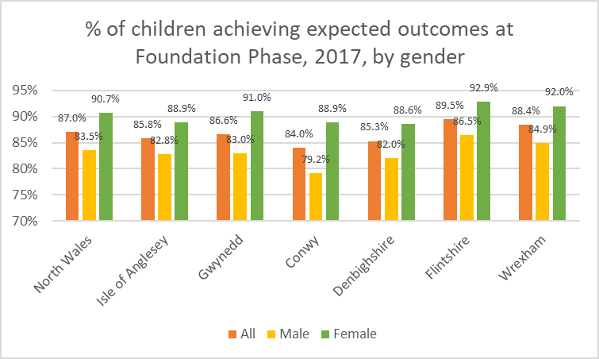

4.1.2 Attainment at school-leaving age

Attainment at the end of compulsory education is measured through the achievement of the ‘Level 2 Inclusive Threshold’, which requires the equivalent of five GCSEs at grade A*-C including English or Welsh first language and mathematics. In 2016/17 (the data year for the “Is Wales Fairer?” comparisons) **53.6%** of Year 11 pupils achieved the threshold in North Wales compared with **54.6%** throughout Wales.

For the purpose of this analysis however, we use the latest 2017/18 data which shows **52.0%** of Year 11 pupils achieving the Threshold across North Wales (compared with **55.1%** across Wales).

Breaking down the results **by gender**, 58.5% of girls in North Wales achieved the Threshold compared to 45.9% of boys.

Analysis at local authority level (chart below) shows that a higher percentage of girls achieved the Threshold in each local authority area. The size of the gap varied between 8.6% (Conwy) and 19.2% (Isle of Anglesey).

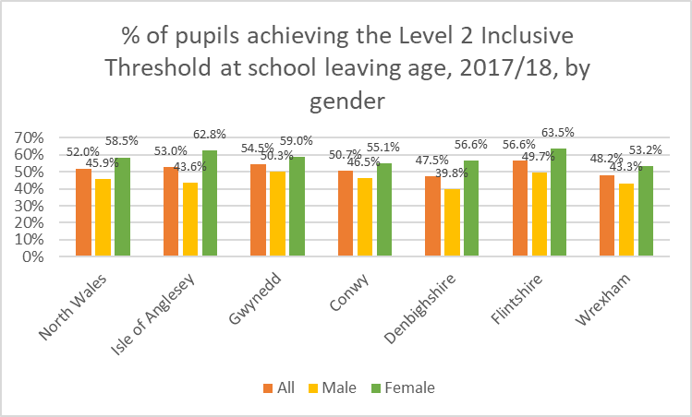

Analysing the results **by socio-economic group**, 57.9% of pupils in North Wales who were not free school meals (FSM) claimants achieved the Threshold, compared to 27.8% of FSM claimants.

Analysis at local authority level (chart below) shows that a substantially higher percentage of non-FSM claimants achieved the Threshold in each local authority area, compared to FSM claimants. The size of the gap varied from 23.8% (Isle of Anglesey) to 34.3% (Gwynedd).

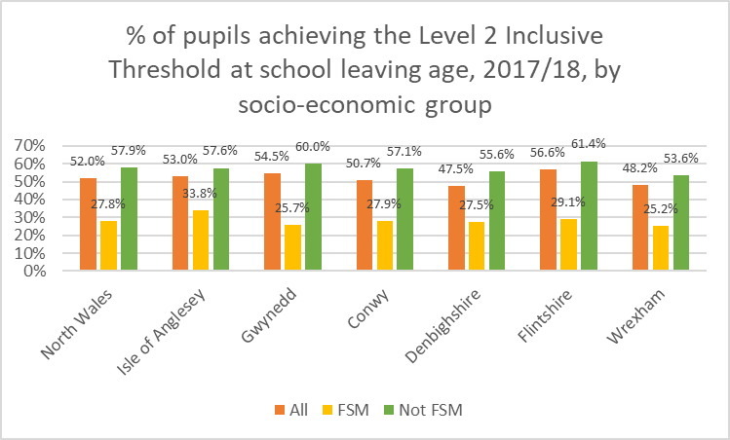

4.1.3 Impact of gender bias and stereotyping on educational outcomes

Unable to find relevant local data to supplement the discussion in “Is Wales Fairer?”.

4.1.4 Impact of poverty and social exclusion on educational attainment

Unable to find relevant local data to supplement the discussion in “Is Wales Fairer?”, other than already covered in 4.1.2 above.

4.1.5 Data gaps

We were unable to provide further analysis of the Foundation Phase attainment data (by FSM / non-FSM; by SEN provision and category; by ethnicity) because this data is only available at an all-Wales level. This data would need to be sourced from the Welsh Government, but since the data release (even at all-Wales level) has now been discontinued[4] it is doubtful whether they would now be willing to release any further data on this.

Similarly, further analysis of the Year 11 Level 2 Inclusive Threshold data (by SEN provision and category; by ethnicity) was not possible because the data is only available at all-Wales level. This would need to be sourced from the Welsh Government although it is uncertain whether it could all be released due to risk of individual disclosure (even in the data published at all-Wales level, the ethnicity data is pooled over three years to overcome the problem of small sample sizes).

In addition, none of the data is available at lower than local authority level (e.g. for LSOAs). This again could be requested from the Welsh Government although individual disclosure issues would probably arise as well as definitional issues (we would presumably need the home LSOAs of pupils rather than the area where the school is located?).

The Public Health Outcomes Framework for Wales reporting tool contains data on ‘Average Capped 9 Score’ for Year 11 pupils and is analysable by gender or by area characteristic (deprivation / rurality) at all-Wales level, and also by area (local authority / USOA / MSOA), but not by both. Developing the tool so that the data could be analysed both ways (by pupil characteristic and by local area) would greatly enhance the evidence base.

On the potential impact of gender bias / stereotyping, data is available at all-Wales level on the numbers of male / female pupils entering A level examinations, and male / female pupil attainment, in each individual subject. If Welsh Government were to release the data at a more local level, this could be a valuable addition to the evidence base.

4.2 **School exclusions, bullying and NEET**

4.2.1 Exclusions from school

Exclusions is measured by the rate of exclusions from schools per 1,000 pupils. In 2015/16 (the data year for the “Is Wales Fairer?” comparisons) the rate of pupils excluded (permanent or fixed-term) in North Wales was **33.1** per 1,000 pupils, compared to **32.6** per 1,000 pupils throughout Wales.

Analysis at local authority level (chart below) shows that a higher rate of pupils in Denbighshire (70.2 per 1,000 pupils) were excluded with the lowest rate in Gwynedd (15.4 per 1,000 pupils).

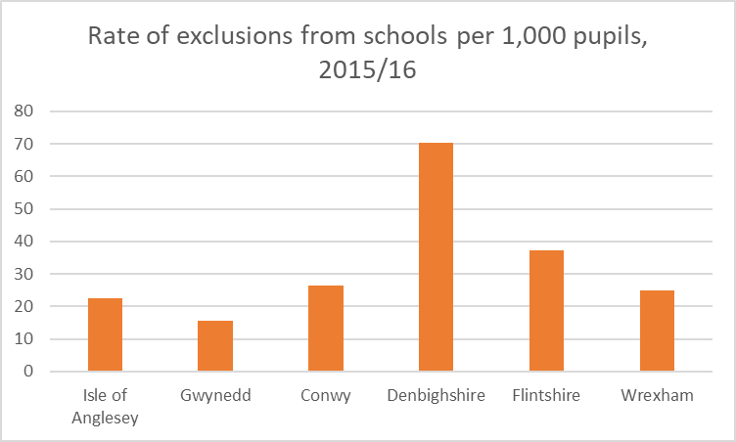

4.2.2 Bullying in schools

Survey-based data by the School Health Research Network for 2017/18 suggests that 17% of secondary school (year 7 to 11) pupils in North Wales had bullied another person at school in the past couple of months; the figure across Wales was also 17%.

Analysing this result by gender, 20% of male pupils in North Wales had bullied another person at school, compared to 14% of female pupils (the corresponding figures across Wales were 20% and 13% respectively).

The same research found that 37% of secondary school (year 7 to 11) pupils in North Wales reported some experience of being bullied at school in the past couple of months, compared to 36% across Wales as a whole.

Analysing this result by gender, 33% of male pupils in North Wales reported being bullied at school, compared to 40% of female pupils (the corresponding figures across Wales were 33% and 39% respectively).

At the NWPSEN Stakeholder Engagement Event (24 May 2018) a commonly-raised concern was that schools may not be aware of recent trends in the prevalence of identity-based bullying and may not have the tools to identify and address it properly.

4.2.3 NEET (not in education, employment or training)

The NEET figures quoted in “Is Wales Fairer?” (for 16-18 year-olds) are based on analysis specifically conducted for that report using privileged access to data from the Office for National Statistics (ONS) Annual Population Survey. We have been unable to replicate this analysis for this report, although some data is available on the prevalence of NEET generally in North Wales (not the analysis by protected characteristic).

**13.1%** of people aged 16-24 in North Wales were NEET, compared to **13.3%** across Wales as a whole (3 period average from ONS Annual Population Survey Quarter 4 2016 – Quarter 4 2018).

Analysis of NEET amongst Year 11 leavers at local authority level (chart below) suggests a much higher rate on the Isle of Anglesey compared to other areas; comparison with previous year data suggests that there may be an element of statistical anomaly in this, although the Anglesey figure has generally been higher than other authorities (2.3% in 2016).

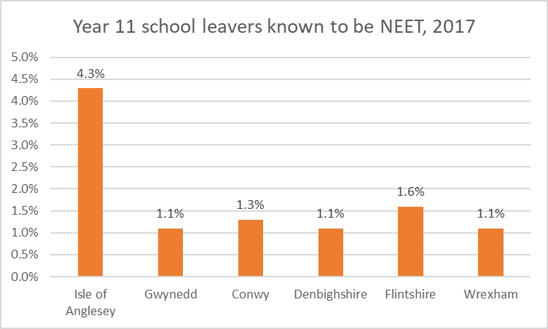

4.2.4 Data gaps

We carried out the local authority analysis for School Exclusions on the basis of supplementary data provided to us by Welsh Government (not publicly available). We were unable to provide further analysis of this (by FSM / non-FSM; by SEN / non-SEN; by ethnicity) since the data is only available at all-Wales level and would need to be further requested from the Welsh Government (if available).

Data on bullying is scarce in general at a local level, and there seems to be no data on how the likelihood of bullying / being bullied varies according to the other protected characteristics (ethnicity, disability etc).

NEET data by protected characteristic is also unavailable at local level; it appears that a substantial piece of analysis work was required to produce statistics even at all-Wales level for the “Is Wales Fairer?” report. The Public Health Outcomes Framework contains analysis of NEET data by gender and by disabled / non-disabled but only at Wales level.

4.3 **Higher education and lifelong learning**

4.3.1 Higher education, including subject choice, attainment and degree-level qualifications

“Is Wales Fairer?” contains data on the percentage of people aged 25-64 in Wales with degree-level qualifications in 2016/17, analysed by age, disability, ethnicity and gender. This analysis was specifically conducted for that report using privileged access to data from the ONS Annual Population Survey. We were unable to replicate this analysis for this report, but we have used 2011 Census data to undertake similar analysis (although obviously not as up-to-date) for North Wales.

In 2011 **29.3%** of people aged 25-64 in North Wales had degree-level qualifications (or above), compared to **30.0%** across Wales as a whole.

Analysing this data by **gender**, **27.6% of males** aged 25-64 across North Wales had degree-level qualifications compared to **31.0% of females**. Analysis at local authority level (chart below) shows that a higher percentage of females had degree-level qualifications in each local authority area, with the size of the gap varying between 1.7% (Flintshire) and 4.7% (Gwynedd, and Denbighshire).

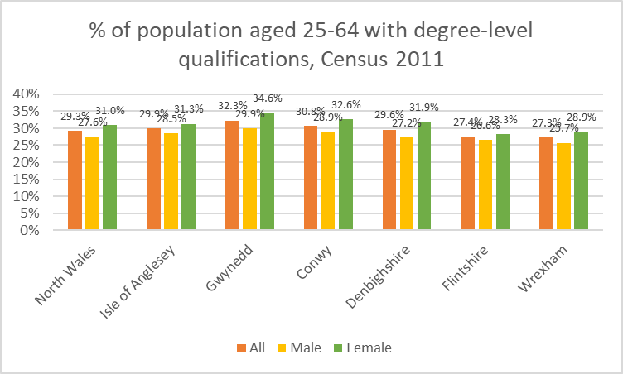

The data can be further analysed into 94 smaller areas (Middle Layer Super Output Areas or MSOAs). The detailed data is shown in **Appendix 2(a)** – the MSOAs with the **largest gap** (% females with degree-level qualifications higher than % males) are as follows:

|  |  |  |  |  |  |
| --- | --- | --- | --- | --- | --- |
| **MSOA Code** | **MSOA Name** | **Areas in MSOA (unofficial description)** | **Male %** | **Female %** | **Gap (Female – Male)** |
| W02000040 | Conwy 014 | Betws-yn-Rhos, Cerrigydrudion | 27.4% | 40.0% | 12.6% |
| W02000057 | Denbighshire 016 | Llangollen, Llandrillo | 28.2% | 38.2% | 10.0% |
| W02000012 | Gwynedd 003 | Bethesda, Llandygai | 35.6% | 44.9% | 9.3% |

There are a few MSOAs where the % of males with degree-level qualifications is higher than females, mainly:

|  |  |  |  |  |  |
| --- | --- | --- | --- | --- | --- |
| **MSOA Code** | **MSOA Name** | **Description (unofficial)** | **Male %** | **Female %** | **Gap (Female – Male)** |
| W02000070 | Flintshire 013 | Hawarden, Ewloe, Buckley (pt) | 40.0% | 36.1% | -3.9% |
| W02000010 | Gwynedd 001 | Most of Bangor, including University | 40.5% | 38.5% | -2.1% |
| W02000047 | Denbighshire 006 | Rhyl (SW part) | 15.6% | 13.6% | -2.0% |

Analysing by **ethnicity**, **29.0% of White Welsh / White British[5]** people aged 25-64 across North Wales had degree-level qualifications compared to **46.0% of Asian[6]** people**, 43.5% of Black[7]** people, **32.5%** of **mixed / multiple ethnic group**, and **30.5% of ‘Other White’[8]** people.

Analysis at local authority level (table below) shows considerable variation locally, in particular:

* a lower proportion of Asian people in Flintshire;
* a higher proportion of Black people in Gwynedd;
* a higher proportion of ‘Other White’ people in Anglesey and Gwynedd, and a lower proportion in Wrexham;

with degree-level qualifications.

% population aged 25-64 with degree-level qualifications, Census 2011

|  |  |  |  |  |  |  |  |
| --- | --- | --- | --- | --- | --- | --- | --- |
|  | **All** | **White Welsh / British** | **Asian** | **Black** | **Mixed / Multiple ethnic** | **Other White** | **All except White Welsh / British** |
| North Wales | 29.3% | 28.9% | 46.0% | 43.5% | 32.5% | 30.5% | 37.3% |
| Isle of Anglesey | 29.9% | 29.3% | 40.5% | 41.1% | 35.9% | 48.3% | 43.4% |
| Gwynedd | 32.3% | 31.2% | 51.7% | 60.2% | 33.3% | 47.6% | 49.5% |
| Conwy | 30.8% | 30.3% | 43.4% | 37.3% | 36.3% | 39.8% | 40.8% |
| Denbighshire | 29.6% | 29.2% | 44.1% | 37.8% | 31.4% | 38.2% | 38.3% |
| Flintshire | 27.4% | 27.4% | 34.5% | 41.8% | 29.8% | 25.0% | 29.2% |
| Wrexham | 27.3% | 27.0% | 52.5% | 40.9% | 29.2% | 19.5% | 31.4% |

|  |  |  |  |  |  |  |
| --- | --- | --- | --- | --- | --- | --- |
|  | All | White Welsh / British | Asian | Black | Mixed / Multiple ethnic | Other White |
| North Wales | 29.3% | 28.9% | 46.0% | 43.5% | 32.5% | 30.5% |
| Isle of Anglesey | 29.9% | 29.3% | 40.5% | 41.1% | 35.9% | 48.3% |
| Gwynedd | 32.3% | 31.2% | 51.7% | 60.2% | 33.3% | 47.6% |
| Conwy | 30.8% | 30.3% | 43.4% | 37.3% | 36.3% | 39.8% |
| Denbighshire | 29.6% | 29.2% | 44.1% | 37.8% | 31.4% | 38.2% |
| Flintshire | 27.4% | 27.4% | 34.5% | 41.8% | 29.8% | 25.0% |
| Wrexham | 27.3% | 27.0% | 52.5% | 40.9% | 29.2% | 19.5% |

The data can be further analysed into MSOAs as shown in **Appendix 2(b);** it is difficult to draw general conclusions from this large volume of data (based on low numbers of some ethnic groups in some areas), but it is notable that in 88 of the 94 MSOAs in north Wales, the percentage of white Welsh / British people with degree-level qualifications is lower than the total percentage for all other ethnic groups. The main exceptions are:-

|  |  |  |  |  |  |
| --- | --- | --- | --- | --- | --- |
| **MSOA Code** | **MSOA Name** | **Areas in MSOA (unofficial description)** | **White Welsh / British %** | **All other groups %** | **Gap (Other - White W/B)** |
| W02000055 | Denbighshire 014 | Ruthin | 36.8% | 29.9% | -6.9% |
| W02000021 | Gwynedd 012 | Pwllheli, Nefyn | 26.0% | 21.2% | -4.9% |
| W02000059 | Flintshire 002 | Holywell (pt), Mostyn | 28.8% | 25.5% | -3.3% |

The areas with the highest gap are:-

|  |  |  |  |  |  |
| --- | --- | --- | --- | --- | --- |
| **MSOA Code** | **MSOA Name** | **Description (unofficial)** | **White Welsh / British %** | **All other groups %** | **Gap (Other - White W/B)** |
| W02000050 | Denbighshire 009 | Rhuddlan, Bodelwyddan | 29.0% | 60.6% | 31.6% |
| W02000010 | Gwynedd 001 | Most of Bangor, including University | 32.3% | 60.0% | 27.7% |
| W02000011 | Gwynedd 002 | Bangor (pt) | 29.9% | 56.8% | 26.9% |

Analysing by **religion**, the percentages across North Wales were as follows:

|  |  |
| --- | --- |
| **Religion** | **% people aged 25-64 with degree-level qualifications** |
| Christian | 29.4% |
| Buddhist | 41.8% |
| Hindu | 72.2% |
| Jewish | 41.3% |
| Muslim | 42.8% |
| Sikh | 42.9% |
| Other religion | 44.9% |
| No religion | 28.8% |
| Religion not stated | 26.2% |

Analysis at local authority level (table below) suggests some variation in the proportions by area, in particular for the Jewish and Muslim populations (also the Sikh population in Anglesey, although this is based on only 24 people of that religion).

% population aged 25-64 with degree-level qualifications, Census 2011

|  |  |  |  |  |  |  |  |  |
| --- | --- | --- | --- | --- | --- | --- | --- | --- |
|  | **All** | **Christian** | **Buddhist** | **Hindu** | **Jewish** | **Muslim** | **Sikh** | **No religion** |
| North Wales | 29.3% | 29.4% | 41.8% | 72.2% | 41.3% | 42.8% | 42.9% | 28.8% |
| Isle of Anglesey | 29.9% | 30.2% | 36.2% | 78.1% | 52.2% | 44.1% | 8.3% | 29.4% |
| Gwynedd | 32.3% | 31.6% | 50.2% | 74.4% | 51.7% | 56.6% | 38.1% | 32.2% |
| Conwy | 30.8% | 31.1% | 39.5% | 66.2% | 29.6% | 37.6% | 46.2% | 30.5% |
| Denbighshire | 29.6% | 29.9% | 44.4% | 66.1% | 52.9% | 34.3% | 33.3% | 29.1% |
| Flintshire | 27.4% | 27.7% | 35.2% | 69.0% | 40.0% | 25.9% | 43.8% | 26.9% |
| Wrexham | 27.3% | 27.7% | 40.9% | 77.0% | 30.3% | 40.9% | 58.3% | 25.9% |

|  |  |  |  |  |  |  |
| --- | --- | --- | --- | --- | --- | --- |
|  | All | White Welsh / British | Asian | Black | Mixed / Multiple ethnic | Other White |
| North Wales | 29.3% | 28.9% | 46.0% | 43.5% | 32.5% | 30.5% |
| Isle of Anglesey | 29.9% | 29.3% | 40.5% | 41.1% | 35.9% | 48.3% |
| Gwynedd | 32.3% | 31.2% | 51.7% | 60.2% | 33.3% | 47.6% |
| Conwy | 30.8% | 30.3% | 43.4% | 37.3% | 36.3% | 39.8% |
| Denbighshire | 29.6% | 29.2% | 44.1% | 37.8% | 31.4% | 38.2% |
| Flintshire | 27.4% | 27.4% | 34.5% | 41.8% | 29.8% | 25.0% |
| Wrexham | 27.3% | 27.0% | 52.5% | 40.9% | 29.2% | 19.5% |

We have not included a further analysis to MSOA level in this report since it would not generally be very meaningful due to very small numbers for some religions at this level, but further analysis for some areas / religions could be carried out as required.

4.3.2 Lifelong learning

“Is Wales Fairer?” contains analysis of the percentage of adults participating in learning activities in last three months (either having attended an education course, or job-related training).

This analysis was specifically conducted for that report using privileged access to data from the ONS Annual Population Survey. We were unable to replicate this analysis for this report, but we have been able to access data on the percentage participating in job-related training (only), by gender.

The results (below) show that a higher proportion of females than males participated in job-related training in each local authority area, with the size of the gap ranging from 0.5% (Conwy) to 7.6% (Gwynedd).

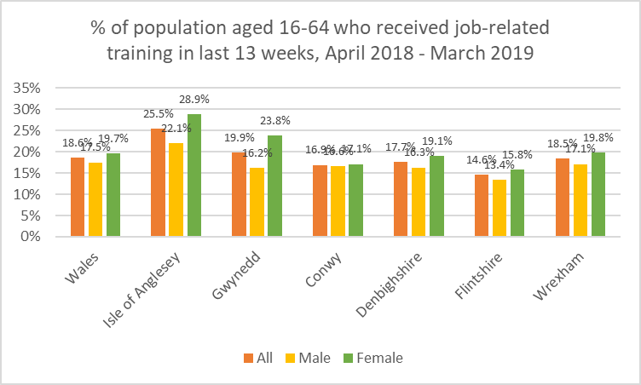

4.3.3 Data gaps

As noted above we were unable to obtain updated data (more recent than 2011 Census) on people with degree-level qualifications; this would require privileged access to ONS Annual Population Survey data and would be likely to be a substantial piece of analysis work.

Similarly, more updated / detailed data on adult participation in learning activities would have to be sourced from privileged access to Annual Population Survey data.

1. **Work**

**5.1 Employment**

5.1.1 Employment

We have replicated the analysis in “Is Wales Fairer?” on the percentage of adults in employment, using publicly-available data to allow us to analyse by gender, age, disability and ethnicity (although for some of the analysis, we have had to use data for the 16-64 age group rather than 16+ as used in “Is Wales Fairer?”). Data by other characteristics (marital status, religion) is not publicly available and would have to use privileged access to data from the ONS Annual Population Survey.

The total employment rate (all adults aged 16+) varies between 52.9% (Conwy) and 61.6% (Wrexham). Analysing this by gender (chart below), a higher proportion of males than females are in employment in each local authority area, which mirrors the pattern across Wales as a whole. The size of the gap ranges from 3.2% (Isle of Anglesey) to 10.7% (Conwy).

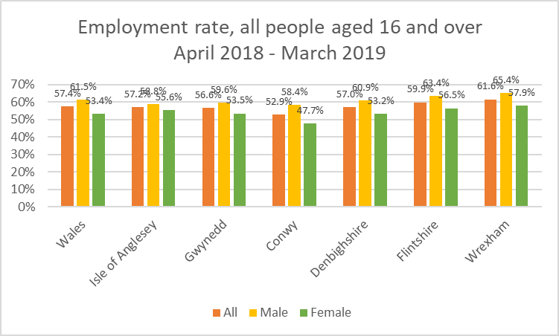

Analysing by age group (chart below) shows some variation between local authorities in the 16-24, and the over 65, age groups. In particular the percentage of over-65s in employment in Denbighshire (13.3%), and Isle of Anglesey and Gwynedd (both 13.2%) is significantly higher than in Conwy (7.9%).

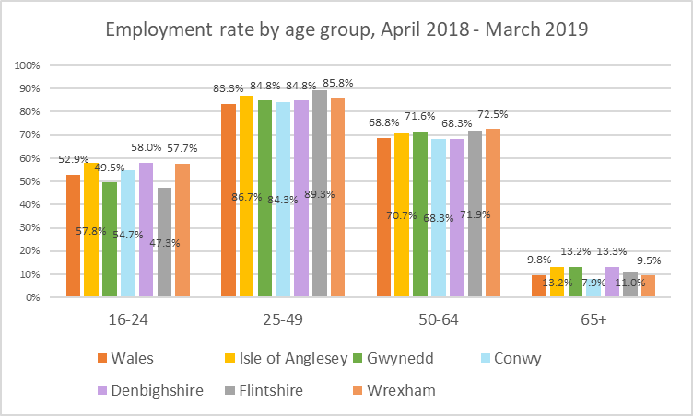

Analysis by ethnicity (white vs ethnic minority groups) shows a marked difference between local areas (chart below; this analysis can be conducted on the 16-64 age group only). Three north Wales authorities mirror the pattern across Wales, in that the employment rate among the white population is higher than in the ethnic minority population, but the three other authorities show the opposite. In particular, the employment rate for minority ethnic groups is particularly high in the Isle of Anglesey whilst the opposite is true in Gwynedd.

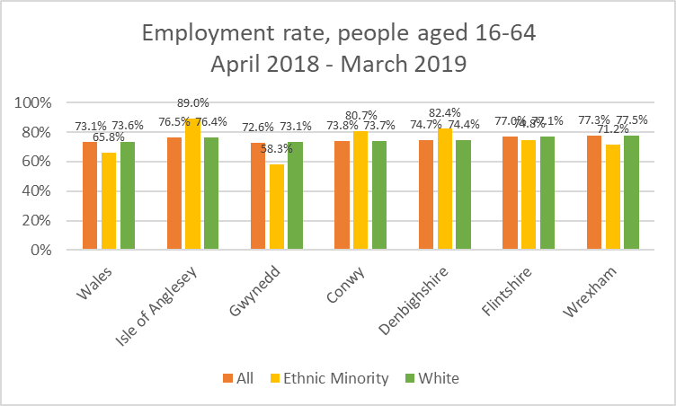

Further analysis by ethnic group (within the minority ethnic population) is not possible due to small sample sizes.

The employment rate for non-disabled people is about 25 to 35 percentage points higher than disabled people, across Wales and in each north Wales local authority (chart below). (It is unclear whether the “Is Wales Fairer?” analysis uses the same disability definition as used here; also that analysis uses total population aged 16+ rather than the 16-64 age group).

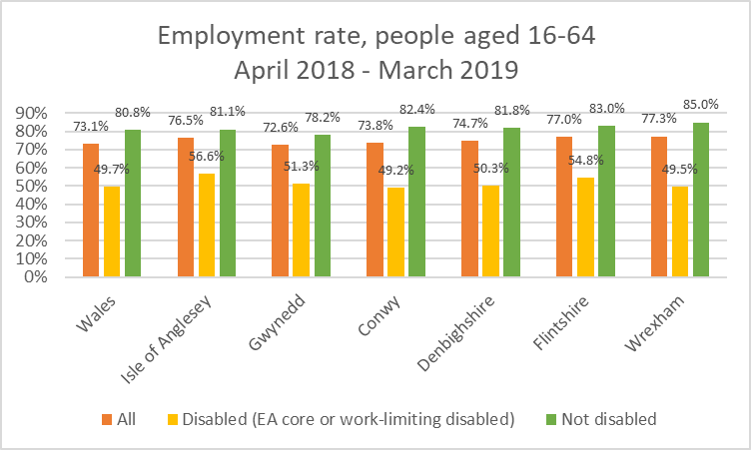

5.1.2 Unemployment

Similarly to 5.1.1 above, we have replicated the “Is Wales Fairer?” analysis on unemployment rates as far as possible using publicly-available data to analyse by gender, age, disability and ethnicity (although we have again had to use data for the 16-64 age group rather than 16+ for some of the analysis). Data by religion is not publicly available and would have to use privileged access to data from the ONS Annual Population Survey.

The total unemployment rate (as a percentage of all economically-active people aged 16 and over) varies between 2.2% (Denbighshire) and 5.5% (Gwynedd). Analysing this by gender (chart below), in general unemployment is higher amongst males than females in north Wales, which mirrors the position in Wales generally. The gap is particularly significant on the Isle of Anglesey (4.2%; mainly due to high male unemployment) and Flintshire (3.2%, the lowest rate of female unemployment amongst the 6 authorities).

The exception to this pattern is Gwynedd, where the female unemployment rate is the highest amongst the 6 authorities and significantly above the male unemployment rate.

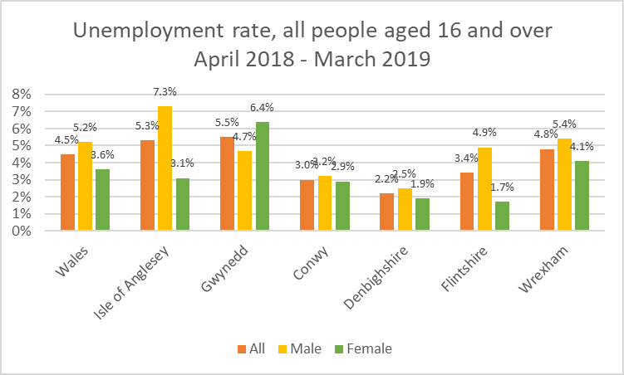

Analysis by age group (chart below) shows significant variation in the unemployment rate by local authority area, in particular a high rate of unemployment in the 16-24 age group in Flintshire (18.8%) and Isle of Anglesey (17.2%).

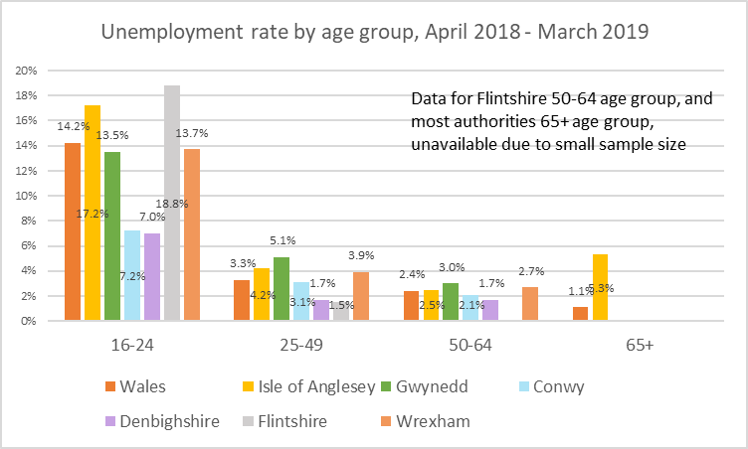

Analysis by ethnicity (white vs ethnic minority groups) is not really possible at local authority level due to small sample sizes (chart below). It can be seen however that the unemployment rate for the white population is similar to the total unemployment rate in each local authority area, as is the case at all-Wales level.

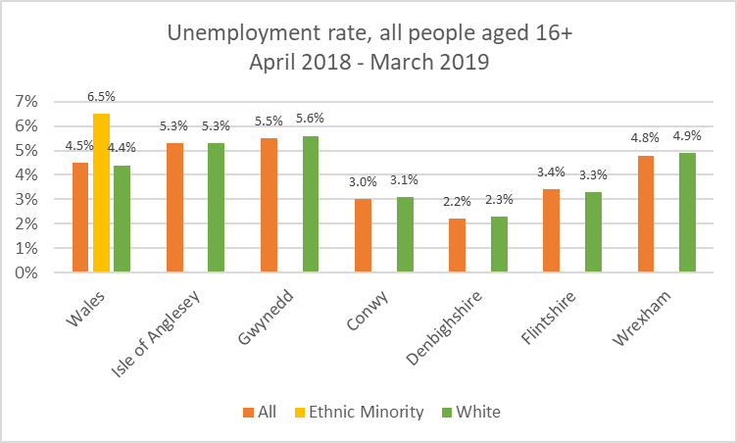

Across Wales, the unemployment rate for disabled people (8.8%) is over twice the rate for non-disabled people (3.7%). The unemployment rate for disabled people is also higher in each north Wales local authority area (chart below) but the size of the gap varies between 0.6% (Isle of Anglesey) and 8.1% (Wrexham). (It is unclear whether the “Is Wales Fairer?” analysis uses the same disability definition as used here; also that analysis uses total population aged 16+ rather than the 16-64 age group).

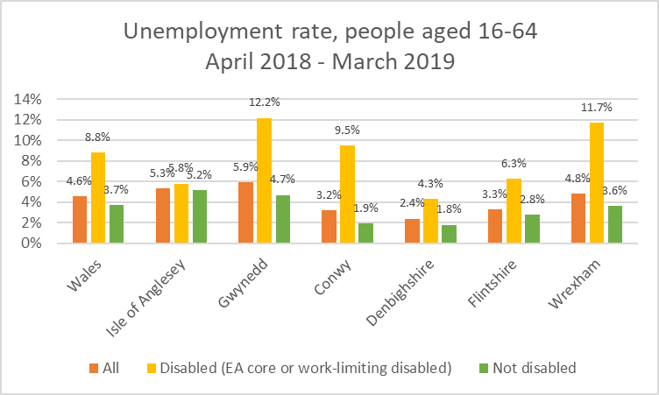

5.1.3 Insecure employment

Unable to obtain relevant local data to supplement the discussion in “Is Wales Fairer?”

5.1.4 Unfair treatment, bullying and harassment in the workplace

Unable to obtain relevant local data to supplement the discussion in “Is Wales Fairer?”

5.1.5 Data gaps

As seen above there is a reasonable amount of data available on employment / unemployment rates by local authority area (but not at lower geographical levels). The analysis is based on survey data and for many characteristics (ethnicity in particular) the data is unavailable due to small sample sizes at local level. Data analysing by marital status / religion is not publicly available and would have to be carried out through privileged access to ONS Annual Population Survey data (and may not be available in any case due to small sample sizes).

The “Is Wales Fairer?” analysis of people “in insecure employment” is based on a bespoke analysis of individual records in the Annual Population Survey through privileged access. Data on unfair treatment, bullying etc in the workplace does not seem to be available.

**5.2 Earnings**

5.2.1 Pay gaps in median hourly earnings

Since the main analysis in “Is Wales Fairer?” can’t be replicated for North Wales due to data confidentiality and sample size issues, we have used the “alternative source“ of data quoted in that report – the ONS Annual Survey of Hours and Earnings – to compute estimates of gender pay gaps by local authority area.

Across Wales, median hourly earnings excluding overtime for all employees (i.e. both full-time and part-time) in 2018 were £12.61 for men and £10.70 for women; the gender pay gap is therefore 15.1%.

The equivalent data for the six north Wales authority areas are shown in the chart below. The resultant gender pay gaps are as follows (note that in Conwy, the figures show a negative pay gap i.e. women earning more than men):

|  |  |
| --- | --- |
| **Authority area** | **Gender pay gap (% female lower than male)** – based on median hourly earnings excluding overtime |
| Isle of Anglesey | 17.3% |
| Gwynedd | 10.7% |
| Conwy | (4.0%) |
| Denbighshire | 16.7% |
| Flintshire | 5.2% |
| Wrexham | 16.4% |

It is important to note that:-

* this analysis is based on employee residence rather than workplace
* the data refers to the working population of the area in general, rather than the workforce of the relevant local authorities

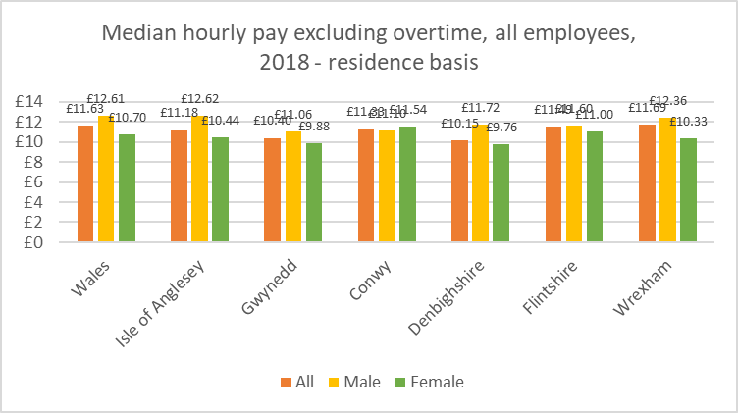

It was noted by participants in the NWPSEN Stakeholder Engagement Event (24/5/18) that there is a lack of information and data on pay gaps by other protected characteristics, such as disabilities.

5.2.2 Low pay

No specific local data / information to supplement the discussion in “Is Wales Fairer?”

5.2.3 Gender differences in earnings by occupation, sector and industry

The analysis in 5.2.1 can also be carried out on full-time jobs and part-time jobs separately, as shown in the tables below.

For full-time workers, the pattern is quite varied with the pay of women higher than men in 3 authorities, but male hourly pay over 12% higher than female pay in Isle of Anglesey and Denbighshire. For part-time workers, female pay is generally higher than male pay, except in Wrexham.

**Full-time workers:** Median hourly earnings excluding overtime

|  |  |  |  |
| --- | --- | --- | --- |
| **Authority area** | **Female**  **£** | **Male**  **£** | **Gender pay gap (% female lower than male)** |
| Isle of Anglesey | £11.27 | £12.88 | 12.5% |
| Gwynedd | £12.23 | £12.06 | (1.4%) |
| Conwy | £12.49 | £12.17 | (2.6%) |
| Denbighshire | £11.60 | £13.24 | 12.4% |
| Flintshire | £13.11 | £12.52 | (4.7%) |
| Wrexham | £12.52 | £13.21 | 5.2% |
| *Wales* | *£12.32* | *£13.42* | *8.2%* |

**Part-time workers:** Median hourly earnings excluding overtime

|  |  |  |  |
| --- | --- | --- | --- |
| **Authority area** | **Female**  **£** | **Male**  **£** | **Gender pay gap (% female lower than male)** |
| Isle of Anglesey | not available | £8.60 | female component not available |
| Gwynedd | £8.77 | £8.51 | (3.1%) |
| Conwy | £9.42 | £7.84 | (20.2%) |
| Denbighshire | £8.69 | £8.18 | (6.2%) |
| Flintshire | £8.90 | £8.41 | (5.8%) |
| Wrexham | £8.78 | £9.53 | 7.9% |
| *Wales* | *£9.10* | *£8.71* | *(4.5%)* |

5.2.4 Data gaps

Since we had to rely on data from the Annual Survey of Hours and Earnings, rather than the Annual Population Survey, for this analysis we were unable to analyse pay gaps by marital status, age, disability, ethnicity and socio-economic category. This would have to be sourced by privileged access to the data (if available at all because of small sample sizes).

**5.3 Occupational segregation**

5.3.1 Vertical and horizontal segregation

*By gender*

Analysing the proportion of employees who are in jobs likely to be high-paid (managerial and professional posts) and low-paid (caring, leisure and other service occupations; sales and customer service occupations; elementary occupations) we can see (charts below) that the proportion of women in the **higher-paid occupations** is somewhat higher than the proportion of men in 5 of the 6 local authority areas (the exception is Flintshire). This is different to the situation across Wales where the proportions are more or less equal.

In contrast, the proportion of women in the lowest-paid occupations is about double the proportion of men in 4 of the 6 local areas, which mirrors the all-Wales pattern. The exceptions are Wrexham where the gap is slightly lower, and Flintshire where the proportion of women in low-paid posts is over three times higher than men.

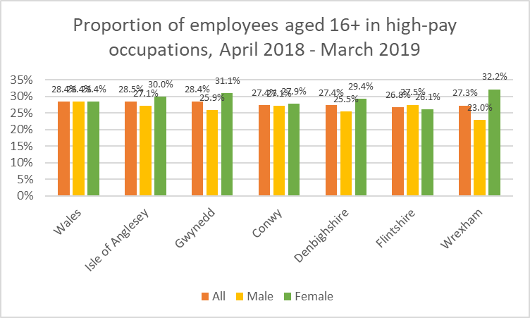

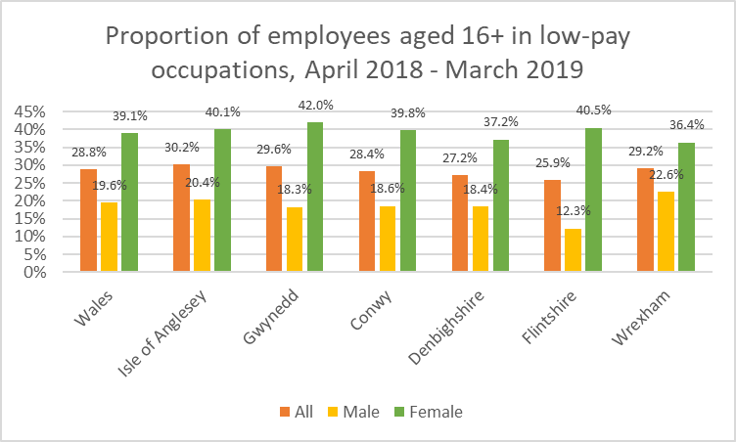

*By ethnic group*

Analysis by ethnic group is not really possible due to small sample sizes in the survey; however it is possible to say (charts below) that the proportion of white employees in high-pay / low-pay occupations is similar to the proportion of employees in general.

The other piece of information available is the proportion of ethnic minority employees in high-pay occupations in Denbighshire (36.3%) is significantly higher than the corresponding percentage of white employees (27.2%).

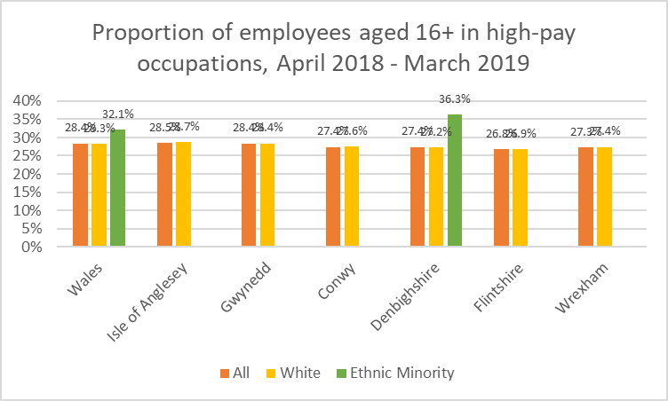

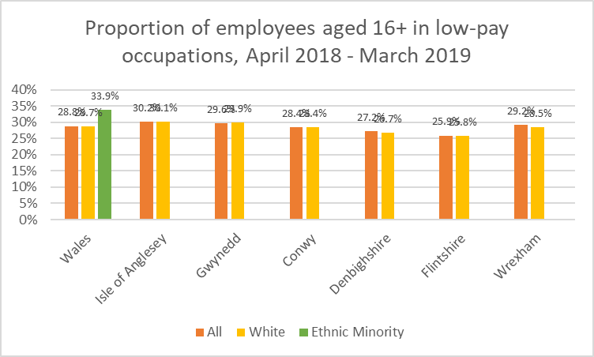

5.3.2 Segregation within apprenticeships

*By gender*

Data on apprenticeships (chart below) shows that over 60% of people on apprenticeship programmes across north Wales are female; there are more female than male apprenticeships in each local authority area with the gap at its smallest in Flintshire and at its largest in Conwy.

Further analysis by sector (table below) shows a considerable degree of gender-segregation with apprenticeships in the Construction and Engineering sectors, in particular, being male-dominated whilst in sectors such as Hair and Beauty, and Healthcare and Public Services, the overwhelming majority of apprentices are female.

**Number of apprenticeships by sector, North Wales totals, 2017/18**

*(numbers rounded to nearest 5)*

|  |  |  |  |
| --- | --- | --- | --- |
| **Sector** | **Male apprentices** | **Female apprentices** | **% Male** |
| Agriculture | 40 | 65 | 36% |
| Construction | 1,035 | 20 | 98% |
| Engineering | 910 | 55 | 94% |
| Manufacturing | 270 | 125 | 68% |
| Transportation | 15 | n/a | 75% |
| Management & Professional | 380 | 665 | 36% |
| Business Administration | 455 | 1,210 | 27% |
| Retailing & Customer Service | 305 | 460 | 40% |
| Leisure, Sport and Travel | 105 | 345 | 23% |
| Hospitality | 340 | 390 | 47% |
| Hair and Beauty | 45 | 355 | 11% |
| Healthcare & Public Services | 710 | 3,680 | 16% |
| Media and Design | 15 | 15 | 50% |

*By ethnicity*

The great majority (98.3%) of people on apprenticeship programmes across north Wales in 2017/18 self-identified as White. 0.3% self-identified as Black, 0.5% as Asian, 0.3% as Mixed and 0.2% as Other. The proportions in each local authority area are shown in the table below.

**Percentage of apprenticeships by ethnicity, 2017/18**

|  |  |  |  |  |  |
| --- | --- | --- | --- | --- | --- |
| **Local authority area** | **White** | **Black** | **Asian** | **Mixed** | **Other** |
| *North Wales* | *98.3%* | *0.3%* | *0.5%* | *0.3%* | *0.2%* |
| Isle of Anglesey | 98.9% | n/a | n/a | n/a | n/a |
| Gwynedd | 98.7% | 0.3% | 0.3% | 0.5% | n/a |
| Conwy | 98.1% | 0.5% | 0.5% | 0.5% | 0.5% |
| Denbighshire | 97.6% | 0.3% | 1.2% | 0.3% | 0.3% |
| Flintshire | 98.8% | 0.5% | 0.2% | 0.2% | n/a |
| Wrexham | 98.2% | 0.4% | 0.7% | 0.4% | 0.2% |

*n/a: data item not disclosed due to very small numbers*

*By disability*

2.1% of people on apprenticeship programmes across north Wales stated that they had a disability that affected their ability to learn and / or use facilities. The proportion varied a little by local authority area (chart below), the highest proportion being in Wrexham (2.5%).

5.3.3 Data gaps

The above analysis of people in low-paid vs. high-paid occupations includes employees only (i.e. excludes self-employed). In addition the data available does not enable us to replicate the “Is Wales Fairer” analysis of occupations by age, disability, marital status, and religion.

1. **Living standards**

**6.1 Housing**

6.1.1 Overcrowding and suitable accommodation

Unable to find relevant local data to supplement the discussion in “Is Wales Fairer?”.

6.1.2 Homelessness

Of households threatened with homelessness across north Wales in 2018/19, 63% of applicants were women; this is analysed by local authority area in the chart below.

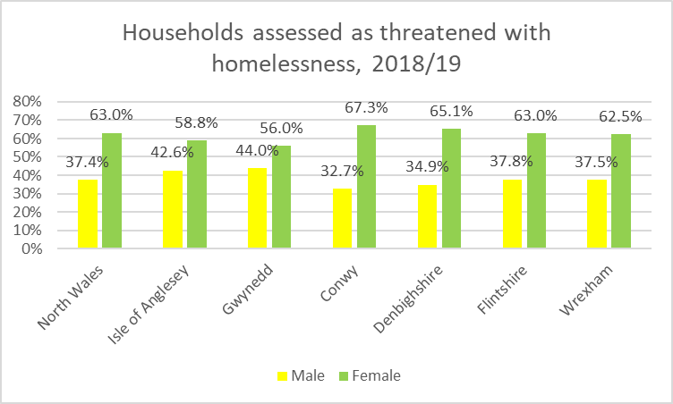

On the other hand, of the households who were homeless and given assistance to find accommodation, the majority of applicants were men, as shown below.

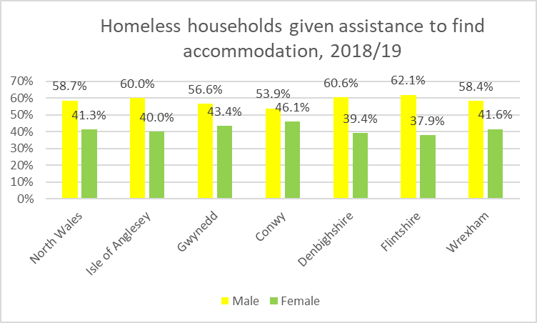

6.1.3 Housing benefits

Unable to find relevant local data to supplement the discussion in “Is Wales Fairer?”.

6.1.4 Housing tenure

Across north Wales around 69% of households own their own homes, with the remaining proportion split fairly equally between social-rented and private-rented housing.

Analysing the pattern by ethnic group of the ‘household reference person’ of each household, we see (chart below) a lower proportion owning their own homes in all non-white ethnic groups. In particular a high proportion of Asian and ‘other’ ethnic group households live in private-rented / rent-free housing.

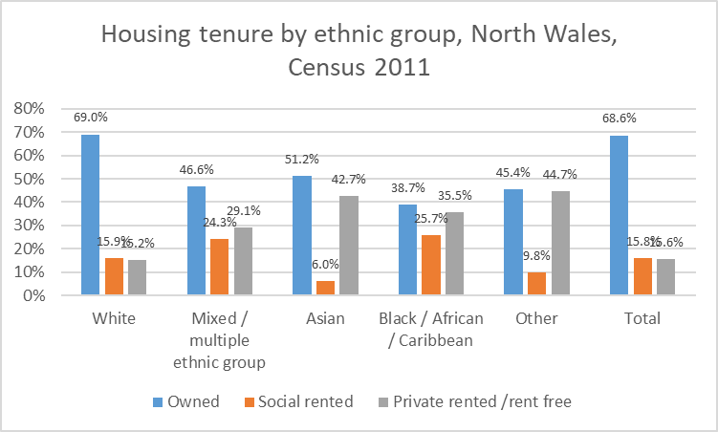

Analysing by age group, we see (chart below) that the proportion of households owning their own homes is fairly constant at age 35 and above but considerably lower for younger age groups. In particular, the distribution of private-rented households is skewed towards younger age groups whilst the proportion of households living in social-rented households is below 15% for most age groups above 35, but starts to increase again in the older age groups rising to around 20% for the 85+ age group.

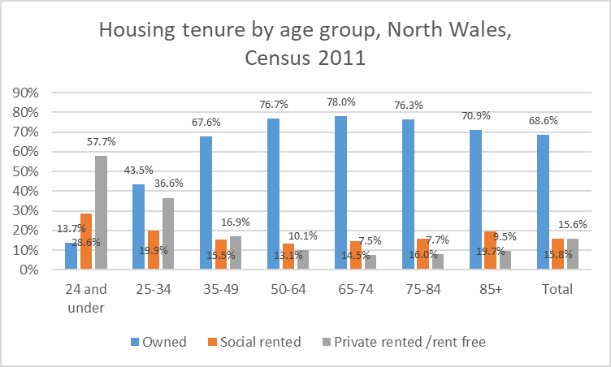

6.1.5 Housing for Gypsies and Travellers

According to the latest data there are 212 gypsy / traveller caravans across north Wales, as follows:

**Number of gypsy and traveller caravans, 19 January 2019**

|  |  |  |  |  |
| --- | --- | --- | --- | --- |
|  | **At authorised sites – Local authority** | **At authorised sites - Private** | **At unauthorised sites** | **Total** |
| Isle of Anglesey | 0 | 0 | 1 | 1 |
| Gwynedd | 13 | 3 | 6 | 22 |
| Conwy | 4 | 0 | 0 | 4 |
| Denbighshire | 0 | 0 | 0 | 0 |
| Flintshire | 33 | 77 | 29 | 139 |
| Wrexham | 30 | 16 | 0 | 46 |
|  | **80** | **96** | **36** | **212** |

6.1.6 Accessible housing for disabled people

In 2017/18, a total of 716 Disabled Facilities Grants were completed across north Wales, the majority in owner-occupied properties, as follows:

**Number of Disabled Facilities Grants completed, 2017/18**

|  |  |  |  |  |
| --- | --- | --- | --- | --- |
|  | **Owner occupier** | **Private renting** | **Local authority / RSL tenant** | **Total** |
| Isle of Anglesey | 89 | 10 | 0 | 99 |
| Gwynedd | 43 | 11 | 0 | 54 |
| Conwy | 105 | 25 | 2 | 132 |
| Denbighshire | 78 | 23 | 0 | 101 |
| Flintshire | 56 | 2 | 0 | 58 |
| Wrexham | 91 | 11 | 170 | 272 |
|  | **462** | **82** | **172** | **716** |

6.1.7 Housing for refugees and asylum seekers

Unable to find relevant local data to supplement the discussion in “Is Wales Fairer?”.

6.1.8 Data gaps

The “Is Wales Fairer?” report uses data from the National Survey for Wales to analyse the percentage of people satisfied with their accommodation by age, disability, marital status and gender. Access to the corresponding data at a more local level would have been useful for the purpose of this report.

Analysis by gender of homeless people provided with accommodation, and analysis by ethnicity of all homelessness data, is not really meaningful below all-Wales level since the data is suppressed due to low numbers.

**6.2 Poverty**

6.2.1 Relative poverty and severe material deprivation

Data on the **percentage of people living in households in material deprivation** is available by local authority; unfortunately however low sample sizes mean that this information is not published by age group or by gender (except for a few authorities where a figure for females is available).

Material deprivation is measured here by the self-reported ability of households to afford particular goods and activities. It can be seen (table below) that the level is broadly similar across north Wales authorities, except that the proportion is somewhat higher in Denbighshire and lower in Flintshire. There is some suggestion that the proportion of females may be slightly higher than the overall proportion.

**Percentage of people living in households in material deprivation, 2018-19**

|  |  |  |
| --- | --- | --- |
|  | **Total**  **%** | **Females**  **%** |
| Isle of Anglesey | 14% | 14% |
| Gwynedd | 12% | n/a |
| Conwy | 13% | n/a |
| Denbighshire | 16% | 17% |
| Flintshire | 9% | 10% |
| Wrexham | 12% | 14% |

6.2.2 Social security and the benefit system

No specific local data to add to the discussion in “Is Wales Fairer?”.

6.2.3 Experiences of at-risk groups: child poverty and poverty of disabled people, refugees and asylum seekers

Unfortunately, data on child poverty is not available below Wales level therefore we are unable to add to the analysis on this in “All Wales Fairer?”.

6.2.4 Food and fuel poverty

Although comprehensive data on food and (especially) fuel poverty is now published by the Welsh Government, unfortunately this isn’t analysable below all-Wales level, therefore we are unable to add to the analysis in “Is Wales Fairer?”.

6.2.5 Wealth and income distribution

In 2017, gross disposable household income per head ranged from £15,071 in Gwynedd, to £16,486 in Conwy / Denbighshire, £16,600 in Isle of Anglesey and £16,968 in Flintshire / Wrexham.

These are (with the exception of Gwynedd) higher than the Wales figure (£15,754) but they are all considerably lower than the UK average (£19,514).

6.2.6 Data gaps

The data on relative poverty / material deprivation in “Is Wales Fairer?” are based on DWP sample data; the results are only publicly available at Wales level or (at UK level) by age, disability, ethnicity, sex, marital status, etc. Any lower-level data would need to be sourced from DWP although it is doubtful whether the data would be sufficiently representative or robust for smaller sample sizes.

Alternatively, the National Survey for Wales results for material deprivation could be further developed, with the sample size boosted so that analysis by some of the protected characteristics would become possible at local levels.

Similarly, data on child poverty is not published at all below all-Wales level and this is something which the Welsh Government could further develop via the National Survey for Wales.

No official statistics on food and fuel poverty exist below all-Wales level; this could be pursued further with the Welsh Government.

**6.3 Social Care**

6.3.1 Access to social care

Across north Wales, around 41 adults per 1,000 population receive support through social care services. However, the pattern varies considerably with age, from around 8 per 1000 population in the 18-24 age group, to around 412 per 1000 population for ages over 85.

As shown below this general pattern is fairly consistent across all six local authorities, although two authorities (Gwynedd and Wrexham) have a higher proportion of people receiving services at age groups 75 and above.

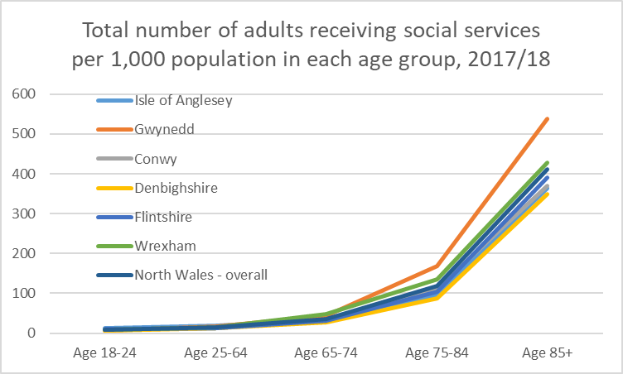

6.3.2 Impact of social care funding on the provision of services

No specific local data to add to the discussion in “Is Wales Fairer?”.

6.3.3 Quality of social care

The review of healthcare support for older people living in care homes in North Wales (referred to in “Is Wales Fairer?”, page 62) has now been completed.

The review found some common issues across services which need to be addressed, including being clear about roles and responsibilities between care homes and the health board; improved communication between care homes and the health board to enable ongoing feedback; and organisations working together in the best interests of the people they support.

Areas for improvement identified were:

* The health board should work with care homes to identify training to maintain care workers’ confidence and competence in managing residents’ routine health needs.
* An information pack should be developed setting out what is available to people living in care homes and how to access it, along with dedicated points of contact for information and feedback.
* The health board to work proactively with the care home sector to identify concerns and issues around continence support and how these will be addressed.
* Ensure that sufficient resources are available to meet the needs of people with dementia in care homes and that services are provided in a timely and consistent way across North Wales.

The National Survey for Wales asks respondents whether they “agree good social care services are available in the area”; unfortunately the results are not analysed by protected characteristic.

The results by area are as follows:

**Percentage of people who agree good social care services available in their area, 2018-19**

|  |  |
| --- | --- |
|  | **Agree**  **%** |
| Isle of Anglesey | 50% |
| Gwynedd | 58% |
| Conwy | 58% |
| Denbighshire | 57% |
| Flintshire | 48% |
| Wrexham | 50% |

6.3.4 Choice and control over support to enable independent living and independent advocacy

No specific local data to add to the discussion in “Is Wales Fairer?”.

6.3.5 Dignity and respect in social care

No specific local data to add to the discussion in “Is Wales Fairer?”.

6.3.6 Impact of caring on carers

Data from the 2011 Census shows (chart below) that 11.6% of people in north Wales provide unpaid care to family members, friends, neighbours or others because of long-term physical or mental ill health or disability, or problems related to old age. The proportion in each local authority area range from 10.5% (Gwynedd) to 12.6% (Denbighshire).

The proportion of people providing unpaid care is highest in the 50-64 age group (20.6% of this age group). 2.8% of people aged 0-24 across north Wales provide unpaid care.

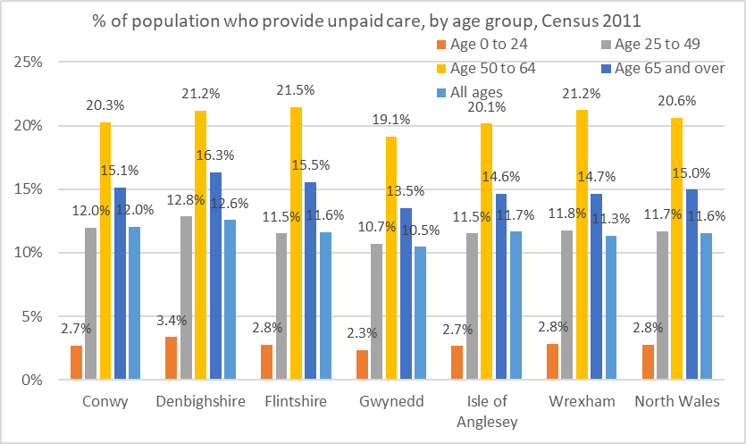

13.1% of the female population of north Wales provide unpaid care, compared to 10.0% of the male population. This pattern is relatively consistent across authority areas as shown below.

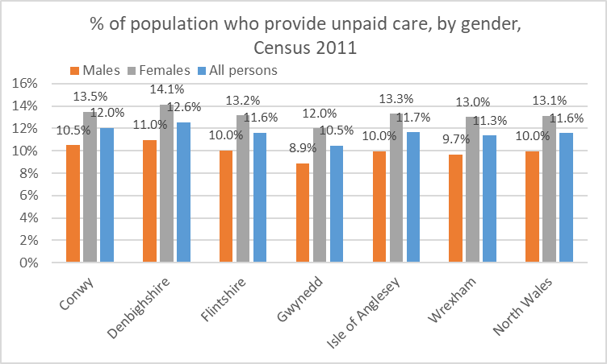

The data also shows that carers themselves are more likely to be in worse health; 7.4% of carers across north Wales reported that they were in “bad or very bad” health, compared to 5.9% of non-carers. 21.2% reported that they were in “fair” health, compared to 13.0% of non-carers. This pattern is true for each local authority area as shown below:

**General health of people who provide / do not provide unpaid care (self-reported), Census 2011**

|  |  |  |  |  |  |  |
| --- | --- | --- | --- | --- | --- | --- |
|  | **Very good or good health** | | **Fair health** | | **Bad or very bad health** | |
|  | **Carer** | **Non-carer** | **Carer** | **Non-carer** | **Carer** | **Non-carer** |
| Isle of Anglesey | 71.9% | 80.0% | 21.0% | 13.9% | 7.2% | 6.0% |
| Gwynedd | 73.1% | 82.1% | 20.7% | 12.7% | 6.2% | 5.2% |
| Conwy | 69.2% | 79.5% | 22.8% | 14.1% | 8.1% | 6.4% |
| Denbighshire | 68.6% | 79.8% | 22.3% | 13.4% | 9.1% | 6.8% |
| Flintshire | 73.0% | 82.5% | 19.9% | 12.1% | 7.2% | 5.3% |
| Wrexham | 72.1% | 81.3% | 21.0% | 12.8% | 6.9% | 5.9% |
| **North Wales** | **71.4%** | **81.1%** | **21.2%** | **13.0%** | **7.4%** | **5.9%** |

6.3.7 Abuse and neglect

In 2017/18 about 2,500 adults were suspected of being at risk of abuse or neglect in north Wales across all adult social services, as follows:

|  |  |
| --- | --- |
|  | **Number of adults suspected at risk of abuse / neglect** |
| Isle of Anglesey | 174 |
| Gwynedd | 326 |
| Conwy | 468 |
| Denbighshire | 422 |
| Flintshire | 403 |
| Wrexham | 793 |
|  | **2,586** |

6.3.8 Data gaps

The National Survey for Wales data for the questions “Do you agree that good social care services are available in your area?” and “Do you agree that care and support services have helped you to have a higher quality of life?” (for social care service users) would be useful to have available at local level and analysable by protected characteristic.

Similarly the National Survey also includes data on whether respondents are carers / time spent caring, which is analysable by gender and age at all-Wales level but not available more locally.

1. **Health**

**7.1 Access to health**

7.1.1 Waiting and referral times

In North Wales (Betsi Cadwaladr University Health Board area) **12.7%** of patients waited more than 26 weeks for treatment (referral to treatment waiting times) according to the latest data (July 2019). Over recent years this measure has generally increased (chart below).

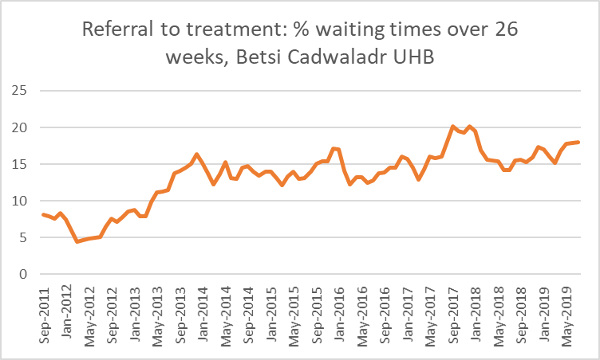

Data is also available for ambulance service emergency response times for red calls and amber calls. Red calls are immediately life-threatening (someone in imminent danger of death, such as a cardiac arrest). There is a target for 65.0% of these calls to be responded to within 8 minutes. The % for North Wales was **69.0%** in June 2019, compared to 72.5% in Wales.

Amber calls are serious but not immediately life-threatening (patients who will often need treatment to be delivered on the scene, and may then need to be taken to hospital). There is no time-based target for amber calls. However, **13.6%** of Amber calls were attended within 8 minutes in North Wales compared to 12.1% in Wales.

7.1.2 Access issues for at risk groups

No specific local data to add to the discussion in “Is Wales Fairer?”.

7.1.3 Data gaps

Data on treatment and ambulance waiting times is analysed by health board area but not further by protected characteristic or lower level geography.

As the “Is Wales Fairer?” report suggests there is a lack of published evidence about access to healthcare services for people with a disability in Wales. This is also true for evidence in terms of access for homeless people.

7.2 **Health outcomes**

7.2.1 People’s current health status

In 2015 **84.0%** of adults in North Wales (16 years old and above) reported that their general health was either excellent, very good or good.

Analysis at local authority level (chart below) shows that a higher percentage of adults in Gwynedd, Isle of Anglesey and Conwy report their general health as being excellent, very good or good.

*Source : Welsh Health Survey, 2015*

Analysing the results **by age**, 92.5% of 16-44 year olds; 81.4% of 45-64 year olds and 69.6% of people aged 65 years old and above in North Wales reported their general health as being excellent, very good or good.

Analysis at local authority level (chart below) by age can be seen below. As expected the % of adults in the 65+ age band is lower than those in the other two age bands in all authorities.

*Source : Welsh Health Survey, 2015*

2011 Census data reveals that Gypsy or Irish Travellers reported the worst health from all ethnic minority groups. It is at its highest in Wrexham with nearly a third of all Gypsy or Irish Travellers reporting their general health as being bad or very bad.

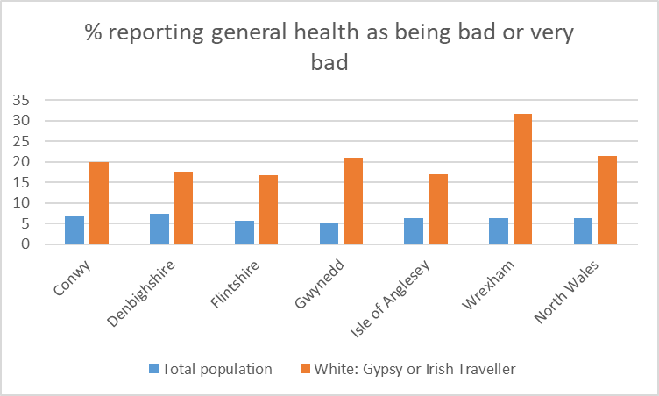

Also we see that the Gypsy or Irish Traveller ethnic group was among the highest providers of 20 hours or more unpaid care in North Wales at 9%. Again the highest proportion was in Wrexham with 17% providing 20 or more hours of unpaid care; however in Denbighshire no person from the Gypsy or Irish traveller ethnic group provided more than 20 hours of unpaid care.

Child health is measured through the percentage of children (under 16 years old) reporting general health as being either very good or good. In 2015 **95.2%** of children in North Wales (Betsi Cadwaladr University Health Board area) reported that their general health was very good or good.

Analysis at local authority level (chart below) shows that the highest percentage of children reporting that their general health as being very good or good is in Flintshire (97.1%) with the lowest being Wrexham (92.6%).

*Source : Welsh Health Survey, 2015*

7.2.2 Health outcomes for other groups

As noted in the “Is Wales fairer?” report no recent evidence has been collated on health outcomes for other groups such as transgender people and migrants, refugees and asylum seekers.

7.2.3 Suicide

Using Public Health Wales Observatory data we can see that the suicide rate for North Wales was 11.5 per 100,000 adults between 2014 and 2018. This is the lower than the Wales average of 12.0, and the second-lowest amongst the seven Welsh health boards (see chart below).

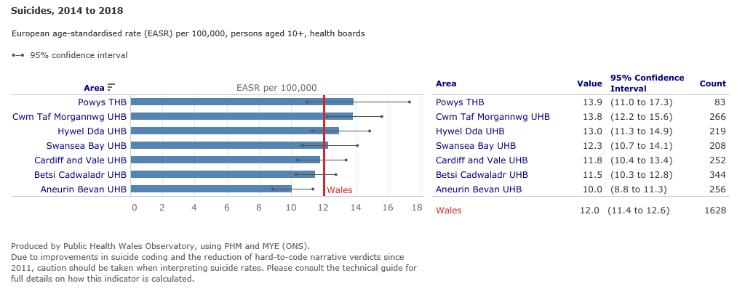

Analysis at local authority level (below) shows that the highest rate in north Wales (14.2) was in Gwynedd, whilst Conwy (10.0) has the lowest rate in North Wales.

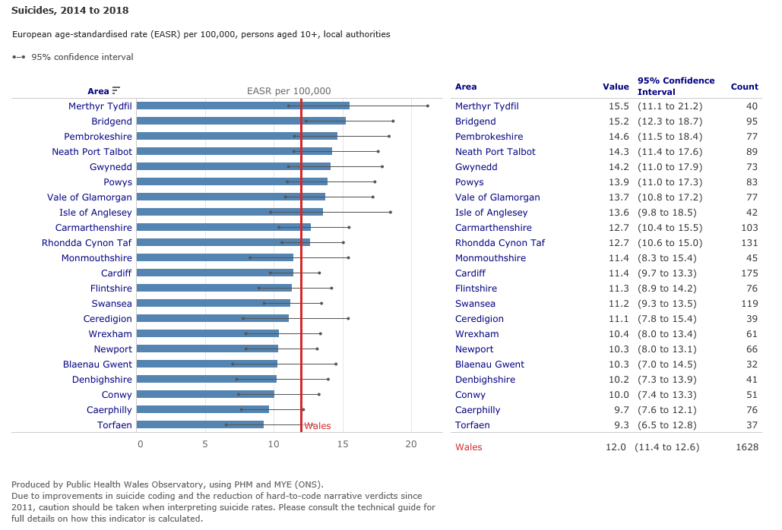

The latest data available for analysing by age and gender dates from 2011; the rate for that year (chart below) across north Wales is highest in the 35-54 age group (16.4 per 100,000 population) and second highest in the 55-74 age group (11.9 per 100,000 population). This general pattern is also apparent in each local authority area although the small numbers at local level mean that it is difficult to draw definite conclusions.

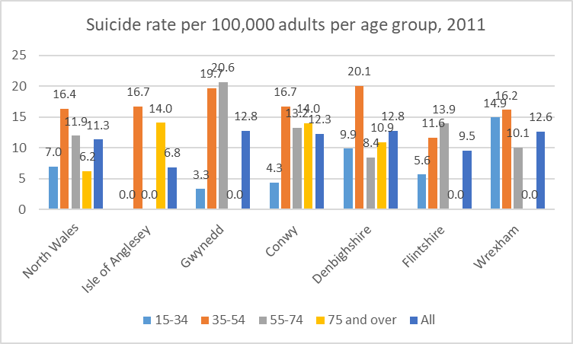

The suicide rate for males is over 3 times higher than females across north Wales and this pattern is generally reflected in each local authority area (chart below: except Anglesey where the overall numbers in the year in question were lower).

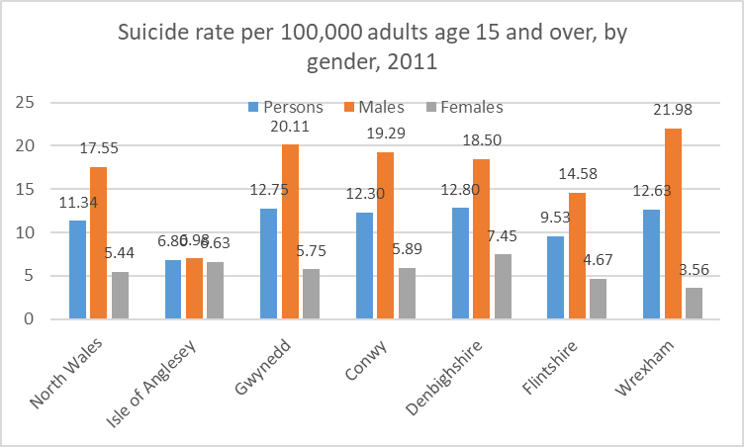

7.2.4 Life expectancy

In 2014–16, life expectancy at birth in North Wales was 78.8 years for males and 82.6 years for females. Disability-free life expectancy across north Wales was 61.8 years (males) and 61.7 years (females). Therefore females in North Wales have a higher life expectancy but are also expected to live longer with a limiting long-term physical or mental health condition (20.9 years, compared to 17.0 years for males).

Analysis at local authority level (charts below) shows that the highest life expectancy for males is in Flintshire (79.2) with the lowest being Denbighshire (77.5). For females the highest is Gwynedd (83.6) and the lowest Wrexham (81.6). Looking at disability-free life expectancy we see that for Gwynedd and Denbighshire it is higher for females while higher for males in all other four authorities. In all authorities, females are expected to live with a limiting long-term physical or mental health condition for more years of their lives than males. Females in Conwy (23.5 years) are expected to live for more years with a limiting long-term physical or mental health condition, with the lowest being Isle of Anglesey (19.9 years). For males the number of years ranges from Denbighshire (19.7 years) to Flintshire (15.7 years).

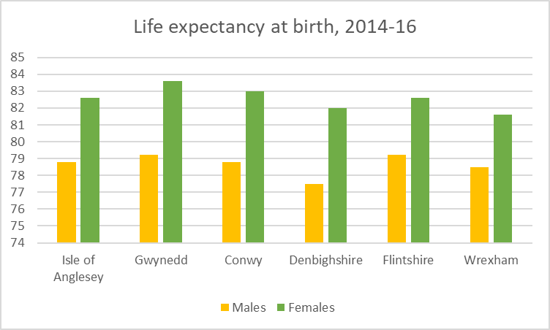

*Source : Office for National Statistics, 2014-16*

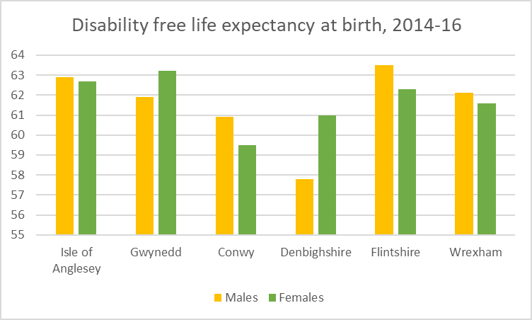

*Source : Office for National Statistics, 2014-16*

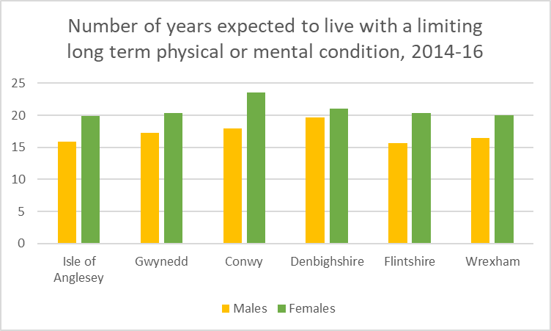

*Source : Office for National Statistics, 2014-16*

7.2.5 Malnutrition

As noted in “Is Wales Fairer?” there is only limited information on malnutrition in general; we are unable to find local data to add to that discussion.

Looking at the percentage of adults who eat five fruit or vegetable portions a day, the percentage across Wales was 23.8% in 2016/17 - 2017/18. This level is not reached by any of the authorities in North Wales, with the highest being 22.8% in Gwynedd, and lowest being 19.0% in Wrexham.

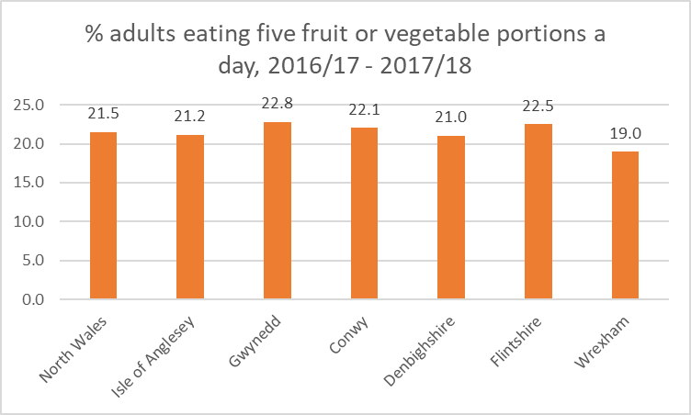

*Source: Public Health Outcomes Framework*

Across North Wales, 88% of children aged 3-7 eat fruit every day and 65% eat vegetables every day (National Survey for Wales 2017-18). No breakdown by protected characteristic is published.

Across north Wales, 78.5% of girls aged 11-16 were of healthy weight in 2013/14, compared to 77.3% of boys aged 11-16.

7.2.6 Infant Mortality

Infant mortality is measured by the deaths per 1,000 live births of infants up to 1 year old. In 2016 the rate for North Wales was 4.1. Analysing by local authority (chart below) the rate for Anglesey was much higher than elsewhere.

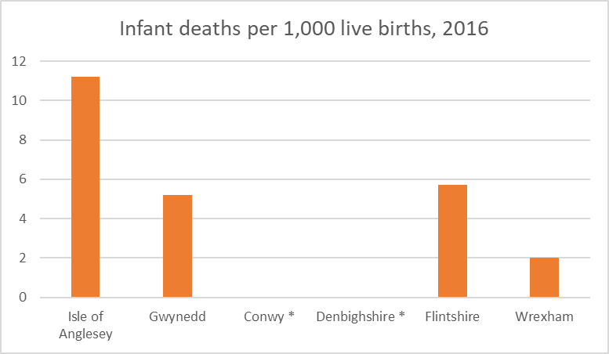

*\* figures not available*

7.2.7 Low birth weight

During 2017, **6.1%** of babies in North Wales were born with a low birth weight (below 2,500g). The lowest percentage was in Isle of Anglesey with 4.9% and the highest in Wrexham at 7.0%. The figure for Wales was 5.6%.

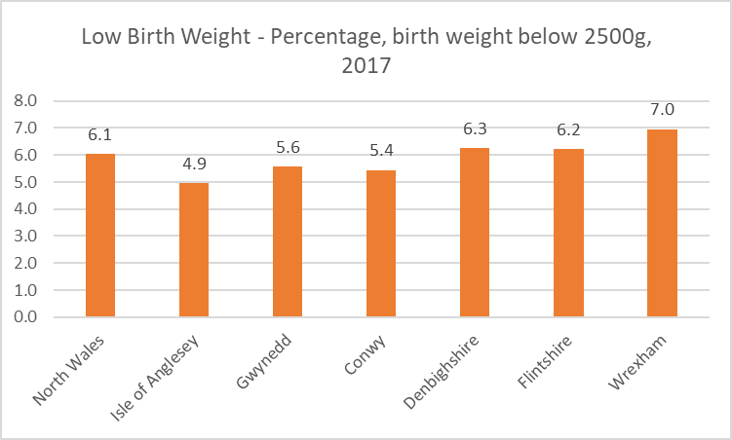

7.2.8 Data gaps

Although there is a considerable amount of data available for this subject area, very little is available by both local area (below all-Wales level) and by protected characteristic. This applies to most National Survey for Wales data (some of which is analysable by gender and age, but mostly only at all-Wales level).

**7.3 Mental Health**

7.3.1 Population reporting poor mental health and wellbeing

“Is Wales Fairer?” used analysis conducted specifically for the report on poor mental health / wellbeing from the Welsh Health Survey. We cannot therefore replicate the data to Local Authority level or lower.

In 2015 (chart below) the highest % of adults being treated for a mental illness was in Denbighshire with 12%, and the lowest being Gwynedd with 7%. The percentage for North Wales was 10% and Wales 12%.

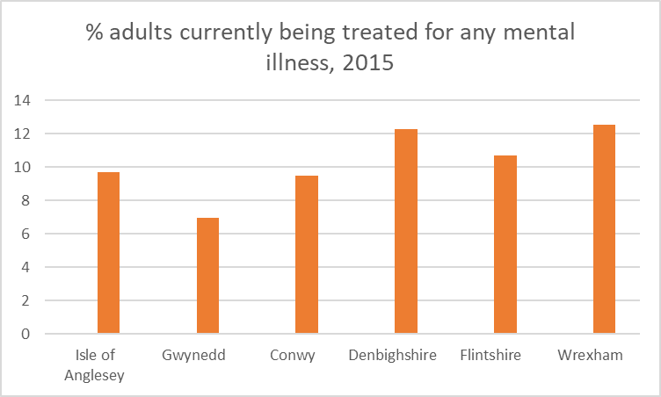

In 2016-17, 1,262 patients were admitted to mental health facilities in Betsi Cadwaladr UHB area, of whom 51.6% were male and 48.4% were female.

In 2018, there were 224 patients with a mental illness in mental health hospitals / units in north Wales. The majority (129 patients; 57.6%) were male and 42.4% female.

2.2% of these patients were under 18 years of age, 41.5% between 18 and 44, 23.2% between 45 and 64, and 33.0% over 65.

7.3.2 Access to, and quality of, mental health services

No specific local information to add to the discussion in “Is Wales Fairer?”.

7.3.3 Access to psychological therapies

No specific local information to add to the discussion in “Is Wales Fairer?”.

7.3.4 Mental health provision for looked after children

No specific local information to add to the discussion in “Is Wales Fairer?”.

7.3.5 Suicides of mental health service users

No specific local information to add to the discussion in “Is Wales Fairer?”.

7.3.6 Use of restraint of mental health service users

No specific local information to add to the discussion in “Is Wales Fairer?”.

7.3.7 Use of Mental Health Act and supervised community treatment

No specific local information to add to the discussion in “Is Wales Fairer?”.

7.3.8 Data gaps

As for some other subject areas, the data from the National Survey for Wales available at local level is not generally analysable by protected characteristic. The sample size may need to be increased before reliable information could be published at this level.

Similarly, the Public Health Outcomes Framework tool provides a wealth of data in this area, which is often analysable by geographical area (below all-Wales level), or by protected characteristic, but usually not both.Health

1. **Justice and personal security**

**8.1 Criminal and civil justice: public confidence and access to justice**

8.1.1 Public confidence in the justice system

In North Wales, 65.0% of adults aged 16 and over interviewed for the Local Crime Survey 2018/19 responded that the police “did an excellent / good job”, compared to 59.9% across Wales as a whole.

63.4% of respondents in North Wales agreed that the “police deal with local concerns”, compared with 59.0% across Wales as a whole.

On attitudes to the local police working in partnership, 62.5% of respondents in North Wales agreed / strongly agreed that the “police and local council are dealing with issues”, which is slightly below the all-Wales percentage of 62.9%.

8.1.2 Access to courts and tribunals

No specific local information to add to the discussion in “Is Wales Fairer?”.

8.1.3 Provision of legal aid

No specific local information to add to the discussion in “Is Wales Fairer?”.

8.1.4 Data gaps

The Crime Survey for England and Wales (ONS) contains questions on attitudes towards / experiences of the police and the criminal justice system; these are analysed by gender, ethnicity etc at all-Wales level (as used in ‘Is Wales Fairer’?) but not at a more local level.

**8.2 Violence and abuse: hate crimes, homicides, and sexual and domestic abuse**

8.2.1 Hate crime and prejudice-based harassment

**681** offences were recorded by North Wales Police as hate crime in 2017/18.

There are five strands by which hate crime is recorded. Of the total 733[9] offences recorded across all strands, 467 (64%) related to race, 148 (20%) to sexual orientation, 65 (9%) to disability, 46 (6%) to religion, and 7 (1%) to transgender identity.

The number of offences recorded as hate crime has increased over recent years (in particular between 2016/17 (465 offences) and 2017/18 (681 offences) – a 46% increase) as shown in the chart below. Participants at the NWPSEN Stakeholder Engagement Event (24/5/18) noted a recent increase in reported hate crime, which they attributed to raised awareness and better procedures for reporting.

The chart also shows the breakdown by motivating factor – this shows that the increase between the two years is largely composed of an increase in crimes relating to race (39% increase), sexual orientation (135% increase) and religion (188% increase).

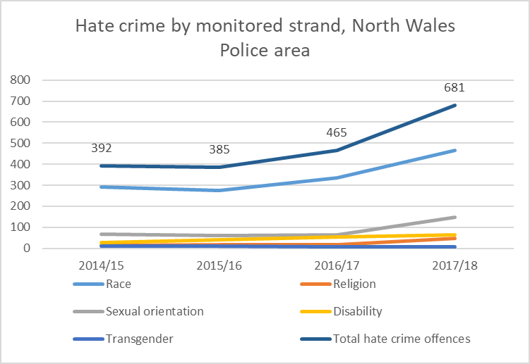

8.2.2 Homicides

No specific local information to add to “Is Wales Fairer?”; given that the number of homicides across north Wales is relatively low (5 recorded in 2018/19) analysis by protected characteristic would be unlikely to yield meaningful results.

8.2.3 Sexual violence and abuse

2,723 sexual offences were reported in North Wales in 2018/19.

This compares with 2,990 offences in 2017/18, and 1,917 in 2016/17.

8.2.4 Domestic violence and abuse

9,449 domestic abuse-related offences were recorded by North Wales Police during the year April 2017 – March 2018. This represents 18% of all offences during this period (in Wales as a whole, domestic abuse-related offences represented 15% of all offences).

This represents a substantial increase on the number of domestic abuse-related offences recorded in North Wales in previous years – in 2015/16 and 2016/17 the corresponding number of offences were 4,798 and 5,763 respectively.

7,401 violence against the person domestic abuse-related offences were recorded by North Wales Police in 2017/18, which represented 38% of all violence offences in that period (across Wales the corresponding percentage was 36%).

Again this represents a substantial increase on the number recorded in North Wales in previous years – in 2015/16 and 2016/17 the corresponding number of offences were 3,774 and 4,484 respectively.

For 2017/18, the rate of domestic abuse-related offences per 1,000 population was 14 in North Wales, compared to 11 across Wales and 10 across England and Wales.

The rate of violence against the person domestic abuse-related offences per 1,000 population was 11 in North Wales, compared to 9 across Wales and 8 across England and Wales.

8.2.5 Crimes against children

Experimental statistics on child sexual abuse / sexual exploitation by police force area show that in 2018/19, 1,929 crimes were flagged as child sexual abuse in North Wales. Of these, 85 crimes were flagged as child sexual exploitation. There were a total of 39 incidents flagged as child sexual exploitation.

These statistics need to be used with care due to their experimental status and the recording / flagging practices seem to be an emerging stage (for instance, the child sexual abuse figure for North Wales represents over 65% of the total figures reported across Wales).

8.2.6 Data gaps

A substantial amount of data is published and regularly updated on crime, some at very local levels. However most data published at local level is not very useful for the purpose of this analysis; data on issues such as hate crime is published at force area level (i.e. North Wales) but this only includes total numbers and is not categorised by e.g. age or gender of victim.

**8.3 Conditions of detention**

8.3.1 Detained population

Detentions under the Mental Health Act

In 2016/17, 65.6 per 100,000 of adults in north Wales were detained formally under Mental Health Acts.

Breaking down the results **by gender**, the rate per 100,000 was 74.8 amongst males and 56.9 amongst women in north Wales (Betsi Cadwaladr University Health Board area).

Youth custodial sentences

In North Wales 23 youth custodial sentences were given to children in 2017/18. 7 of these were in the Conwy / Denbighshire YOT area, 3 in Flintshire, 13 in Wrexham and none in Gwynedd Môn.

8.3.2 Overcrowding and conditions of detention

The only prison in north Wales (HMP Berwyn) currently has fewer prisoners than its full operational capacity (1448 prisoners in August 2019 compared with 1550 capacity).

8.3.3 Non-natural deaths

No specific local information to add to “Is Wales Fairer?”.

8.3.4 Safety of those detained

There were 591 self-harm incidents at HMP Berwyn in the year to March 2019. This compares to 358 incidents in the previous year, although the number of prisoners has also increased in that time.

In the year to March 2019 there were 288 prisoner-on-prisoner assaults at HMP Berwyn, and 204 assaults on staff. This compares with 79 and 45 in the previous year.

8.3.5 Use of force and restraint

In 2017/18 North Wales Police used CEDs (Conducted Energy Devices or ‘Tasers’) 134 times, of which the device was actually discharged 12 times.

As noted in ‘Is Wales Fairer?’ the statistics do not include the age or ethnicity of those against whom Tasers are used.

As the report also notes, data on the use of restraint in health and care settings is also very limited.

8.3.6 Data gaps

As is the case for some other subject areas, there is a substantial amount of data available but most of it is either only available at England & Wales or Wales level, or (as for the HMP Berwyn data quoted above) is not available by protected characteristic, so is of limited use for this analysis.

The lack of reliable data on the Welsh prisoner population has been highlighted in a number of recent reports – the Wales Governance Centre has recently published a number of studies (<https://www.cardiff.ac.uk/wales-governance-centre/publications/justice>) concentrating more specifically at present on the geographical distance between prisons and prisoners’ home areas – it would be useful to keep an eye on this research as it develops.

1. **Participation**

**9.1 Political and civic participation and representation**

9.1.1 Voting

No specific local information to add to “Is Wales Fairer?”. In fact we would question the finding quoted in that report that voter turnout in Wales is substantially higher for women than for men; this is not borne out by other similar studies, and is probably attributable to a small sample size even at all-Wales level.

9.1.2 Political participation and freedom of expression, assembly and association; trade unions, legislation and membership

No local data to add to the information in “Is Wales Fairer?” – although the data on local government members / candidates could in theory be reported at a local level it is published only at all-Wales level at present.

9.1.3 Civic participation, including public appointments and volunteering; ability to influence decisions in the local area

In total, of the 333 elected members across north Wales local authorities, 74 (22.9%) are women. The percentages are lower than this in Wrexham and (in particular) Anglesey as shown below:

|  |  |
| --- | --- |
|  | **% female elected members** |
| Isle of Anglesey | 10% |
| Gwynedd | 23% |
| Conwy | 25% |
| Denbighshire | 23% |
| Flintshire | 26% |
| Wrexham | 19% |

Participants at the NWPSEN Stakeholder Engagement Event (24/5/18) felt that councillors were not generally representative of the “mainstream” of local society and were not drawn from, for example, ethnic minorities or young people in many counties.

9.1.4 Data gaps

Detailed information on diversity of the membership of local government / other public bodies is not generally available (other than by gender) as noted in the Electoral Reform Society’s report “New Voices: How Welsh politics can begin to reflect Wales”.

**9.2 Access to services**

9.2.1 Access to transport

Using data from the 2011 Census, car or van availability can be analysed by different characteristics.

Across north Wales, 14.7% of the population live in households without access to a car or van. Analysis by ethnicity shows that the corresponding percentages in each ethnic group are: White 14.5%, Mixed / multiple ethnic group 21.6%, Asian 20.6%, Black / African / Caribbean 28.9%, and Other ethnic group 24.1%.

Analysis by local authority area (chart below) shows a broadly similar pattern across areas, the main exception being the Asian / Asian British ethnic group, for which car / van access is significantly below that of the general population in Gwynedd and Wrexham, but broadly similar to the area in general in the other 4 authorities.

Analysis by social grade shows that across north Wales, 12.1% of people aged 16-64 have no access to a car / van in their household, but that this proportion varies from 3.4% in social grade AB (Higher and intermediate occupations), to 9.1% in grade C1, 7.4% in grade C2, to 24.8% in grade DE (Semi-skilled and unskilled manual occupations and unemployed).

The pattern across authority areas is broadly similar as shown in the chart below.

Analysing by religion, 19.6% of households across north Wales which identified their religion as Christian had no access to a car or van. The corresponding percentages for other religions are: Buddhist 22.6%, Hindu 19.7%, Jewish 22.3%, Muslim 25.9%, Sikh 14.7%, Other 24.0%, No religion 20.6%.

Analysis by local authority area (chart below) suggests that the local pattern can vary considerably from the North Wales average.

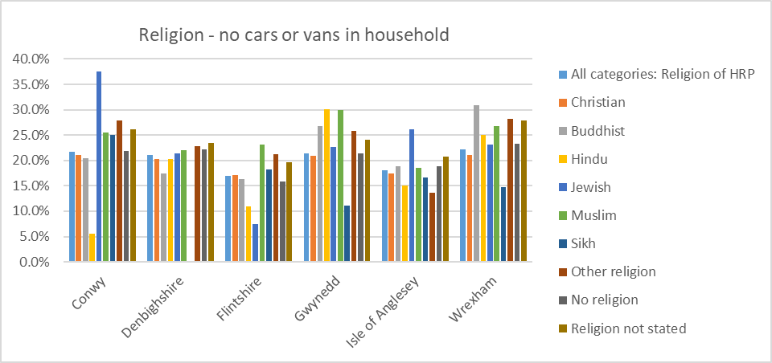

Across north Wales, 30.9% of people whose day-to-day activities are “limited a lot” because of a long-term health problem or disability had no access to a car / van. The corresponding percentage for people whose activities are “limited a little” was 22.4%, compared to 11.5% for people whose activities were not limited.

As shown in the chart below, this is a pattern which repeats itself across the local authority areas – the main exception being that in Anglesey, the proportion of people with health problems / disabilities without access to a car / van is slightly lower than in other areas.

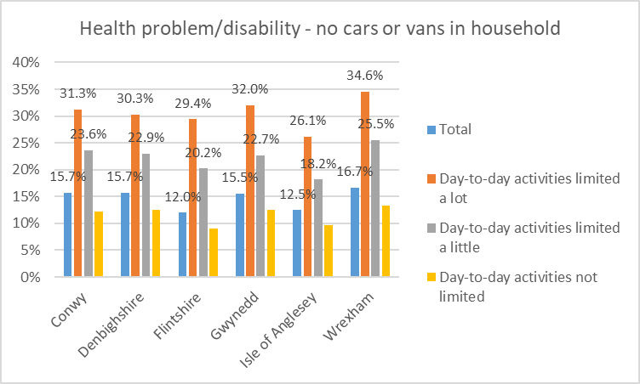

Across north Wales, 14.1% of people aged 0-15 lived in households with no access to a car / van, compared with 14.1% of people aged 16-49 and 10.2% of people aged 50 to 64. The proportion increases to 23.4% for people aged 65 and over.

This general pattern is apparent in each local authority area as shown below. In particular, the proportion of over-65s in Wrexham without access to a car / van is higher than other areas at 27.3%.

The proportion of males living in households without access to a car / van is lower than females, in each local area as shown below. Across north Wales as a whole, 12.6% of males have no access compared to 16.7% of females.

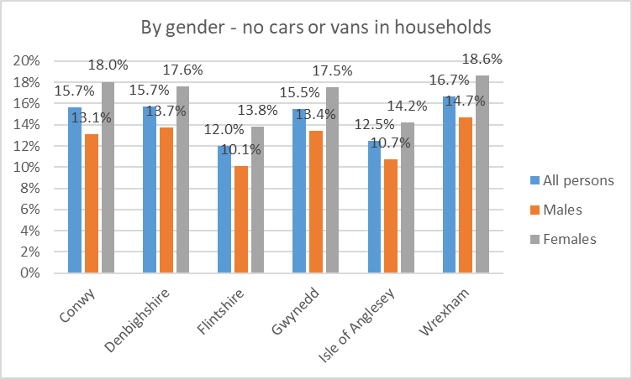

9.2.2 Access to digital services

Data from the National Survey for Wales (graph below) shows the level of internet access is broadly similar between different areas of north Wales at around 84-88%. Unfortunately this data is not further analysed by protected characteristic.

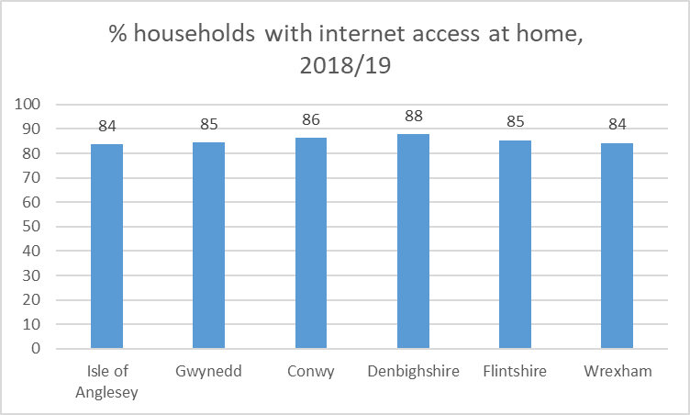

Participants at the NWPSEN Stakeholder Engagement Event (24/5/18) noted that access to public transport continues to be problematic particularly for those with a physical or sensory impairment.

9.2.3 Barriers to financial access and vulnerability to fraud

In total, 282 cases of alleged financial abuse were reported in 2017/18 in north Wales, where the alleged victim was aged 65 and over. In around 65% of these cases, the alleged victim was female. This general pattern is consistent across local authorities as shown in the chart below.

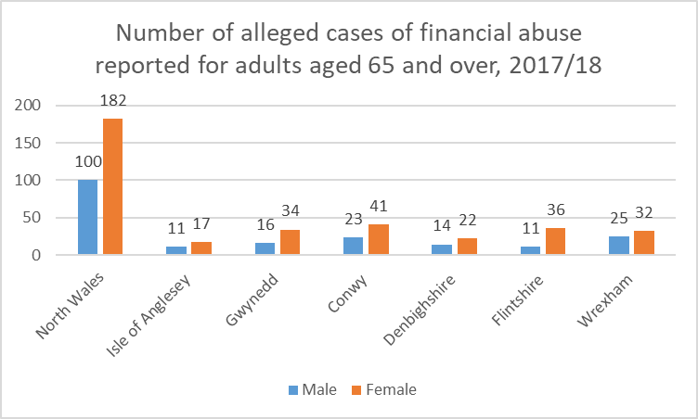

9.2.4 Access to culture, leisure and sport

Participation in sport or exercise is measured through the percentage of adults doing sport or exercise in last four weeks. In 2016 **56.2%** of adults in north Wales had participated in sport or exercise in the previous four weeks.

Breaking down the results **by gender**, 60.5% of men in North Wales participated in sport or exercise in the previous four weeks compared to 52.5% of women.

Analysis at local authority level (chart below) shows that a higher percentage of men compared to women in all authorities participated in sport or exercise in the previous four weeks. The lowest participation by both men and women is seen in Denbighshire.

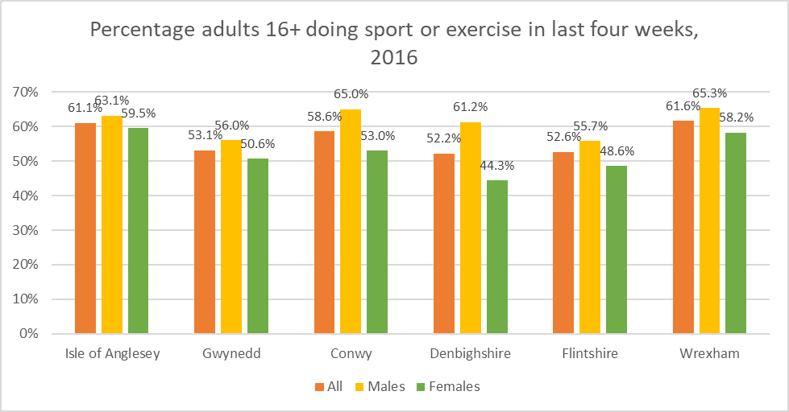

*Source: National Survey for Wales, 2016/17*

Breaking down the results **by age**, 71.0% of 16-24 year olds in North Wales participated in sport or exercise in the previous four weeks with the rest of age band as follows; 25-34 year olds – 68.6%; 35-44 year olds – 69.3%; 45-54 year olds – 63.7%; 55-64 year olds – 52.0%; 65-74 year olds – 45.4% and 75 years and over – 18.5%.

Although data on Local Authority level is available for age ranges it is not complete and therefore not comparable at this level.

9.2.5 Data gaps

There is very little information available on access to transport, other than Census data on households with no car / van which doesn’t really tell the full story on whether safe and accessible transport is available.

We have been unable to find local data on access to other cultural / leisure facilities (other than participating in exercise). Data on internet access / use is not available at local level by protected characteristic.

**9.3 Privacy and surveillance**

9.3.1 Internet use and awareness of privacy settings

No specific local information to add to “Is Wales Fairer?”.

9.3.2 Treatment of personal data

No specific local information to add to “Is Wales Fairer?”.

9.3.3 Data gaps

We have been unable to find local data for this subject heading – the analysis in “Is Wales Fairer?” is based on data from the Opinions and Lifestyle Survey which is available only at all-Wales level.

**9.4 Social and community cohesion**

9.4.1 Trust and sense of belonging in the local neighbourhood

The data used in ‘Is Wales Fairer?’ on whether survey respondents feel that “most people can be trusted” in available only at all-Wales level.

Data on whether people aged 16 and over are “satisfied with their local area as a place to live” is available at local authority level from the National Survey for Wales. In general (chart below) men are somewhat more satisfied than women with their local area (with Conwy the exception).

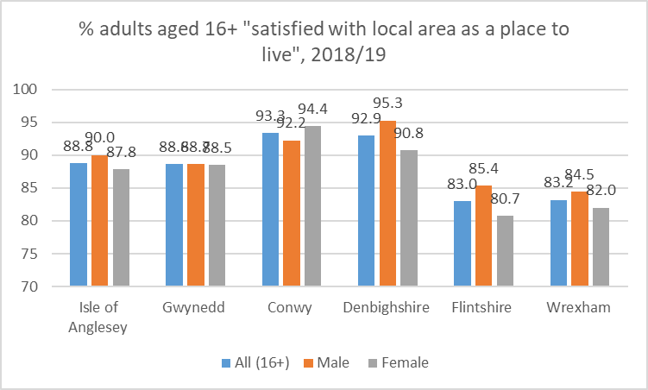

Data on whether people agree that they “belong to their local area” is available at local authority level from the National Survey for Wales (chart below), but unfortunately is not analysed by gender or other protected characteristics.

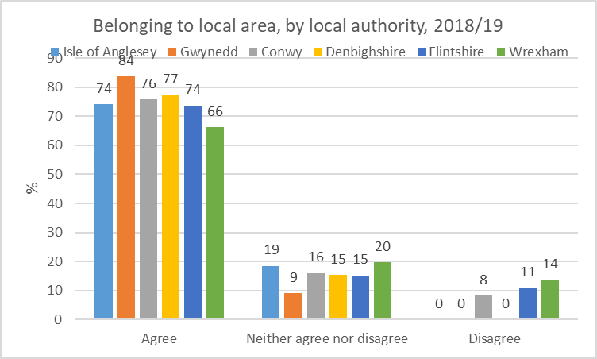

9.4.2 Social and community cohesion, building relationships to counter radicalisation and extremism

No specific local information to add to “Is Wales Fairer?”.

9.4.3 Community interaction and use of common spaces; access to, and exclusion from, engaging with the local community

Data from the National Survey for Wales on whether respondents (aged 16 and over) felt they were lonely, shows a wide variation in the overall percentage by local authority from 11.1% (Flintshire) to 20.9% (Wrexham).

Analysing by gender (chart below – data not published for all categories due to small sample sizes), there is no uniform pattern - loneliness amongst females seems to be somewhat higher than the authority average in three areas (Conwy, Denbighshire and Flintshire) whilst the opposite is true in Gwynedd and Wrexham.

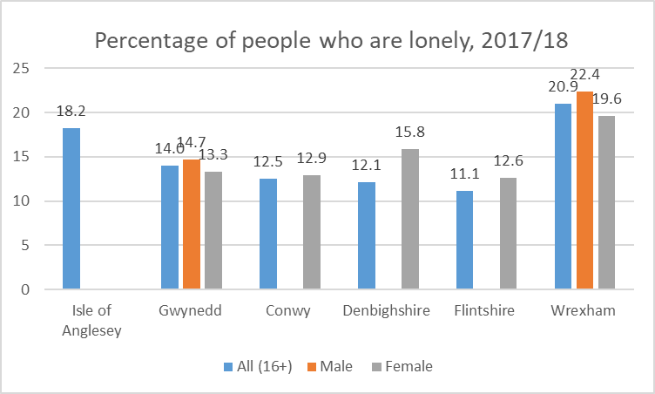

2011 Census data shows that, of the households across north Wales where someone has a long-term health problem or disability, 35.8% of them are single-person households. This compares with 28.6% of households where there is no-one with a long-term health problem or disability.

Although not directly related to this topic (or to any other single topic in isolation), data on life satisfaction among working-age adults, and among older people, is shown below.

Life satisfaction among older people is higher than among working age adults in each local authority area on this measure. In addition, life satisfaction is generally somewhat higher than the Wales average (4 of the 6 authorities have higher scores than the Wales average for working-age adults; 5 of the 6 authorities for older people).

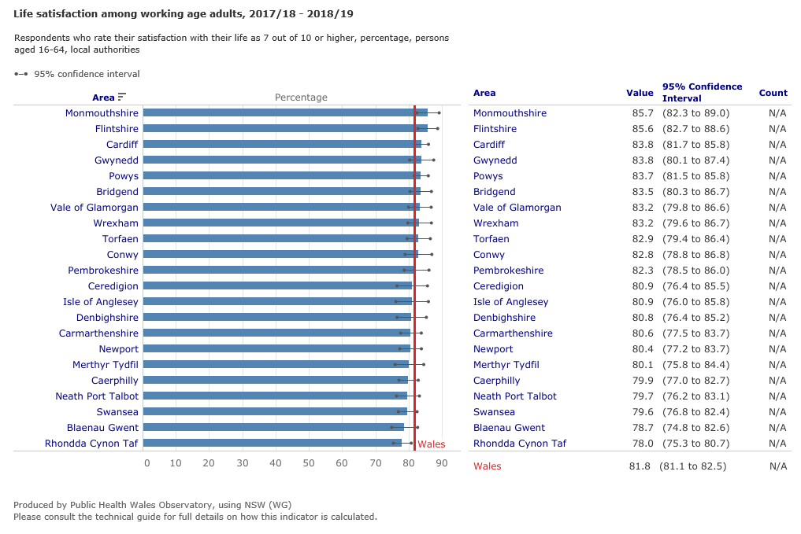

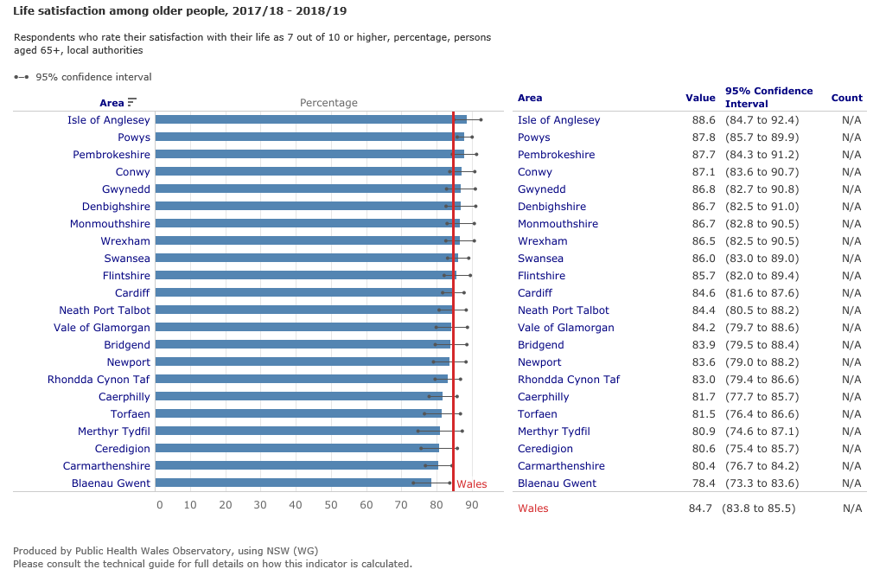

9.4.4 Data gaps

Most of the data in this section are based on responses from the National Survey for Wales. The ability to analyse this data at local level and by protected characteristic is limited; the data is generally not published at this level of aggregation, and even if it is (as in the ‘loneliness’ data above) some elements are usually not disclosed due to small sample sizes.

1. **Conclusions**

In general the main findings of this report amplify those in “Is Wales Fairer?” and show that the effects of poverty, inequality and exclusion, which were highlighted at Wales level in that report, are also very much in evidence in local communities across north Wales.

The main themes which become evident are:

* **Socio-economic disadvantage:** the impact of poverty and deprivation on peoples’ lives is very apparent from the information in the report. A particularly striking example is educational attainment: 28% of pupils claiming free school meals achieve the Level 2 Inclusive Threshold at school-leaving age, compared with 58% of other pupils. Households in lower socio-economic groups are also much less likely to have access to a car – which will have a particularly significant impact on people living in rural areas.
* **Disabled people:** although the additional evidence available locally is patchy, the data for employment in particular suggest that opportunities for disabled people are limited; for example in one local authority area (Conwy) disabled people are five times more likely than non-disabled people to be unemployed.
* **Outcomes for women / girls:** the data suggests a mixed picture:
  + girls achieve higher educational attainment than boys in north Wales schools, and among the working-age population there are more females than males with degree-level qualifications;
  + unemployment is lower amongst females than males (except in Gwynedd), and more females than males participate in job-related training and apprenticeships;
  + female life expectancy is higher (in line with the national pattern),

However:

* + women generally earn less than men (except in Conwy), with the pay gap reaching up to 17% in some local authority areas;
  + females are more likely than males to provide unpaid care, to be in households threatened with homelessness, and to live with a limiting long-term health condition;
  + the “Is Wales Fairer?” finding that *“women continue to be under-represented among local election candidates and public appointments…”* seems to be true in north Wales as well – in particular less than a quarter of elected councillors are female.
* **Race inequality:** the data available is patchy because of small numbers / data disclosure issues, but show for example that people from ethnic minority groups in north Wales are more likely than the White Welsh / British population to have a degree-level qualification; however in Gwynedd, Flintshire and Wrexham the employment rate amongst ethnic minorities is lower than amongst the White Welsh / British population (the opposite is true in the other three local authority areas). In 2017/18 64% of hate offences across North Wales related to race.

It should again be emphasised that these conclusions are based on the information available for each protected characteristic; the “Is Wales Fairer?” report notes that *“there are serious gaps in data for Wales that make it very difficult to make a full assessment of equality in Wales”*. This is even truer at North Wales and lower geographical levels, and the absence of evidence in this report should not be taken to imply that inequalities for other protected groups do not exist or are somehow less important.

The additional questions in the 2021 Census, and the greater availability / flexibility of the Census results, will help fill some of the gaps but a more systematic and robust approach to data collection and dissemination will be needed to enable a comprehensive assessment of equality at local level.

In particular, some of the questions already included in the National Survey for Wales (commissioned by the Welsh Government) could be a very useful source of information particularly on issues such as health, lifestyles and participation. The results however are generally published by area, or by protected characteristic, but not both. Pressing the Welsh Government to publish these results in more detail (or to boost the sample size, if this is the reason they are not published) would be a useful first step towards improving the data available.

**Appendix 1: Data sources and links**

**Education**

|  |  |  |
| --- | --- | --- |
| **Indicator** | **Source** | **Link** |
| **Educational attainment of children and young people** | | |
| Percentage of children achieving the expected outcomes at Foundation Phase (Foundation Phase Indicator) | National teacher assessment data collection, Welsh Government  *No longer updated after 2017* | <https://statswales.gov.wales/Catalogue/Education-and-Skills/Schools-and-Teachers/Examinations-and-Assessments/Foundation-Phase/results-by-localauthority-outcome> |
| Percentage of Year 11 pupils achieving Level 2 (5 GCSEs A*-C) including English/Welsh and Maths (Level 2 Inclusive Threshold) | Welsh Examinations Database, Welsh Government | General, and analysis by gender: <https://statswales.gov.wales/Catalogue/Education-and-Skills/Schools-and-Teachers/Examinations-and-Assessments/Key-Stage-4/examinationachievementsofpupilsaged15-by-localauthority>  Analysis by FSM eligibility:  <https://statswales.gov.wales/Catalogue/Education-and-Skills/Schools-and-Teachers/Examinations-and-Assessments/Key-Stage-4/ks4keyindicators-by-freeschoolmealentitlement-area> |
| **School exclusions, bullying and NEET** | | |
| Exclusions from schools: rate per 1,000 pupils | Pupils’ Exclusions Record, Welsh Government | <https://gov.wales/sites/default/files/statistics-and-research/2019-01/170928-permanent-fixed-term-exclusions-from-schools-2015-16-en.pdf>  This data is the latest available since it is not now published at local authority level; although the statistical bulletin states that “the local authority breakdown is available on request” we have been unable to obtain this from Welsh Government. |
| Percentage of Year 7-11 pupils having bullied / being bullied at school | Health Behaviour in School-aged Children Survey / Student Health and Wellbeing Survey, School Health Research Network | <http://www.shrn.org.uk/wp-content/uploads/2019/05/SHRN-HBSC-NR_31.05.2019.pdf> |
| Young people (aged 16-24) not in education, employment or training (NEET) | Annual Population Survey 2016-2018, ONS | <https://gov.wales/young-people-not-education-employment-or-training-neet-2018> Table 3 |
| Year 11 school leavers known to be NEET | Pupil Destinations from Schools in Wales, Careers Wales | <https://gov.wales/young-people-not-education-employment-or-training-neet-2018> Table 5 |
| **Higher education and lifelong learning** | | |
| Percentage of 25-64 year olds with degree-level qualification (‘Level 4 and above’) | Census 2011, ONS | Calculated from datasets in <https://www.nomisweb.co.uk/query/construct/summary.asp?mode=construct&version=0&dataset=1102> (by sex and age)  <https://www.nomisweb.co.uk/query/construct/summary.asp?mode=construct&version=0&dataset=1107> (by ethnic group)  <https://www.nomisweb.co.uk/query/construct/summary.asp?mode=construct&version=0&dataset=1109> (by religion) |
| Percentage of population aged 16-64 who received job related training in last 13 weeks | Annual Population Survey Apr 2018 – Mar 2019, ONS | <https://www.nomisweb.co.uk/query/construct/components/variableComponent.asp?menuopt=7&subcomp=130> |

**Work**

|  |  |  |
| --- | --- | --- |
| **Indicator** | **Source** | **Link** |
| **Employment** | | |
| Employment rate for ages 16+, 16-64 | Annual Population Survey Apr 2018 – Mar 2019, ONS | <https://www.nomisweb.co.uk/query/construct/components/variableComponent.asp?menuopt=7&subcomp=130> |
| Unemployment rate for ages 16+, 16-64 | Annual Population Survey Apr 2018 – Mar 2019, ONS | <https://www.nomisweb.co.uk/query/construct/components/variableComponent.asp?menuopt=7&subcomp=130> |
| **Earnings** | | |
| Median hourly earnings, males / females, full-time / part-time | Annual Survey of Hours and Earnings, 2018, ONS | <https://www.nomisweb.co.uk/query/construct/components/stdListComponent.asp?menuopt=12&subcomp=100> |
| **Occupational segregation** | | |
| % of employees aged 16+ by occupation (SOC2010 classification) – by ethnicity, gender | Annual Population Survey Apr 2018 – Mar 2019, ONS  High-paid occupations: categories 1 and 2  Low-paid occupations: categories 6, 7 and 9 | <https://www.nomisweb.co.uk/query/construct/components/variableComponent.asp?menuopt=7&subcomp=130> |
| Number of unique learners on apprenticeship programmes | Lifelong Learning Wales Record, Welsh Government | <https://statswales.gov.wales/Catalogue/Education-and-Skills/Post-16-Education-and-Training/Further-Education-and-Work-Based-Learning/Learners/Work-Based-Learning/uniquelearnersworkbasedlearning-by-programmetype-domicile> |
| Apprenticeship programmes in work-based learning, by sector | Lifelong Learning Wales Record, Welsh Government | <https://statswales.gov.wales/Catalogue/Education-and-Skills/Post-16-Education-and-Training/Further-Education-and-Work-Based-Learning/Lifelong-Learning-Wales-Record/learningprogrammesapprenticeships> |

**Living Standards**

|  |  |  |
| --- | --- | --- |
| **Indicator** | **Source** | **Link** |
| **Homelessness** | | |
| Households for which assistance provided, by gender | Homelessness data collection, Welsh Government | <https://statswales.gov.wales/Catalogue/Housing/Homelessness/Statutory-Homelessness-Prevention-and-Relief/householdsforwhichassistancehasbeenprovided-by-outcome-age-gender> |
| **Housing tenure** | | |
| Household tenure by ethnicity, age of Household Reference Person | Census 2011, ONS | <https://www.nomisweb.co.uk/query/construct/summary.asp?mode=construct&version=0&dataset=710> |
| **Housing for Gypsies and Travellers** | | |
| Numbers of gypsy / traveller caravans | Gypsy and traveller caravan count, Welsh Government | <https://gov.wales/sites/default/files/statistics-and-research/2019-04/gypsy-and-traveller-caravan-count-january-2019-587.pdf> |
| **Accessible housing for disabled people** | | |
| Disabled Facilities Grants completed | DFG Data Collection, Welsh Government | <https://statswales.gov.wales/Catalogue/Housing/Disabled-Facitilities-Grants/disabledfacilitiesgrants-by-area-granttype> |
| **Relative poverty and severe material deprivation** | | |
| Percentage of people living in households in material deprivation | National Survey for Wales, Welsh Government | <https://statswales.gov.wales/Catalogue/National-Survey-for-Wales/Well-being-and-Finances/percentageofpeoplelivinginhouseholdsinmaterialdeprivation-by-localauthority-year> |
| **Wealth and income distribution** | | |
| Gross Disposable Household Income | Regional Accounts, ONS | <https://statswales.gov.wales/Catalogue/Business-Economy-and-Labour-Market/Regional-Accounts/Household-Income/grossdisposablehouseholdincome-by-area-measure> |
| **Access to social care** | | |
| Adults receiving services by age group | Adults Receiving Care and Support, Welsh Government  *Rates per age group calculated using these + ONS population estimates* | <https://statswales.gov.wales/Catalogue/Health-and-Social-Care/Social-Services/Adult-Services/Service-Provision/adultsreceivingservices-by-localauthority-agegroup> |
| **Quality of social care** | | |
| Review of healthcare support for older people living in care homes | Joint review: Care Inspectorate Wales / Healthcare Inspectorate Wales, November 2018 | <https://careinspectorate.wales/sites/default/files/2018-11/181115-joint-hiw-ciw-healthcare-support-en.pdf> |
| % people who agree good social care services available in their area | National Survey for Wales, Welsh Government | <https://gov.wales/national-survey-wales-results-viewer> |
| **Impact of caring on carers** | | |
| Provision of unpaid care by general health by sex by age | Census 2011, ONS | <https://www.nomisweb.co.uk/query/construct/summary.asp?menuopt=200&subcomp>= |
| **Abuse and neglect** | | |
| Adults suspected of being at risk | Adult Safeguarding, Welsh Government | <https://statswales.gov.wales/Catalogue/Health-and-Social-Care/Social-Services/Adult-Services/Adult-Safeguarding/adultssuspectedofbeingatrisk-by-localauthority-measure> |

**Health**

|  |  |  |
| --- | --- | --- |
| **Indicator** | **Source** | **Link** |
| **Access to healthcare** | | |
| Percentage of people waiting for treatment for more than 26 weeks | Referral to Treatment Times, NHS Wales Informatics Services | <https://statswales.gov.wales/Catalogue/Health-and-Social-Care/NHS-Hospital-Waiting-Times/Referral-to-Treatment/percentage-patientpathwayswaiting-month-grouped-weeks> |
| Percentage of Ambulance service emergency red calls responded within 8 minutes | Welsh Ambulance Services NHS Trust | <https://statswales.gov.wales/Catalogue/Health-and-Social-Care/NHS-Performance/Ambulance-Services/emergencyresponsesminutebyminuteperformanceredcalls-by-localhealthboard-month> |
| **Health Outcomes** | | |
| Percentage of adults (16 years old and above) reporting general health as being either excellent, very good or good | Welsh Health Survey 2015, Welsh Government | <https://gweddill.gov.wales/statistics-and-research/welsh-health-survey/?tab=previous&lang=en> |
| Percentage of Gypsy or Irish Traveller reporting their general health as bad or very bad | Census 2011, ONS | <https://www.nomisweb.co.uk/query/select/getdatasetbytheme.asp?collapse=yes> |
| Percentage of Gypsy or Irish Traveller providing unpaid care | Census 2011, ONS | <https://www.nomisweb.co.uk/query/select/getdatasetbytheme.asp?collapse=yes> |
| Percentage of children (under 16 years old) reporting general health as being either very good or good | Welsh Health Survey 2015, Welsh Government | <https://gweddill.gov.wales/statistics-and-research/welsh-health-survey/?tab=previous&lang=en> |
| Suicide rate per 100,000 (adults) | Public Health Wales Observatory 2013 to 2017, NHS Wales | <https://public.tableau.com/views/PHOF2017LAHB-HOME/LAHB?:embed=y&:showVizHome=no> |
| Suicide rate by local authority, age and gender | Calculated from ‘Deaths by cause’ data, ONS (link as shown) and 2011 Mid-Year Estimate population | <https://statswales.gov.wales/Catalogue/Health-and-Social-Care/Births-Deaths-and-Conceptions/Deaths/Deaths-by-Cause> |
| Life expectancy | Health state life expectancy at birth | <https://www.ons.gov.uk/peoplepopulationandcommunity/healthandsocialcare/healthandlifeexpectancies/bulletins/healthstatelifeexpectanciesuk/2014to2016/relateddata> |
| Adults and children eating five fruit / vegetable portions daily | National Survey for Wales, Welsh Government (via Public Health Outcomes Framework) | <http://www.publichealthwalesobservatory.wales.nhs.uk/phof> |
| Children aged 11-16 of healthy weight, by gender | Health Behaviour in School-aged Children Survey (via Public Health Outcomes Framework) | <http://www.publichealthwalesobservatory.wales.nhs.uk/phof> |
| Deaths per 1,000 live births of infants up to 1 year old | Child Mortality Statistics, ONS | <https://www.ons.gov.uk/peoplepopulationandcommunity/birthsdeathsandmarriages/deaths/datasets/childmortalitystatisticschildhoodinfantandperinatalchildhoodinfantandperinatalmortalityinenglandandwales> |
| Percentage of babies born with birth weight below 2,500g | Public Health Wales Observatory 2017, NHS Wales (via Public Health Outcomes Framework) | <https://public.tableau.com/views/PHOF2017LAHB-HOME/LAHB?:embed=y&:showVizHome=no> |
| **Mental Health** | | |
| Percentage of adults treated for any mental illness | Welsh Health Survey 2015 | <https://gweddill.gov.wales/statistics-and-research/welsh-health-survey/?tab=previous&lang=en> |
| Admissions to mental health facilities by gender | Welsh Government | <https://statswales.gov.wales/Catalogue/Health-and-Social-Care/Mental-Health/Admissions-to-Mental-Health-Facilities/admissionstomentalhealthfacilitiesbylhb> |
| Patients in mental health hospitals / units with a mental illness, by gender and age | Psychiatric Census, NHS Wales Informatics Service | <https://statswales.gov.wales/Catalogue/Health-and-Social-Care/Mental-Health/Psychiatric-Census/patientsinmentalhealthhospitalsandunitsinwaleswithamentalillness> |

**Justice and personal security**

|  |  |  |
| --- | --- | --- |
| **Indicator** | **Source** | **Link** |
| **Criminal and civil justice: public confidence and access to justice** | | |
| Perceptions of local police | Crime Survey for England and Wales, Year ending March 2019, ONS | <https://www.ons.gov.uk/peoplepopulationandcommunity/crimeandjustice/datasets/crimeinenglandandwalesannualsupplementarytables> |
| **Violence and abuse: hate crimes, homicides, and sexual and domestic abuse** | | |
| Hate crime, by police force area | Police recorded crime, Home Office Data Hub | <https://www.gov.uk/government/statistics/hate-crime-england-and-wales-2017-to-2018> |
| Number of recorded offences by category | Crime in England and Wales, Police Force Area tables | <https://www.ons.gov.uk/peoplepopulationandcommunity/crimeandjustice/datasets/policeforceareadatatables> |
| Domestic abuse recorded offences | Police recorded crime, ONS published tables | <https://www.ons.gov.uk/peoplepopulationandcommunity/crimeandjustice/datasets/domesticabuseinenglandandwalesappendixtables> |
| Child sexual abuse / exploitation offences | Police recorded crime, ONS published tables | <https://www.ons.gov.uk/peoplepopulationandcommunity/crimeandjustice/datasets/crimeinenglandandwalesotherrelatedtables> |
| **Conditions of detention** | | |
| Formal admissions under Mental Health Act | Admissions and detentions under MH Act 1983, Welsh Government | <https://statswales.gov.wales/Catalogue/Health-and-Social-Care/Mental-Health/Admissions-to-Mental-Health-Facilities/admissionstomentalhealthfacilitiesbylhb> |
| Youth custodial sentences | Youth Justice Statistics, Ministry of Justice / Youth Justice Board for England and Wales | <https://www.gov.uk/government/statistics/youth-justice-statistics-2017-to-2018> |
| Prison population | Prison population monthly bulletin, MoJ / HM Prison Service / HM Prison & Probation Service | <https://www.gov.uk/government/statistics/prison-population-figures-2019> |
| Self-harm and assault incidents in prison | Safety in Custody quarterly bulletin, MoJ / HM Prison & Probation Service | <https://www.gov.uk/government/statistics/safety-in-custody-quarterly-update-to-march-2019> |
| Use of CEDs (Tasers) | Police Use of Force statistics, Home Office | <https://www.gov.uk/government/statistics/police-use-of-force-statistics-england-and-wales-april-2017-to-march-2018> |

**Participation**

|  |  |  |
| --- | --- | --- |
| **Indicator** | **Source** | **Link** |
| **Political and civic participation and representation** | | |
| Local authority members by gender | Electoral Reform Society | <https://www.electoral-reform.org.uk/latest-news-and-research/publications/new-voices-how-welsh-politics-can-begin-to-reflect-wales/> |
| **Access to services** | | |
| Access to car / van | Census 2011, ONS | <https://www.nomisweb.co.uk/query/select/getdatasetbytheme.asp?theme=75&subgrp=Detailed+Characteristics> |
| Households with internet access | National Survey for Wales, Welsh Government | <https://gov.wales/national-survey-wales-results-viewer> |
| Number of reported cases of alleged financial abuse, adults aged 65+ | Adult Safeguarding, Welsh Government | <https://statswales.gov.wales/Catalogue/Health-and-Social-Care/Social-Services/Adult-Services/Adult-Safeguarding/typesofabuse-by-localauthority-measure-age> |
| Participation in sport or exercise | National Survey for Wales, Welsh Government | <https://gov.wales/national-survey-wales-results-viewer> |
| **Social and community cohesion** | | |
| Satisfaction with local area as a place to live | National Survey for Wales, Welsh Government | <https://gov.wales/national-survey-wales-results-viewer> |
| Belonging to local area | National Survey for Wales, Welsh Government | <https://gov.wales/national-survey-wales-results-viewer> |
| Loneliness | National Survey for Wales, Welsh Government | <https://gov.wales/national-survey-wales-results-viewer> |
| Single-person households vs long-term health problem / disability | Census 2011, ONS | <https://www.nomisweb.co.uk/query/construct/summary.asp?mode=construct&version=0&dataset=758> |
| Life satisfaction | National Survey for Wales, Welsh Government | Charts supplied by Public Health Wales Observatory |

The highlighted indicators use the same definitions / sources as those in the “Is Wales Fairer?” report.

**Appendix 2: % of population aged 25-64 with degree-level qualifications (or above)**

Analysis by MSOA (Middle Super Output Area)

Source: 2011 Census

(a): By gender

| **MSOA Code** | **MSOA Name** | **All %** | **Male %** | **Female %** | **Gap (Female % - Male %)** |
| --- | --- | --- | --- | --- | --- |
| W02000001 | Isle of Anglesey 001 | 24.5% | 22.6% | 26.3% | 3.6% |
| W02000002 | Isle of Anglesey 002 | 32.1% | 29.4% | 34.8% | 5.4% |
| W02000003 | Isle of Anglesey 003 | 15.9% | 15.6% | 16.2% | 0.6% |
| W02000004 | Isle of Anglesey 004 | 30.3% | 30.3% | 30.3% | 0.0% |
| W02000005 | Isle of Anglesey 005 | 39.4% | 37.3% | 41.3% | 4.1% |
| W02000006 | Isle of Anglesey 006 | 26.1% | 23.8% | 28.2% | 4.4% |
| W02000007 | Isle of Anglesey 007 | 29.0% | 28.7% | 29.2% | 0.5% |
| W02000008 | Isle of Anglesey 008 | 43.5% | 41.7% | 45.3% | 3.6% |
| W02000009 | Isle of Anglesey 009 | 34.7% | 33.6% | 35.7% | 2.1% |
| W02000010 | Gwynedd 001 | 39.7% | 40.5% | 38.5% | -2.1% |
| W02000011 | Gwynedd 002 | 34.2% | 35.1% | 33.3% | -1.7% |
| W02000012 | Gwynedd 003 | 40.2% | 35.6% | 44.9% | 9.3% |
| W02000013 | Gwynedd 004 | 42.7% | 40.3% | 45.1% | 4.8% |
| W02000014 | Gwynedd 005 | 38.3% | 35.5% | 41.2% | 5.6% |
| W02000015 | Gwynedd 006 | 26.9% | 25.5% | 28.3% | 2.7% |
| W02000016 | Gwynedd 007 | 36.6% | 34.3% | 38.8% | 4.5% |
| W02000017 | Gwynedd 008 | 30.7% | 28.3% | 33.1% | 4.8% |
| W02000018 | Gwynedd 009 | 23.8% | 21.0% | 26.7% | 5.7% |
| W02000019 | Gwynedd 010 | 31.7% | 28.5% | 35.1% | 6.6% |
| W02000020 | Gwynedd 011 | 32.0% | 28.1% | 35.8% | 7.7% |
| W02000021 | Gwynedd 012 | 25.8% | 23.7% | 28.0% | 4.4% |
| W02000022 | Gwynedd 013 | 29.0% | 25.4% | 32.6% | 7.2% |
| W02000023 | Gwynedd 014 | 31.1% | 27.3% | 34.9% | 7.6% |
| W02000024 | Gwynedd 015 | 30.7% | 26.5% | 35.1% | 8.6% |
| W02000025 | Gwynedd 016 | 26.8% | 25.7% | 28.0% | 2.3% |
| W02000026 | Gwynedd 017 | 27.4% | 25.9% | 28.9% | 2.9% |
| W02000027 | Conwy 001 | 28.3% | 28.2% | 28.5% | 0.3% |
| W02000028 | Conwy 002 | 26.3% | 24.6% | 27.8% | 3.3% |
| W02000029 | Conwy 003 | 39.2% | 38.0% | 40.3% | 2.3% |
| W02000030 | Conwy 004 | 36.6% | 35.5% | 37.5% | 2.0% |
| W02000031 | Conwy 005 | 16.5% | 16.0% | 16.9% | 1.0% |
| W02000032 | Conwy 006 | 35.0% | 35.2% | 34.9% | -0.2% |
| W02000033 | Conwy 007 | 28.4% | 26.4% | 30.7% | 4.3% |
| W02000034 | Conwy 008 | 38.4% | 37.5% | 39.3% | 1.8% |
| W02000035 | Conwy 009 | 29.6% | 27.5% | 31.5% | 4.0% |
| W02000036 | Conwy 010 | 27.6% | 26.3% | 28.8% | 2.5% |
| W02000037 | Conwy 011 | 26.3% | 24.6% | 27.9% | 3.3% |
| W02000038 | Conwy 012 | 36.1% | 34.0% | 37.9% | 3.9% |
| W02000039 | Conwy 013 | 33.8% | 30.2% | 37.4% | 7.2% |
| W02000040 | Conwy 014 | 33.6% | 27.4% | 40.0% | 12.6% |
| W02000041 | Conwy 015 | 31.9% | 28.3% | 35.5% | 7.2% |
| W02000042 | Denbighshire 001 | 22.3% | 21.3% | 23.3% | 2.0% |
| W02000043 | Denbighshire 002 | 26.7% | 24.2% | 29.0% | 4.8% |
| W02000044 | Denbighshire 003 | 27.8% | 27.4% | 28.1% | 0.7% |
| W02000045 | Denbighshire 004 | 17.2% | 15.1% | 19.3% | 4.2% |
| W02000047 | Denbighshire 006 | 14.5% | 15.6% | 13.6% | -2.0% |
| W02000049 | Denbighshire 008 | 32.5% | 29.6% | 35.1% | 5.5% |
| W02000050 | Denbighshire 009 | 30.6% | 28.9% | 32.2% | 3.3% |
| W02000051 | Denbighshire 010 | 36.0% | 33.0% | 38.9% | 5.9% |
| W02000052 | Denbighshire 011 | 29.0% | 26.4% | 31.7% | 5.2% |
| W02000053 | Denbighshire 012 | 40.0% | 36.1% | 44.0% | 7.9% |
| W02000054 | Denbighshire 013 | 44.7% | 41.5% | 47.9% | 6.4% |
| W02000055 | Denbighshire 014 | 36.4% | 32.8% | 39.9% | 7.1% |
| W02000056 | Denbighshire 015 | 35.9% | 32.5% | 39.4% | 6.9% |
| W02000057 | Denbighshire 016 | 33.1% | 28.2% | 38.2% | 10.0% |
| W02000419 | Denbighshire 017 | 22.8% | 20.9% | 24.4% | 3.5% |
| W02000058 | Flintshire 001 | 25.3% | 23.6% | 26.8% | 3.2% |
| W02000059 | Flintshire 002 | 28.7% | 27.7% | 29.6% | 1.9% |
| W02000060 | Flintshire 003 | 16.8% | 15.9% | 17.6% | 1.6% |
| W02000061 | Flintshire 004 | 13.9% | 13.7% | 14.0% | 0.3% |
| W02000062 | Flintshire 005 | 24.2% | 23.9% | 24.5% | 0.6% |
| W02000063 | Flintshire 006 | 39.4% | 37.4% | 41.3% | 3.8% |
| W02000064 | Flintshire 007 | 14.4% | 13.8% | 15.0% | 1.2% |
| W02000065 | Flintshire 008 | 21.5% | 20.5% | 22.5% | 2.0% |
| W02000066 | Flintshire 009 | 17.5% | 16.9% | 18.2% | 1.3% |
| W02000067 | Flintshire 010 | 32.0% | 31.7% | 32.4% | 0.7% |
| W02000068 | Flintshire 011 | 20.9% | 19.7% | 22.2% | 2.5% |
| W02000069 | Flintshire 012 | 35.0% | 35.0% | 35.0% | 0.0% |
| W02000070 | Flintshire 013 | 38.0% | 40.0% | 36.1% | -3.9% |
| W02000071 | Flintshire 014 | 30.1% | 28.5% | 31.5% | 2.9% |
| W02000072 | Flintshire 015 | 24.9% | 25.0% | 24.8% | -0.2% |
| W02000073 | Flintshire 016 | 34.2% | 33.5% | 34.8% | 1.3% |
| W02000074 | Flintshire 017 | 22.2% | 20.9% | 23.4% | 2.5% |
| W02000075 | Flintshire 018 | 38.4% | 36.7% | 40.1% | 3.4% |
| W02000076 | Flintshire 019 | 37.5% | 35.6% | 39.3% | 3.7% |
| W02000077 | Flintshire 020 | 33.8% | 30.6% | 36.9% | 6.3% |
| W02000080 | Wrexham 003 | 21.2% | 19.8% | 22.6% | 2.9% |
| W02000081 | Wrexham 004 | 23.7% | 22.4% | 25.0% | 2.6% |
| W02000082 | Wrexham 005 | 22.5% | 20.2% | 24.8% | 4.6% |
| W02000083 | Wrexham 006 | 26.8% | 24.4% | 29.1% | 4.6% |
| W02000084 | Wrexham 007 | 33.0% | 32.6% | 33.3% | 0.8% |
| W02000085 | Wrexham 008 | 33.2% | 31.7% | 34.7% | 3.0% |
| W02000086 | Wrexham 009 | 23.6% | 20.6% | 26.5% | 5.9% |
| W02000087 | Wrexham 010 | 10.5% | 10.4% | 10.5% | 0.1% |
| W02000088 | Wrexham 011 | 33.2% | 32.6% | 34.0% | 1.4% |
| W02000089 | Wrexham 012 | 20.6% | 19.5% | 21.9% | 2.4% |
| W02000090 | Wrexham 013 | 25.5% | 23.6% | 27.4% | 3.8% |
| W02000091 | Wrexham 014 | 25.7% | 22.3% | 29.1% | 6.8% |
| W02000092 | Wrexham 015 | 19.9% | 17.1% | 22.8% | 5.7% |
| W02000093 | Wrexham 016 | 31.9% | 30.6% | 33.1% | 2.5% |
| W02000094 | Wrexham 017 | 19.5% | 17.8% | 21.1% | 3.4% |
| W02000095 | Wrexham 018 | 39.0% | 35.6% | 42.2% | 6.6% |
| W02000096 | Wrexham 019 | 26.4% | 23.3% | 29.4% | 6.1% |
| W02000420 | Wrexham 020 | 42.7% | 42.3% | 43.0% | 0.7% |

(b): By ethnic group

| **MSOA Code** | **MSOA Name** | **All %** | **White Welsh / British %** | **Asian %** | **Black %** | **Mixed / multiple ethnic %** | **Other White %** | **All except White Welsh / British %** |
| --- | --- | --- | --- | --- | --- | --- | --- | --- |
| W02000001 | Isle of Anglesey 001 | 24.5% | 24.1% | 55.6% | 25.0% | 25.0% | 34.2% | 38.4% |
| W02000002 | Isle of Anglesey 002 | 32.1% | 32.0% | 33.3% | 25.0% | 20.0% | 42.9% | 38.5% |
| W02000003 | Isle of Anglesey 003 | 15.9% | 15.6% | 25.6% | 57.1% | 13.7% | 22.0% | 22.3% |
| W02000004 | Isle of Anglesey 004 | 30.3% | 30.2% | 0.0% | 66.7% | 50.0% | 36.8% | 35.6% |
| W02000005 | Isle of Anglesey 005 | 39.4% | 38.5% | 46.2% | 53.8% | 40.7% | 68.8% | 55.1% |
| W02000006 | Isle of Anglesey 006 | 26.1% | 26.0% | 47.8% | 0.0% | 42.9% | 17.0% | 29.2% |
| W02000007 | Isle of Anglesey 007 | 29.0% | 28.5% | 39.1% | 11.1% | 50.0% | 49.0% | 43.8% |
| W02000008 | Isle of Anglesey 008 | 43.5% | 42.1% | 43.8% | 80.0% | 47.6% | 71.1% | 57.6% |
| W02000009 | Isle of Anglesey 009 | 34.7% | 34.3% | 41.2% | 33.3% | 51.5% | 43.6% | 47.0% |
| W02000010 | Gwynedd 001 | 39.7% | 32.3% | 64.8% | 75.0% | 35.7% | 64.0% | 60.0% |
| W02000011 | Gwynedd 002 | 34.2% | 29.9% | 57.6% | 70.4% | 24.1% | 51.7% | 56.8% |
| W02000012 | Gwynedd 003 | 40.2% | 38.9% | 34.5% | 40.0% | 63.8% | 72.8% | 64.7% |
| W02000013 | Gwynedd 004 | 42.7% | 41.7% | 37.9% | 77.8% | 40.0% | 65.4% | 60.8% |
| W02000014 | Gwynedd 005 | 38.3% | 37.2% | 71.9% | 62.5% | 45.8% | 61.4% | 60.5% |
| W02000015 | Gwynedd 006 | 26.9% | 26.8% | 30.9% | 71.4% | 31.8% | 27.7% | 30.2% |
| W02000016 | Gwynedd 007 | 36.6% | 36.4% | 28.6% | 0.0% | 23.5% | 45.9% | 41.1% |
| W02000017 | Gwynedd 008 | 30.7% | 30.4% | 38.1% | 85.7% | 5.6% | 45.0% | 41.9% |
| W02000018 | Gwynedd 009 | 23.8% | 23.4% | 33.3% | 12.5% | 16.7% | 30.8% | 35.2% |
| W02000019 | Gwynedd 010 | 31.7% | 31.2% | 45.9% | 28.6% | 35.7% | 38.2% | 42.0% |
| W02000020 | Gwynedd 011 | 32.0% | 31.6% | 42.1% | 0.0% | 38.9% | 50.9% | 43.4% |
| W02000021 | Gwynedd 012 | 25.8% | 26.0% | 27.3% | 0.0% | 26.7% | 20.8% | 21.2% |
| W02000022 | Gwynedd 013 | 29.0% | 28.7% | 47.4% | 50.0% | 39.1% | 25.6% | 36.2% |
| W02000023 | Gwynedd 014 | 31.1% | 30.2% | 46.2% | 40.0% | 18.2% | 47.2% | 50.4% |
| W02000024 | Gwynedd 015 | 30.7% | 30.5% | 30.0% | n/a | 21.4% | 42.2% | 37.3% |
| W02000025 | Gwynedd 016 | 26.8% | 26.5% | 33.3% | 37.5% | 23.8% | 37.0% | 33.8% |
| W02000026 | Gwynedd 017 | 27.4% | 27.3% | 29.5% | 25.0% | 16.7% | 30.3% | 30.2% |
| W02000027 | Conwy 001 | 28.3% | 27.6% | 42.1% | 16.0% | 34.7% | 28.9% | 33.2% |
| W02000028 | Conwy 002 | 26.3% | 25.6% | 39.6% | 62.5% | 37.5% | 31.7% | 36.5% |
| W02000029 | Conwy 003 | 39.2% | 38.7% | 50.0% | 33.3% | 50.0% | 41.3% | 49.6% |
| W02000030 | Conwy 004 | 36.6% | 35.8% | 44.4% | 55.6% | 45.5% | 48.4% | 48.1% |
| W02000031 | Conwy 005 | 16.5% | 16.3% | 21.3% | 21.4% | 35.3% | 9.1% | 20.2% |
| W02000032 | Conwy 006 | 35.0% | 34.0% | 56.9% | 55.6% | 60.9% | 57.4% | 55.4% |
| W02000033 | Conwy 007 | 28.4% | 27.3% | 46.9% | 25.0% | 23.3% | 43.5% | 40.6% |
| W02000034 | Conwy 008 | 38.4% | 37.6% | 51.1% | 38.5% | 37.9% | 51.7% | 48.4% |
| W02000035 | Conwy 009 | 29.6% | 28.9% | 55.3% | 100.0% | 45.8% | 50.8% | 48.4% |
| W02000036 | Conwy 010 | 27.6% | 27.1% | 43.6% | 0.0% | 28.1% | 34.4% | 36.8% |
| W02000037 | Conwy 011 | 26.3% | 26.2% | 22.2% | 40.0% | 41.7% | 36.6% | 27.9% |
| W02000038 | Conwy 012 | 36.1% | 35.5% | 64.3% | 40.0% | 37.5% | 46.0% | 50.0% |
| W02000039 | Conwy 013 | 33.8% | 33.3% | 42.9% | 66.7% | 28.6% | 52.8% | 46.8% |
| W02000040 | Conwy 014 | 33.6% | 33.3% | 41.2% | 12.5% | 18.2% | 44.4% | 43.0% |
| W02000041 | Conwy 015 | 31.9% | 31.5% | 27.8% | 50.0% | 38.1% | 48.8% | 44.5% |
| W02000042 | Denbighshire 001 | 22.3% | 21.8% | 36.2% | 42.9% | 33.3% | 40.0% | 35.1% |
| W02000043 | Denbighshire 002 | 26.7% | 25.9% | 60.5% | 50.0% | 25.0% | 37.0% | 41.0% |
| W02000044 | Denbighshire 003 | 27.8% | 27.4% | 24.0% | 75.0% | 50.0% | 40.0% | 37.8% |
| W02000045 | Denbighshire 004 | 17.2% | 16.2% | 31.8% | 50.0% | 18.9% | 25.8% | 27.0% |
| W02000047 | Denbighshire 006 | 14.5% | 13.3% | 37.9% | 33.3% | 0.0% | 30.0% | 30.6% |
| W02000049 | Denbighshire 008 | 32.5% | 32.2% | 31.3% | 33.3% | 33.3% | 65.5% | 42.2% |
| W02000050 | Denbighshire 009 | 30.6% | 29.0% | 74.7% | 0.0% | 27.8% | 54.8% | 60.6% |
| W02000051 | Denbighshire 010 | 36.0% | 35.6% | 65.8% | 28.6% | 16.7% | 45.8% | 46.4% |
| W02000052 | Denbighshire 011 | 29.0% | 28.6% | 32.4% | 54.5% | 66.7% | 31.3% | 37.0% |
| W02000053 | Denbighshire 012 | 40.0% | 39.8% | 31.0% | 25.0% | 66.7% | 49.0% | 46.3% |
| W02000054 | Denbighshire 013 | 44.7% | 44.6% | 53.3% | 0.0% | 46.7% | 62.2% | 49.5% |
| W02000055 | Denbighshire 014 | 36.4% | 36.8% | 46.9% | 0.0% | 15.0% | 27.1% | 29.9% |
| W02000056 | Denbighshire 015 | 35.9% | 35.4% | 66.7% | 33.3% | 57.1% | 41.3% | 49.5% |
| W02000057 | Denbighshire 016 | 33.1% | 32.6% | 57.1% | 25.0% | 32.0% | 46.5% | 43.5% |
| W02000419 | Denbighshire 017 | 22.8% | 22.4% | 40.5% | 41.7% | 23.7% | 24.7% | 30.2% |
| W02000058 | Flintshire 001 | 25.3% | 25.1% | 27.3% | 33.3% | 42.9% | 29.3% | 31.0% |
| W02000059 | Flintshire 002 | 28.7% | 28.8% | 11.1% | 100.0% | 33.3% | 28.3% | 25.5% |
| W02000060 | Flintshire 003 | 16.8% | 16.6% | 25.0% | 33.3% | 14.3% | 19.0% | 19.8% |
| W02000061 | Flintshire 004 | 13.9% | 13.7% | 25.0% | 100.0% | 26.7% | 10.4% | 15.1% |
| W02000062 | Flintshire 005 | 24.2% | 24.1% | 41.7% | 50.0% | 25.0% | 20.3% | 27.7% |
| W02000063 | Flintshire 006 | 39.4% | 39.5% | 25.0% | 0.0% | 45.5% | 32.7% | 36.6% |
| W02000064 | Flintshire 007 | 14.4% | 13.9% | 17.1% | 0.0% | 10.5% | 23.9% | 21.6% |
| W02000065 | Flintshire 008 | 21.5% | 21.3% | 48.1% | n/a | 41.2% | 19.5% | 24.1% |
| W02000066 | Flintshire 009 | 17.5% | 16.9% | 28.0% | 42.9% | 25.0% | 20.9% | 23.6% |
| W02000067 | Flintshire 010 | 32.0% | 31.8% | 36.0% | 66.7% | 28.6% | 35.2% | 37.3% |
| W02000068 | Flintshire 011 | 20.9% | 21.2% | 25.0% | 33.3% | 7.1% | 17.3% | 18.2% |
| W02000069 | Flintshire 012 | 35.0% | 34.8% | 45.0% | 25.0% | 31.3% | 40.7% | 38.5% |
| W02000070 | Flintshire 013 | 38.0% | 37.6% | 54.9% | 36.4% | 39.3% | 37.0% | 46.2% |
| W02000071 | Flintshire 014 | 30.1% | 29.9% | 13.3% | 60.0% | 55.6% | 37.3% | 37.4% |
| W02000072 | Flintshire 015 | 24.9% | 24.3% | 43.2% | 40.0% | 27.0% | 30.2% | 34.5% |
| W02000073 | Flintshire 016 | 34.2% | 34.1% | 31.7% | 42.9% | 31.8% | 33.0% | 35.6% |
| W02000074 | Flintshire 017 | 22.2% | 22.0% | 30.3% | 0.0% | 32.0% | 28.4% | 28.4% |
| W02000075 | Flintshire 018 | 38.4% | 38.2% | 52.9% | 0.0% | 23.1% | 52.9% | 46.6% |
| W02000076 | Flintshire 019 | 37.5% | 37.1% | 38.5% | 66.7% | 50.0% | 54.0% | 54.4% |
| W02000077 | Flintshire 020 | 33.8% | 33.6% | 50.0% | 0.0% | 28.6% | 36.1% | 42.3% |
| W02000080 | Wrexham 003 | 21.2% | 20.7% | 37.9% | 47.1% | 37.5% | 25.0% | 35.9% |
| W02000081 | Wrexham 004 | 23.7% | 22.9% | 50.0% | 55.6% | 33.3% | 29.7% | 38.9% |
| W02000082 | Wrexham 005 | 22.5% | 22.1% | 45.0% | 35.3% | 28.6% | 23.7% | 31.8% |
| W02000083 | Wrexham 006 | 26.8% | 26.2% | 51.3% | 75.0% | 35.3% | 26.4% | 36.8% |
| W02000084 | Wrexham 007 | 33.0% | 32.7% | 59.0% | 57.1% | 30.0% | 28.1% | 39.1% |
| W02000085 | Wrexham 008 | 33.2% | 32.4% | 66.7% | 46.2% | 22.2% | 21.8% | 39.7% |
| W02000086 | Wrexham 009 | 23.6% | 23.0% | 41.9% | 52.9% | 36.8% | 21.2% | 29.7% |
| W02000087 | Wrexham 010 | 10.5% | 8.8% | 48.8% | 34.1% | 17.9% | 12.2% | 24.1% |
| W02000088 | Wrexham 011 | 33.2% | 33.4% | 54.0% | 45.5% | 39.5% | 15.3% | 32.8% |
| W02000089 | Wrexham 012 | 20.6% | 20.5% | 51.6% | 28.8% | 25.7% | 14.7% | 21.2% |
| W02000090 | Wrexham 013 | 25.5% | 25.4% | 16.7% | 30.0% | 11.8% | 27.3% | 27.5% |
| W02000091 | Wrexham 014 | 25.7% | 25.3% | 48.2% | 18.2% | 21.4% | 23.1% | 32.2% |
| W02000092 | Wrexham 015 | 19.9% | 19.8% | 22.5% | 18.8% | 13.3% | 19.6% | 21.3% |
| W02000093 | Wrexham 016 | 31.9% | 31.9% | 50.0% | 48.6% | 18.2% | 17.6% | 32.1% |
| W02000094 | Wrexham 017 | 19.5% | 19.2% | 40.0% | 31.3% | 5.0% | 27.3% | 25.6% |
| W02000095 | Wrexham 018 | 39.0% | 38.9% | 57.1% | 50.0% | 50.0% | 35.8% | 39.4% |
| W02000096 | Wrexham 019 | 26.4% | 26.3% | 57.9% | 16.7% | 27.3% | 22.4% | 29.5% |
| W02000420 | Wrexham 020 | 42.7% | 42.4% | 63.2% | 57.1% | 55.9% | 34.7% | 48.2% |

1. <https://www.ons.gov.uk/peoplepopulationandcommunity/culturalidentity/sexuality/datasets/sexualidentityuk>
2. <https://statswales.gov.wales/Catalogue/Equality-and-Diversity/Disability/disabilitystatus-by-region>
3. 2017 is the last year this data will be available below national level, following The Education (Amendments Relating to Teacher Assessment Information) (Wales) Regulations 2018
4. See Welsh Government consultation at <https://gov.wales/education-amendments-relating-teacher-assessment-information-wales-regulations-2018>
5. ‘White Welsh / White British’ includes White English / White Scottish / White Northern Irish
6. ‘Asian’ includes Asian British
7. ‘Black’ includes Black African / Black Caribbean / Black British
8. ‘Other White’ excludes White Irish
9. The total number across all strands is greater than the number of offences, since some offences were attributed to more than one motivating factor.