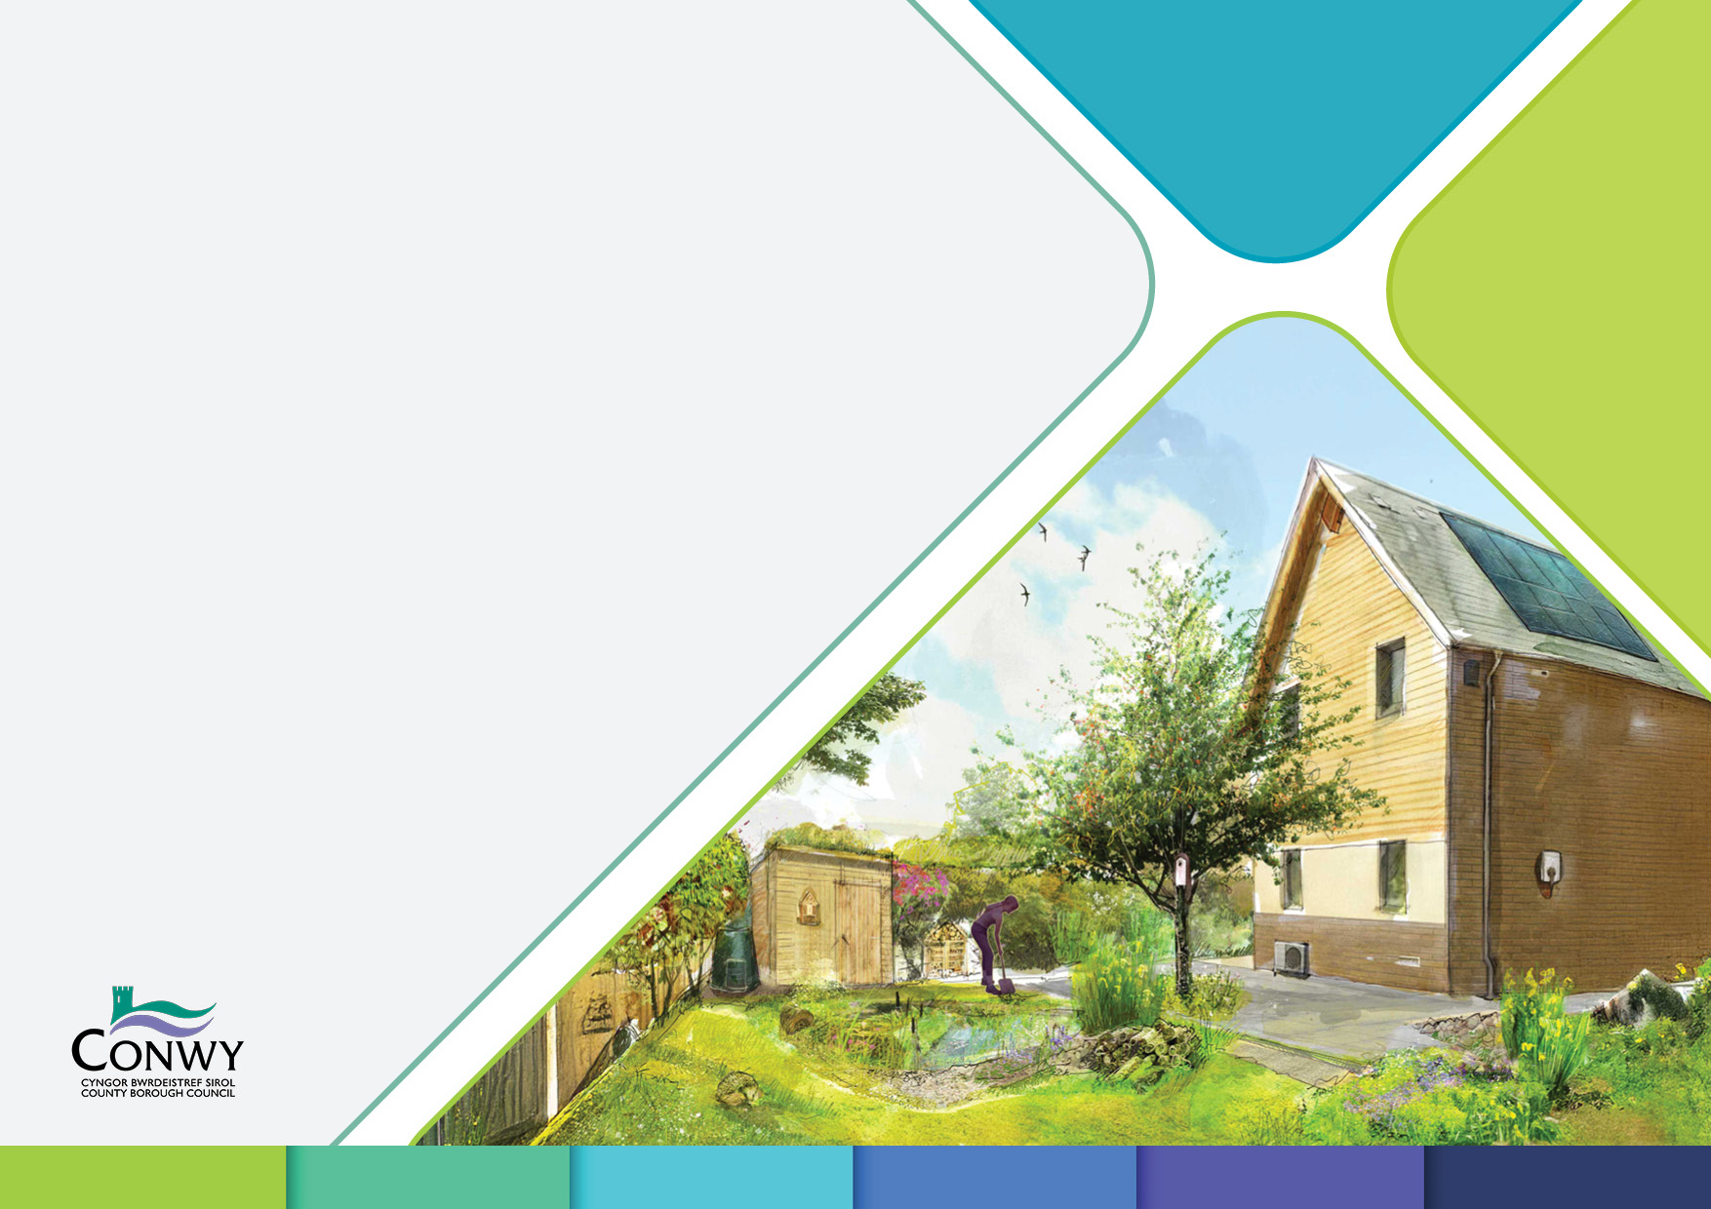

Mae’r ddogfen hon ar gael yn Gymraeg hefyd.

**Green Infrastructure Statement**

**Minor Development**

**Change of Use and Householder applications which impact existing biodiversity and green infrastructure.**

**GREEN INFRASTRUCTURE STATEMENT FORM A green and white circle with arrows and leaves
**

**For Householder Developments, Change of Use, or for a Single Dwelling**

**1 Introduction**

* 1. What is the proposal?

|  |
| --- |
|  |

* 1. Where is the development?

|  |
| --- |
|  |

**2 Green Infrastructure Features and the Step-wise Approach**

**2.1** Please record any surveys done at the site (note: use the date of the actual survey, not the date of report):

|  |  |  |  |
| --- | --- | --- | --- |
| **Survey number** | **Survey title** | **Author** | **Date(s) of survey** |
| 1 |  |  |  |
| 2 |  |  |  |
| 3 |  |  |  |
| 4 |  |  |  |

**2.2** The table below lists most features of ecological/landscape interest that might be found in a single plot/garden.

1. In the "Present on site or at boundary" column, tick (✓) the items that are either on the site itself or at its edge. Add any other features that are present at the end of the table.
2. Work out which features will be affected by the development (try to limit the number and variety of features that will be affected) and tick the. ‘*Will the feature be avoided by the development?*’ box next to the feature that you want to keep. If the feature is not on site, you don't need to tick this box.
3. If features are avoided/retained by the development they must still be protected, please tick the *‘Recommended protective measures to be undertaken’* or write down an alternative way to protect them in section 2.3.
4. If features will be affected by the development there will need to be a mix of protection (for any parts of the feature retained), minimisation/mitigation (to minimise harm and safeguard protected species) and compensation will be required. In the ‘*Step-wise Approach’* boxes, tick off the steps you will take or write down a different plan in section 2.3.

|  |  |  |  |  |  |  |  |  |  |  |
| --- | --- | --- | --- | --- | --- | --- | --- | --- | --- | --- |
|  | **Feature** | **Present on site or at boundary (tick)** | **Will the feature be avoided by the development?** | | **Stepwise approach (tick the recommendations that will be followed)** | | | | | |
| **Avoided (tick)** | **Unavoidable impact(s) (tick)** | **Recommended protective measures to be undertaken** |  | **Recommended Minimisation/**  **mitigation** |  | **Recommended compensation** |  |
| 1 | Hedge (mixed native species) |  |  |  | Retained hedge and a 2m buffer zone will be protected by temporary fencing during construction |  | The impacted length of hedge will be translocated (with hedge bank if present). Note: If hedge is translocated and fails to establish replacement (compensation) planting of native species rich hedgerow will be required. |  | A new native species hedge (with hedge bank if present) will be replanted by the end of the first planting season following (1) the use/occupation of the development or (2) the completion of the development, whichever is the sooner. It will comprise of at least 5 native species and be at least twice the length of the removed hedge. |  |
| Vegetation removal/translocation will be outside bird breeding season (March to August inclusive) or supervised by an ecologist. |  |
| 2 | Pond or ditch (permanent or seasonal) |  |  |  | Retained ditch and a 1m buffer zone or retained pond and its catchment will be protected by temporary fencing as a construction exclusion zone during construction |  |  |  | New wildlife friendly pond to be created on site. This may be integrated with SuDS. New pond must be created before old ditch is removed. |  |
| 3 | Watercourse (flowing water, permanent or seasonal) |  |  |  | Retained watercourse and a 7m buffer zone will be protected by temporary fencing and a construction exclusion zone. NetRegs Pollution prevention measures described in: *‘GPP 5: Works and maintenance in or near water’* will be followed  during construction |  | NetRegs Pollution prevention measures described in: *‘GPP 5: Works and maintenance in or near water’* will be followed |  |  |  |
| 4 | Meadow (grassland/ flowers more than 100mm height for most of the year) |  |  |  | Protected by temporary fencing as a construction exclusion zone. |  | Vegetation removal will follow a reptile and amphibian method statement. |  | Diverse native wildflower rich meadow planting (of at least an equivalent area to that destroyed by proposals will be planted by the end of the first planting season following (1) the use/occupation of the development or (2) the completion of the development, whichever is the sooner. |  |
| 5 | Native species shrub/scrub areas |  |  |  | Retained scrub and a 2m buffer zone will be protected by temporary fencing during construction as a construction exclusion zone. |  | Vegetation removal will be outside bird breeding season (March to August inclusive) or supervised by an ecologist. |  | New native species trees (can include heritage fruit trees) will be planted by the end of the first planting season following (1) the use/occupation of the development or (2) the completion of the development, whichever is the sooner... They will comprise of at least 5 native species and cover an area at least twice the length of the removed scrub. |  |
| 6 | Woodland (on site or at boundary)  *Ancient Woodland is an irreplaceable habitat and adverse impacts must be avoided.* |  |  |  | Root protection area of trees at boundary of woodland will be protected by temporary fencing during construction as a construction exclusion zone. |  | Method statement in the arboricultural survey will be followed. |  | Woodland planting using a variety of pioneer, mid storey and canopy native species typical of lowland broadleaved woodland in NW Wales or permitting defined and protected areas of natural regeneration in areas adjacent to native broadleaved woodland. Woodland planting or regeneration protection to be implemented by the end of the first planting season following (1) the use/occupation of the development or (2) the completion of the development, whichever is the sooner |  |
| 7 | Individual trees (including on site or boundary trees and orchards) |  |  |  | Root protection area of trees will be protected by temporary fencing during construction. |  | Method statement in the arboricultural survey will be followed. |  | New native species trees (can include heritage fruit trees) will be planted by the end of the first planting season at a replacement ratio of 1:3 in first planting season after development. They will comprise of at least 80% native species and be of benefit to our native wildlife. |  |
| 8 | Other |  |  |  |  |  |  |  |  |  |
| 9 |  |  |  |  |  |  |  |  |  |  |
| 10 |  |  |  |  |  |  |  |  |  |  |

**2.3** If not using the recommendations in section 2.2 please describe how the Step-wise Approach will be followed for the features on site:

|  |
| --- |
|  |

**2.4** Please give any additional details of any protection/mitigation/compensation, e.g. planting schedules with number, species, size, protection (or ensure details are shown on site plans):

|  |
| --- |
|  |

**3 Surrounding Green Infrastructure**

**3.1** Describe what is around the site:

|  |
| --- |
|  |

**4 Net Benefit for Biodiversity**

**4.1** What extra features (in addition to compensation measures) will you add to enhance biodiversity (try and relate this to what is on and around the site)? Please tick (✓) what you will do.

|  |  |
| --- | --- |
| **Enhancement** | **Tick** |
| New bat loft or enhancements to existing bat loft (e.g. bigger, adding entrances, adding roost perches) |  |
| Wildlife pond creation |  |
| Creation of permanent 7m watercourse buffer |  |
| Rain garden creation |  |
| Native hedge planting |  |
| New native tree planting (e.g. including heritage fruit trees) |  |
| Remove area of hardstanding/paving and replace with enhancements from this list |  |
| Green roof |  |
| Green wall |  |
| Diverse wildlife friendly planting (this does not need to be all native species) |  |
| Reptile refugia (stones, logs and turf) |  |
| Built-in bird and/or bat box (integrated into construction) |  |
| Built-in bee brick (integrated into construction) |  |
| Other (please specify): |  |

**4.2** Please give more details of enhancements e.g. planting schedule and establishment management, species, size (and/or ensure details are shown on site plans):

|  |
| --- |
|  |

**------------------------------------------------------------------------------------------------------------------------------------------------------------------------------------------------------------------**

**Please ensure all surveys mentioned in section 2.1 are sent in with the application.**

**Site plans must show all features (retained and proposed) described in section 2 and 4.**