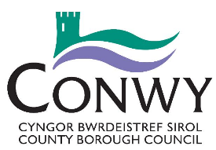
Request for Financial Viability Assessment Advice

For Office Use Only | Ref: | Appointment to be held/Response to be sent (within 10 working days from receiving the form*)
Policy Officer: |  | Other Officers to attend:

Agent Details
Name: |  | Email:
Address |  | Fax:
Telephone
Applicant / Developer Details:
Name: |  | Email:
Address: |  | Fax:
Telephone

* All correspondence will be by email unless you indicate otherwise.

We recommend you utilise the Pre-Application advice service offered via the Development Management Service to gain advice or information about any work you plan to do prior to discussing the viability the scheme.

Have you utilised the Development Management Pre-Application Advice Service Yes / No

If Yes please complete the following information about the advice you were given.

Officer Name:
Reference:
Date of advice: | Click here to enter a date.

Description of Proposed Development:

Required Information

Current Use(s) on site:

Document checklist (please tick the boxes as necessary to confirm that all this information is provided where required. Where required information is not submitted as part of your enquiry it may delay your meeting/letter response):

Site Location Plan

Financial Viability Assessment Pro-forma

Relevant Fee (please see charging schedule)

Cheques should be made payable to Conwy County Borough Council

Declaration:
I confirm that Financial Viability Assessment advice is requested for the above proposal by:

Meeting

Letter

(please indicate as appropriate)

Name (please print):
Signed:
Date: | Click here to enter a date.

