Conwy Family Support Teams / Family Centres
Referral Form
Conwy Family Support Team – Central
(Canolfan Ffordd Douglas)

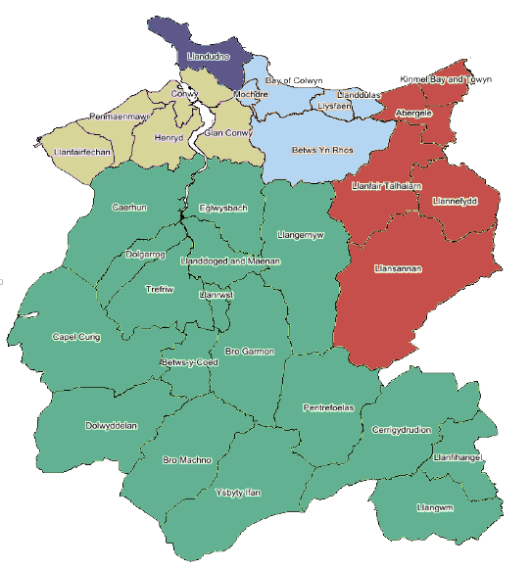
It takes a lot of active people supporting each other to help children become healthy adults.
Conwy Family Support Team – North
(Eryl Wen)

Conwy Family Support Team – East
(Canolfan Dinorben)

Conwy Family Support Team - West

Lots of people and groups across our communities help families, and working together, we continue to help parents and children and young people. We have five Local Family Support Teams, based in Family Centres and the community.
We bring all the support together and focus on what each area needs.
Mae’r ddogfen hon ar gael yn Gymraeg hefyd.

Conwy Family Support Team – South
(Llanrwst Family Centre)
(Office Use) Family Centre: | South ☐ West ☐ East ☐ Central ☐ North ☐
PARENT/CARER DETAILS:
First Name(s): |  | Surname: |  | D.O.B:
First Name(s): |  | Surname: |  | D.O.B:

PRIMARY PARENT/CARER ADDRESS:

Address:
Post Code: |  | Email:
Home Phone No: |  | Mobile Phone No:
Preferred Language: | Welsh ☐ English ☐ Other ☐ If Other, please Specify: _____________________
Ethnicity (if known):
Preferred Method of Contact: | Phone ☐ Text ☐ Joint Visit with Referrer ☐ Letter ☐

NAMES OF CHILDREN AND OTHERS IN HOUSEHOLD:
Name: | D.O.B: | Gender (male/female/prefer not to say): | Person with Parental Responsibility: | School/ Childcare Setting/ Midwife/ Health Visitor/ School Nurse: | Disability/ Additional Learning Needs:

ANY LONE WORKER ISSUES? | Yes ☐ No ☐
If yes, please identify the risks and any mitigating actions required:

REASON FOR REFERRAL (including what matters to the family):
Any other agencies involved?

REFERRER DETAILS:
First Name(s): |  | Surname:
Agency/Service: |  | Position/Role:
Contact Number: |  | Email Address:

REFERRER SIGNATURE: |  | DATE:
SIGNATURE OF FAMILY (If available) |  | DATE:
CONSENT:
Has the family agreed to this referral? Yes ☐ No ☐

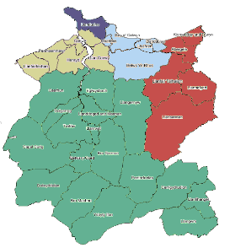
Please complete and send to your nearest Conwy Family Support Team:
(Please note that families can choose which Support Team or Centre they would like to access)
Team | Based at | Postal address | Email | Contact number | Areas covered
Family Support Team – South | Llanrwst Family Centre  Watling Street  Llanrwst  LL26 0LS | Llanrwst Family Centre  Church House,  Watling Street  Llanrwst  LL26 0LS | FamilySupport.South@conwy.gov.uk | 01492 574140 | Rural areas
Family Support Team – East | Canolfan Dinorben  Faenol Avenue  Abergele  LL22 7HT | Canolfan Dinorben  Faenol Avenue  Abergele  LL22 7HT | FamilySupport.East@conwy.gov.uk | 01492 577757 | Kinmel Bay Towyn, Abergele Llansannan  Llanefydd  Llanfair TH
Family Support Team – Central | Canolfan Ffordd Douglas  3 Douglas Road  Colwyn Bay  LL29 7PE | Canolfan Ffordd Douglas  3 Douglas Road  Colwyn Bay  LL29 7PE | FamilySupport.Central@conwy.gov.uk | 01492 576503 | Colwyn Bay  Old Colwyn  Mochdre  Betws yn Rhos  Llanddulas Llysfaen
Family Support Team – North | Eryl Wen (Interim)  Eryl Place  Llandudno  LL30 2TX | Eryl Wen  Eryl Place  Llandudno  LL30 2TX | FamilySupport.North@conwy.gov.uk | 01492 574732 | Llandudno  Penrhyn Bay
Family Support Team – West | Bodlondeb Offices (Interim)  Room 101  Bangor Rd  Conwy  LL32 8DU | Bodlondeb Offices  Room 101  Bangor Rd  Conwy  LL32 8DU | FamilySupport.West@conwy.gov.uk | 01492 574546 | Llandudno Junction Deganwy,  Conwy Penmaenmawr  Llanfairfechan,  Glan Conwy

