|  |  |  |  |  |  |  |  |  |  |  |  |  |  |  |  |  |  |  |  |  |  |  |  |  |  |
| --- | --- | --- | --- | --- | --- | --- | --- | --- | --- | --- | --- | --- | --- | --- | --- | --- | --- | --- | --- | --- | --- | --- | --- | --- | --- |
| **please refer to the flying start outreach referral guidance to support with completing this application**  **Once completed, please email to:** [fs-outreach@conwy.gov.uk](mailto:fs-outreach@conwy.gov.uk) | | | | | | | | | | | | | | | | | | | | | | | | | |
| 1. **CHILD’S DETAILS** | | | | | | | | | | | | | | | | | | | | | | | | | |
| **Child’s first name** | | | |  | | | | | | **Child’s surname** | | | | | | |  | | | | | | | | |
| **D.O.B.** | | | |  | | | | | | **Main language spoken in the home** | | | | | | |  | | | | | | | | |
| **Ethnicity (including Gypsy, Roma or traveller)** | | | |  | | | | | | **Any Disability or Additional Learning Needs? Please state** | | | | | | |  | | | | | | | | |
| **2. PARENT’S DETAILS** | | | | | | | | | | | | | | | | | | | | | | | | | |
| **Name of parent/carer with parental responsibility** | | | |  | | | | | | **Relationship to child** | | | | | | |  | | | | | | | | |
| **Home telephone** | | | |  | | | | | | **Mobile telephone** | | | | | | |  | | | | | | | | |
| **CURRENT**  **Postal Address**  **Post Code** | | | |  | | | | | | **PREVIOUS\***  **Postal Address**  **Post Code** | | | | | | | (*if moving from a Flying Start area) | | | | | | | | |
| **3. DETAILS OF PERSONS IN CURRENT HOUSEHOLD** | | | | | | | | | | | | | | | | | | | | | | | | | |
| **First name** | | | **Surname** | | | | | | **Relationship to child** | | | | **D.O.B.** | | | | | | | | **School / Employment / Childcare setting** | | | | |
|  | | |  | | | | | |  | | | |  | | | | | | | |  | | | | |
|  | | |  | | | | | |  | | | |  | | | | | | | |  | | | | |
|  | | |  | | | | | |  | | | |  | | | | | | | |  | | | | |
| **4. SIGNIFICANT OTHERS – NOT IN HOUSEHOLD** | | | | | | | | | | | | | | | | | | | | | | | | | |
| **First name** | | | **Surname** | | | | | | **Relationship to child including if any parental responsibility** | | | | **D.O.B.** | | | | | | | | **School / Employment / Childcare setting** | | | | |
|  | | |  | | | | | |  | | | |  | | | | | | | |  | | | | |
|  | | |  | | | | | |  | | | |  | | | | | | | |  | | | | |
|  | | |  | | | | | |  | | | |  | | | | | | | |  | | | | |
| **5. REFERRER DETAILS** | | | | | | | | | | | | | | | | | | | | | | | | | |
| **Referrer name** | | | |  | | | | | | **Role/Relationship** | | | | | | |  | | | | | | | | |
| **Contact telephone** | | | |  | | | | | | **E-mail address** | | | | | | |  | | | | | | | | |
| **6. YOUR CONCERNS**  **please record your concerns regarding this child/family** | | | | | | | | | | | | | | | | | | | | | | | | | |
|  | | | | | | | | | | | | | | | | | | | | | | | | | |
| **7. YOUR INVOLVEMENT**  **please provide information below as to your involvement with the family** | | | | | | | | | | | | | | | | | | | | | | | | | |
|  | | | | | | | | | | | | | | | | | | | | | | | | | |
| **9. RELEVANT PROFESSIONALS**  **please provide names of any other known professionals** | | | | | | | | | | | | | | | | | | | | | | | | | |
| **GP/Surgery** | | | |  | | | | | | **Family Centre / Family Support Team** | | | | | | |  | | | | | | | | |
| **Community Midwife** | | | |  | | | | | | **Health Visitor**  **(current and previous if applicable)** | | | | | | |  | | | | | | | | |
| **Social Worker** | | | |  | | | | | | **Any other agencies involved** | | | | | | |  | | | | | | | | |
| **9. OTHER AGENCIES INVOLVED** | | | | | | | | | | | | | | | | | | | | | | | | | |
| **Name** | | | **Agency** | | | | | | **Role** | | | | **Contact Details (email address, telephone)** | | | | | | | | **Period of involvement** | | | | |
|  | | |  | | | | | |  | | | |  | | | | | | | |  | | | | |
|  | | |  | | | | | |  | | | |  | | | | | | | |  | | | | |
|  | | |  | | | | | |  | | | |  | | | | | | | |  | | | | |
|  | | |  | | | | | |  | | | |  | | | | | | | |  | | | | |
|  | | |  | | | | | |  | | | |  | | | | | | | |  | | | | |
|  | | |  | | | | | |  | | | |  | | | | | | | |  | | | | |
|  | | |  | | | | | |  | | | |  | | | | | | | |  | | | | |
|  | | |  | | | | | |  | | | |  | | | | | | | |  | | | | |
|  | | |  | | | | | |  | | | |  | | | | | | | |  | | | | |
| **10. ADVERSE CHILDHOOD EXPERIENCES (ACE’s)**  **if appropriate to ask, have any members of the family been exposed to any of the following adverse childhood experiences? (please tick all relevant boxes)** | | | | | | | | | | | | | | | | | | | | | | | | | |
| **Verbal Abuse** | |  | | | | | **Parental Separation** | | | |  | | | | | **Alcohol Abuse** | | | | | | |  | | |
| **Physical Abuse** | |  | | | | | **Domestic Violence** | | | |  | | | | | **Drug Use** | | | | | | |  | | |
| **Sexual Abuse** | |  | | | | | **Mental Illness** | | | |  | | | | | **Incarceration** | | | | | | |  | | |
| **Emotional Neglect** | |  | | | | | **Physical Neglect** | | | |  | | | | |  | | | | | | | | | |
| **11. CHILD’S DEVELOPMENTAL NEEDS (e.g. physical, mental, emotional, social, relational, language, self-care) including relevant current interventions and services involved for developmental needs** | | | | | | | | | | | | | | | | | | | | | | | | | |
|  | | | | | | | | | | | | | | | | | | | | | | | | | |
| **12. PARENTAL CAPACITY (e.g. basic care, stability, emotional warmth, ensuring safety etc.)** | | | | | | | | | | | | | | | | | | | | | | | | | |
|  | | | | | | | | | | | | | | | | | | | | | | | | | |
| **13. FAMILY AND ENVIORONMENTAL FACTORS (e.g. income, housing, wider family, family history and functioning etc.)** | | | | | | | | | | | | | | | | | | | | | | | | | |
|  | | | | | | | | | | | | | | | | | | | | | | | | | |
| **14. RISKS (e.g. lone worker risks, safeguarding issues)** | | | | | | | | | | | | | | | | | | | | | | | | | |
|  | | | | | | | | | | | | | | | | | | | | | | | | | |
| **15. FLYING START**  **has the family had access to flying start services in the past? if so please provide details of previous support** | | | | | | | | | | | | | | | | | | | | | | | | | |
|  | | | | | | | | | | | | | | | | | | | | | | | | | |
| **16. VIEWS OF THE FAMILY**  **please provide information on what matters and what is important to the family (*from their view*), and outcomes they wish to achieve through outreach support** | | | | | | | | | | | | | | | | | | | | | | | | | |
|  | | | | | | | | | | | | | | | | | | | | | | | | | |
| **17. ELEMENTS OF FLYING START**  **please tick which of the flying start elements you would like to refer for outreach using “x” (please see attached guidance)** | | | | | | | | | | | | | | | | | | | | | | | | | |
| **Health Visiting** |  | | | | **Childcare** | | |  | | | | **Speech & Language** | | |  | | | | | **Family Support/ Parenting including groups** | | | |  | |
| **please complete relevant sections for each of the above elements that have been requested. the sections will expand whilst completing** | | | | | | | | | | | | | | | | | | | | | | | | | |
| **18. HEALTH VISITING**  **to qualify for flying start enhanced health visiting, the family must be intensive or enhanced levels of support. please advise below the level of support** | | | | | | | | | | | | | | | | | | | | | | | | | |
| **INTENSIVE** | | | |  | | | | | | | **ENHANCED** | | | | | | |  | | | | | | | |
| **please document below how flying start health visiting could support the family including child’s development needs. please consult with the current health visitor about whether they support this flying start outreach request and include details here.** | | | | | | | | | | | | | | | | | | | | | | | | | |
|  | | | | | | | | | | | | | | | | | | | | | | | | | |
| **19. CHILDCARE**  **flying start childcare through outreach services is given in exceptional circumstances, please advise below the reasons behind requesting childcare** | | | | | | | | | | | | | | | | | | | | | | | | | |
|  | | | | | | | | | | | | | | | | | | | | | | | | | |
| **20. SPEECH, LANGUAGE & COMMUNICATION**  **flying start programme offers additional support parent/carers to become more confident in supporting their child’s learning. portage service for children with additional needs will only be considered if there is a copy of the schedule of growing skills (sogs).** | | | | | | | | | | | | | | | | | | | | | | | | | |
|  | | | | | | | | | | | | | | | | | | | | | | | | | |
| **21. FAMILY SUPPORT / PARENTING INCLUDING GROUPS**  **please note that in conwy family and parenting support is available on an equal basis across the county. the family support worker will conduct a ‘what matters’ conversation with the family through using our family wellbeing tool. is the family already involved with a local family support team / family centre activities that you know of?** | | | | | | | | | | | | | | | | | | | | | | | | | |
|  | | | | | | | | | | | | | | | | | | | | | | | | | |
| **22. ANY ADDITIONAL INFORMATION TO SUPPORT THIS APPLICATION** | | | | | | | | | | | | | | | | | | | | | | | | | |
|  | | | | | | | | | | | | | | | | | | | | | | | | | |
| **23. SIGNATURE AND CONSENT OF REFERRER AND PARENT/CARER** | | | | | | | | | | | | | | | | | | | | | | | | | |
| **Do you, the parent/carer, agree for this referral to be made, and also agree the information above is correct?** | | | | | | | | | | | | | | | **Yes** | |  | | | | | **No** | | |  |
| **Signature of parent/carer with parental responsibility** | | | | | |  | | | | | | | | **Date** | | | | |  | | | | | | |
| **Signature of referrer** | | | | | |  | | | | | | | | **Date** | | | | |  | | | | | | |
| **PRIVACY NOTICE** | | | | | | | | | | | | | | | | | | | | | | | | | |

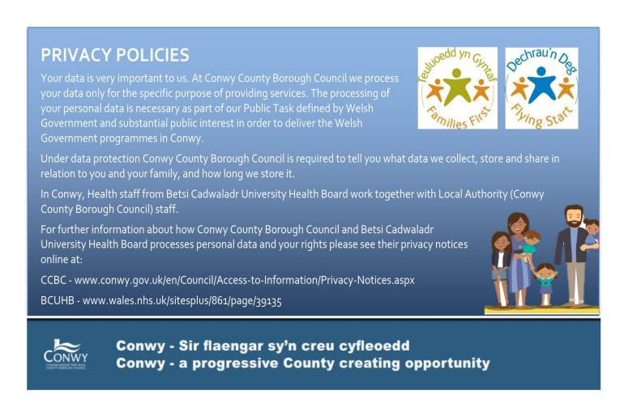Once completed, please email to: [fs-outreach@conwy.gov.uk](mailto:fs-outreach@conwy.gov.uk)

**For office use only: Decision Summary**