### Sent on behalf of Welsh Government

|  |
| --- |
| Dr Frank Atherton Prif Swyddog Meddygol/Cyfarwyddwr Meddygol, GIG Cymru Chief Medical Officer/Medical Director NHS Wales & Albert Heaney Dirprwy Gyfarwyddwr Cyffredinol / DeputyDirector General Y Grŵp Iechyd a Gwasanaethau Cymdeithasol Health and Social Services Group |

5th June 2020

To: Chief Executives of Health Boards and Local Authorities  
Directors of Public Health

Dear Colleagues

**Testing to prevent Covid-19 in care homes in Wales**

We want to thank you for all your hard work to ensure that care homes in Wales are provided with the support they need to minimise harm of Covid-19 on the vulnerable residents in their care. This letter is to advise you on the proposed testing arrangements for care homes going forward.

Your priority of course will be to provide a prompt response to those care homes who report a possible case as this will have the greatest benefit in terms of reducing transmission risk. The introduction of Test, Track and Protect does not change outbreak detection and management arrangements.

Most of you will by now be completing the testing of staff and residents in your care homes. It is important that as we go forward we have a system in place to detect possible introduction of Covid-19 into care homes. At the Antigen Testing Group meeting held on June 3rd it was agreed that from Monday 15th June all care home staff will be offered a weekly test for a four week period. These will be self-administered swabs acquired either through the Care Home Portal or directly from the health board.

We are keeping the need for testing of care home staff under review because for any given test (i.e. sensitivity and specificity remain the same) as prevalence of infection decreases, the Positive Predictive Value decreases because there will be more false positives for every true positive.

Many thanks for your ongoing support.

Kind regards

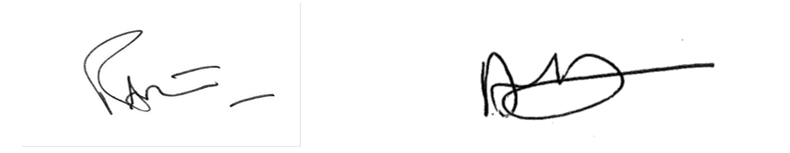

**Dr Frank Atherton                                              Albert Heaney**  
**Chief Medical Officer                                         Deputy Director General**

CC:  
Chief Executive Local authorities  
Chief Executive, PHW  
Social care Planning & Response Sub-group  
Older People’s Commissioner  
Children’s Commissioner  
National Commissioning Board  
Directors of Social Services  
Registered Providers and Responsible Individuals of Care Home Services in Wales (adults  
and children)