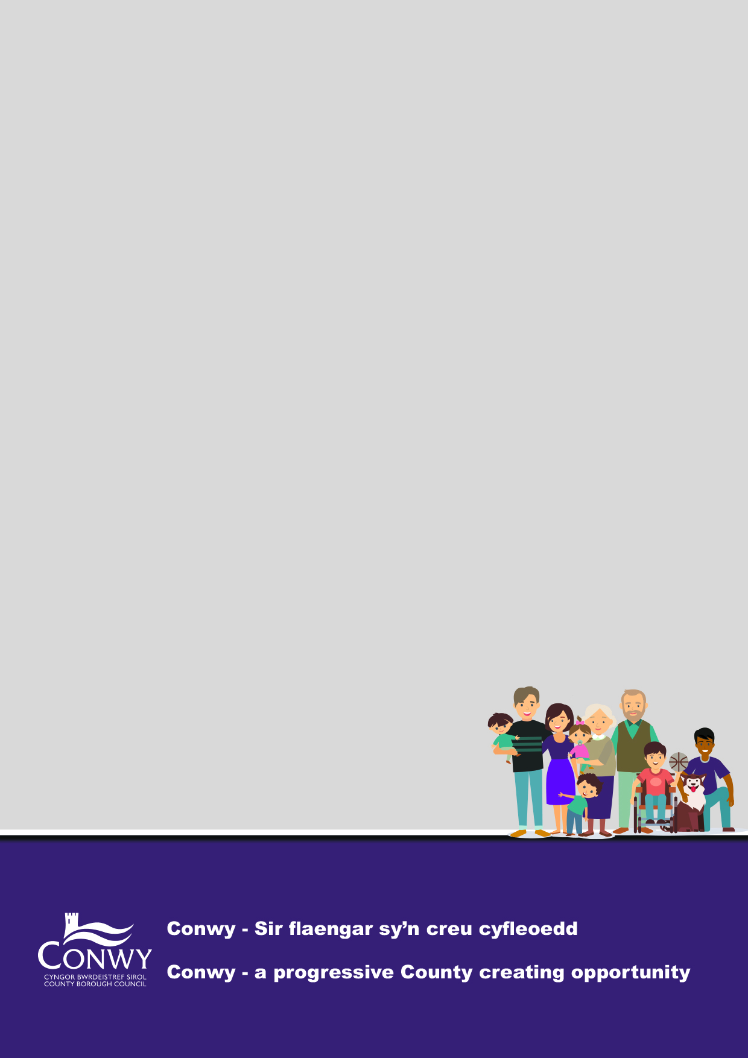
Supporting Information

What is each of the themes about?
Outcome 1 - People are educated and skilled
Focus Area | We want Conwy to be recognised as offering an excellent education. We will focus on improving education and performance across the whole school system so that young people are skilled for job opportunities.
These are the themes we were told about last time | - Improve skills for employment - identify what is needed locally  - Be ready for future employment opportunities across the region  - Making sure school leavers are ready for work, not just with qualifications but practical  - There is a lack of local employment & diversity of Jobs  - Young people leave the area for work

Outcome 2 - People are safe and feel safe
Focus Area | Together we will do our best to ensure vulnerable people are safeguarded.
These are the themes we were told about last time | - Support for carers of all ages  - Tackling loneliness and isolation  - Support/ promote volunteering  - Joined up Mental Health Services  - Parenting support for parents/guardians  - Negative impacts of social media  - Intergenerational Tensions  - Drug & alcohol issues  - Anti-social behaviour (evenings & night time)

Outcome 3 - People have good quality homes they can afford and that make their lives better
Focus Area | We want residents to live in accommodation that supports their positive health and well-being.
These are the themes we were told about last time | - Improve availability of housing:  - housing costs  - Location  - mix  - Don’t overdevelop where other facilities (transport/ schools etc) can’t support the additional numbers  - Tackle affordability for younger people in particular  - Housing conditions are still a problem

Outcome 4 - People are healthy and active
Focus Area | We will focus on actions to promote healthy choices and lifestyles and in turn, reduce the demand on public services.
These are the themes we were told about last time | - Tackle Childhood obesity and unhealthy lifestyles  - Protect and promote leisure facilities and green/ play spaces  - Provide and encourage intergenerational opportunities  - Make leisure facilities (indoor and the countryside) accessible  - Support people with drug & alcohol issues

Outcome 5 - People live in a county which has a prosperous economy
Focus Area | We want the local economy to be confident, resilient and sustainable. We will encourage new ideas and we will work proactively with businesses to promote conditions in which they can grow.
These are the themes we were told about last time | - There is a lack of opportunities for young people and many leave the area  - Support young people with skills and job readiness  - More employment opportunities needed for disabled people  - There is a lack of job variety outside tourism & hospitality  - Support other key sectors – Agriculture & Health  - Invest in businesses – rural and start ups  - Improve connectivity - Broadband and Transport

Outcome 6 - People value and look after the environment
Focus Area | We want communities to be resilient and ready to adapt to the environmental challenges the world faces. We will focus on improving flood defence, increasing recycling and investing in renewable energy.
These are the themes we were told about last time | - Address Flooding and Climate Change  - Balance nature conservation with the development needs  - Maximise our natural assets  - Reduce waste and recycle more  - Look after roads and pavements  - Support communities with local facilities  - Addressing dog fouling hotspots

Outcome 7 - People live in a county where heritage, culture and the Welsh language thrive
Focus Area | We will focus on celebrating our culture and using the arts to maximise well-being.
These are the themes we were told about last time | - Maintain cultural sites, leisure facilities and green spaces including green spaces for children  - Support community assets – look at how we can improve accessibility and affordability  - Focus on activities that encourage Intergenerational opportunities  - Balance development with protecting cultural identity and language and not overwhelming local facilities  - Support Welsh language in communities  - Rethink how Welsh is taught in schools – to be more like modern languages

Outcome 8 - People are informed, included, listened to and can add to their community
Focus Area | We will focus on reviewing the way we engage, communicate and work with communities. We will change the way we work to be more progressive, modern and efficient.
These are the themes we were told about last time | - Simplify communication- use friendly and approachable language  - Respecting view and listening is important  - Be more representative of local communities  - Be more aware of sensory loss needs

