Booking training corses through Employee Self Service

To book any training that is on the Corporate Plan, or managed through Social Services Workforce team, you will need to use this online system for authoirsation. Paper request forms will no longer be accepted if the employee has self service log in details.

Log in to Employee Self Service using your Payroll number as your username and the password you have previously set up. Please contact trent.helpdesk@conwy.gov.uk if you do not know your log in details.

Once logged in, you will see the Self Service home screen. Click on Career & Development in the top ribbon.

In the Learning Activities section, click on ‘Search Courses’
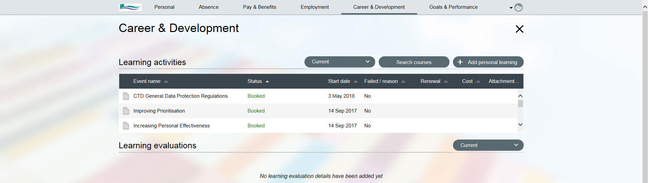

Add the name of the course in the ‘Search for’ box including CTD, CHS, SS, etc. If you are unsure of the exact name of the course, use a * to assist with the search, e.g. *Corporate will look for anything with Corporate in the title.

Any courses which match the search criteria will appear below the criteria. Click on the required course and click on Search in the bottom right corner.

Select which event you would like to attend. There may only be one event in your search criteria.

Course Booking Details page will appear and you must complete the three mandatory fields, which include your learning objectives. Click on ‘Save’.

Once you have click on ‘Save’, your manager will receive an e-mail to authorise the request. N.B. You place is not confirmed on the course until your manager has authorised your request. You will receive the appropriate confirmation e-mail when manager authorises or not authorises the request.

