Editing Netscaler Gateway Connections

During the initial move to Netscaler Gateway staff have made mistakes entering their connection details, or choosing the correct certificate when asked.
The original Netscaler Gateway guide is available on the intranet. If you are having problems logging on you can edit the connection details to correct the error.

- Before logging on your Netscaler Gateway plugin screen looks like this. Click the three bars to the left of the Login option on the top
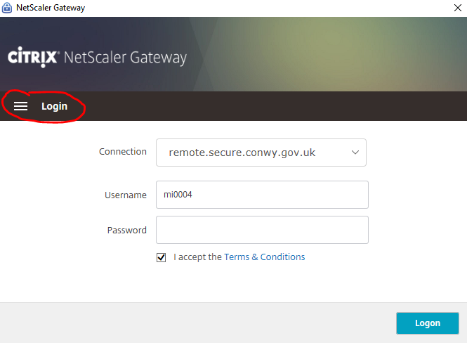
- In the drop-down menu, click Connection
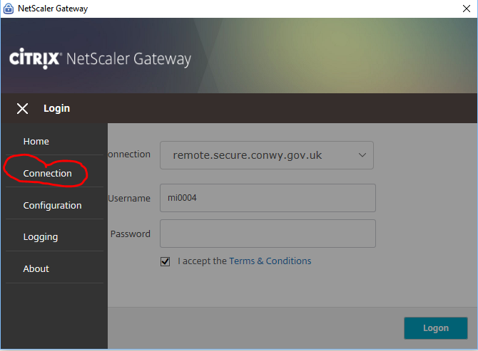

- Move your mouse to the right hand side and a pencil icon should appear. Click this
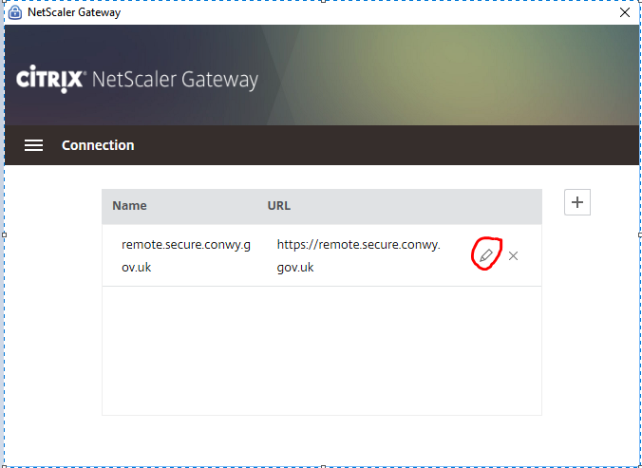
- a. If you are getting a white web page asking you to install java, tick the “clear user certificate” box.
b. If you are getting a spinning icon and failing to log on, make sure the Gateway URL is correct – https://remote.secure.conwy.gov.uk.

Click Save, then go back to the Home menu and try re-connecting. When you are prompted make sure you select the certificate with your USERNAME (eg ZA0014 or RoberZ). DO NOT choose the one with your email address (zack.roberts@conwy.gov.uk)

