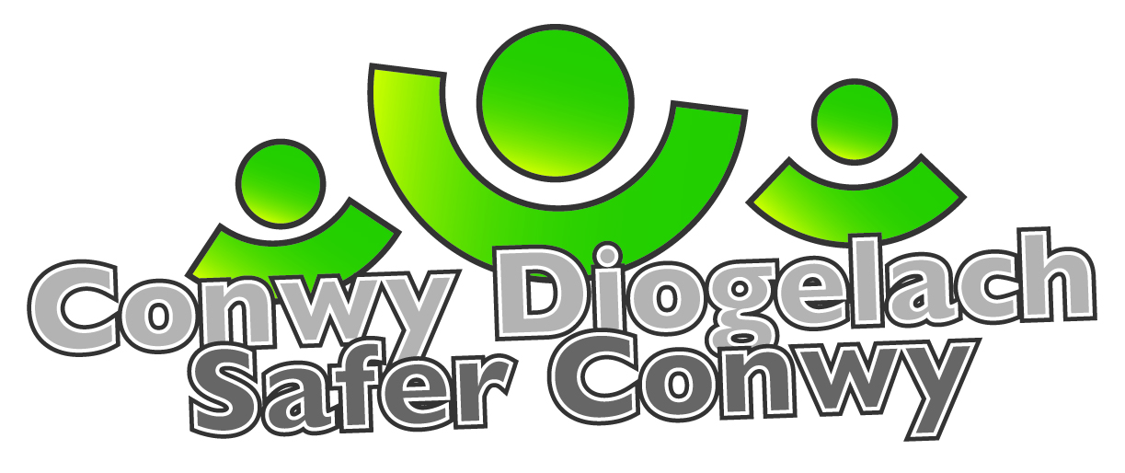
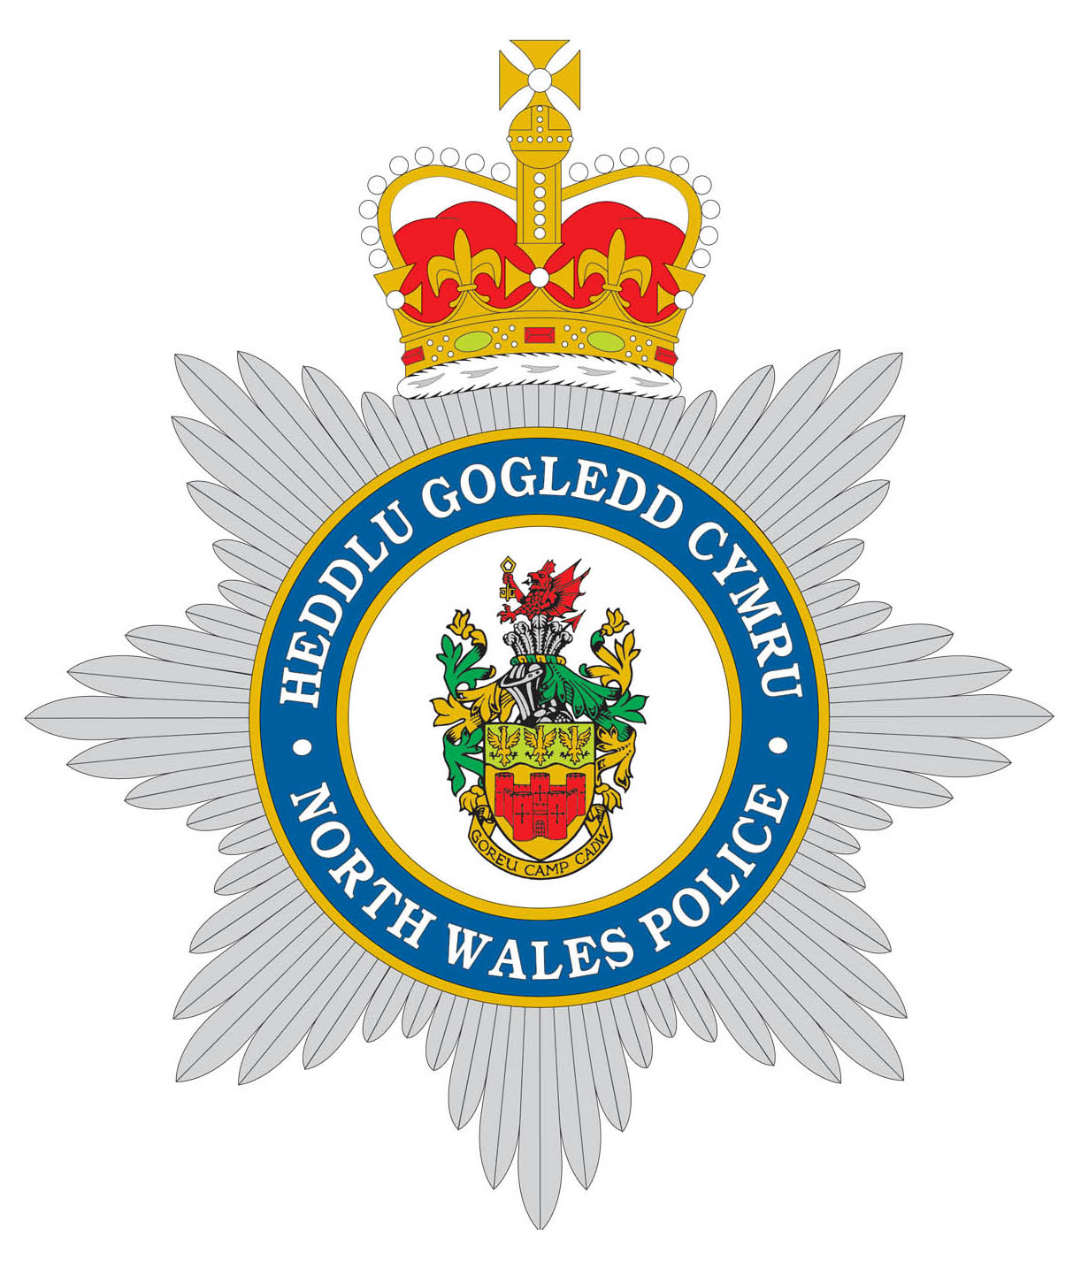 | Prif Switsfwrdd / Main Switchboard: 01492 574000  www.conwy.gov.uk  Ni ddylid cyflwyno dogfennau llys drwy ffacs  Fax not to be used for serving proceedings  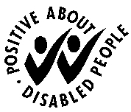 | 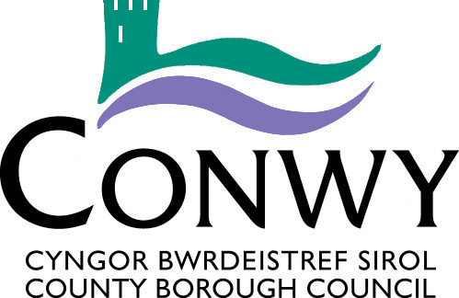

RESIDENT / BUSINESS OWNER  CONFIDENTIAL |  | Gofynnwch am / Please ask for: |  | Rhian Owen
 |  |  | 01492 575177
 |  | 
 |  |  | saferconwy@conwy.gov.uk
 |  | Ein Cyf / Our Ref: |  | ASB/SR408919
 |  | Eich Cyf / Your Ref:
 |  | Dyddiad / Date: |  | March 2022

Dear Resident / Business Owner

PROPOSED PUBLIC SPACE PROTECTION ORDER – CONWY TOWN

As a resident or business owner in the area you may be aware of issues of anti-social behaviour associated with people drinking alcohol on the streets in Conwy town.

Historically, all 30 mph limit areas in Conwy County were covered by a Designated Public Place Order (DPPO). This allowed Police Officers and Police Community Support Officers from North Wales Police to request any person found to be drinking alcohol within restricted areas to stop, failure to do so being an offence. Officers could also confiscate and or dispose of anything they reasonably believed to be alcohol. This was not a “no drinking zone” however could be applied where Officers felt that the persons involved were causing or were likely to cause anti-social behaviour in the area.

The DPPO legislation was replaced by the Anti-social Behaviour Crime & Policing Act 2014 Public Space Protection Orders (PSPOs). All DPPOs previously in force expired in 2020.

North Wales Police and Conwy County Borough Council are jointly seeking measures to address this behaviour for the benefit of residents and visitors in the area.

PSPOs enable Local Authorities to impose prohibitions or requirements to specified areas to enable law abiding citizens to enjoy public space areas without being affected by anti-social behaviour.

We are therefore contacting you as part of the required consultation process for the application for the enclosed proposed Public Spaces Protection Order for this area.

The consultation period will be open for 6 weeks from the 14th March 2022, the closing date for representations will be the 25th April 2022.

If you wish to object to the proposed Order you should please do so in writing, stating the reasons for your objection, by email to SaferConwy@conwy.gov.uk or by post to The Head of Regulatory and Housing Services, Conwy County Borough Council, PO Box 1, Conwy LL30 9GN.

If you have any queries about the proposed Public Spaces Protection Order please do not hesitate to contact us on the details at the top of this letter.

Yours sincerely

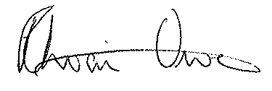
Rhian Owen
Swyddog Ymddygiad Gwrthgymdeithasol
Anti-social Behaviour Officer

