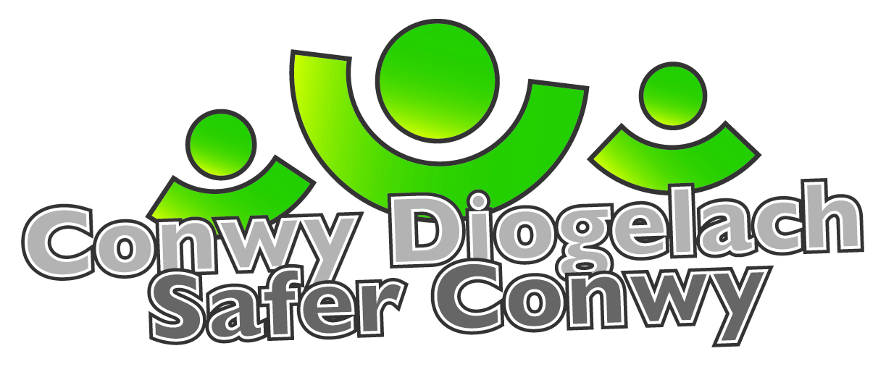

Conwy Diogelach / Safer Conwy
Ymddygiad Gwrthgymdeithasol / Anti-social Behaviour
Gwasanaeth Rheoleiddio a Thai / Regulatory Services
Pennaeth Gwasanaeth/Head of Service – Peter Brown

Cyfeiriad Post / Postal Address: Blwch Post 1, CONWY, LL30 9GN
PO Box 1, CONWY, LL30 9GN

Gweithio gyda’n gilydd i wneud ein cymuned yn ddiogelach
Working together to make our community safer
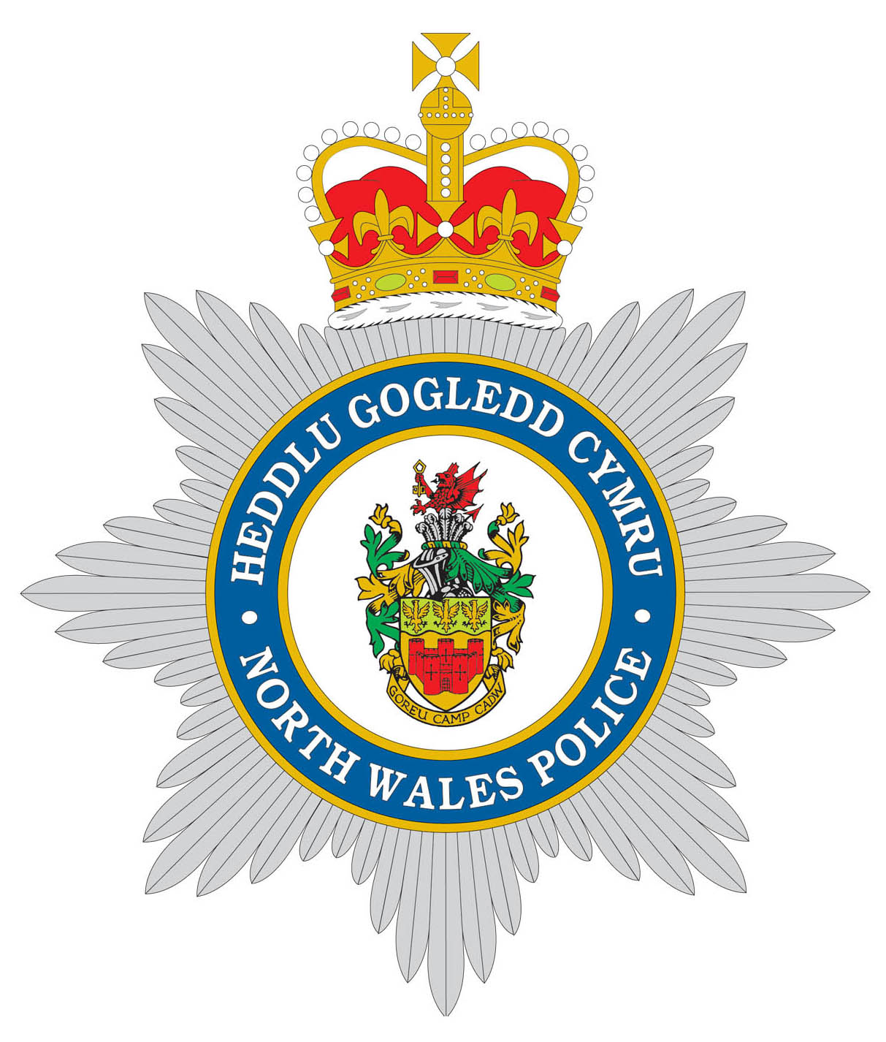 | Prif Switsfwrdd / Main Switchboard: 01492 574000  www.conwy.gov.uk  Ni ddylid cyflwyno dogfennau llys drwy ffacs  Fax not to be used for serving proceedings

Preswylydd / Resident  LLandudno  Maes Colwyn Bay  Conwy | Gofynnwch am / Please ask for: Emma Dowell
 |  | 01492 575113
 |  | saferconwy@conwy.gov.uk
 | Ein Cyf / Our Ref: Maesdu Bridge/Cae Mawr
 | Eich Cyf / Your Ref:
 | Dyddiad / Date: Ionawr / April 2024

Dear Resident

TEMPORARY CCTV CAMERA – Maesdu Bridge/Bryniau Road

Proposed location is on Maesdu Bridge overlooking Green area rear of Cae Mawr.

We are writing to inform you that Conwy County Borough Council are considering the installation of a temporary Public Space CCTV Camera at a location near you as shown below;

Figure 1; Google image with proposed location Figure 2; Actual privacy zone on a current camera view
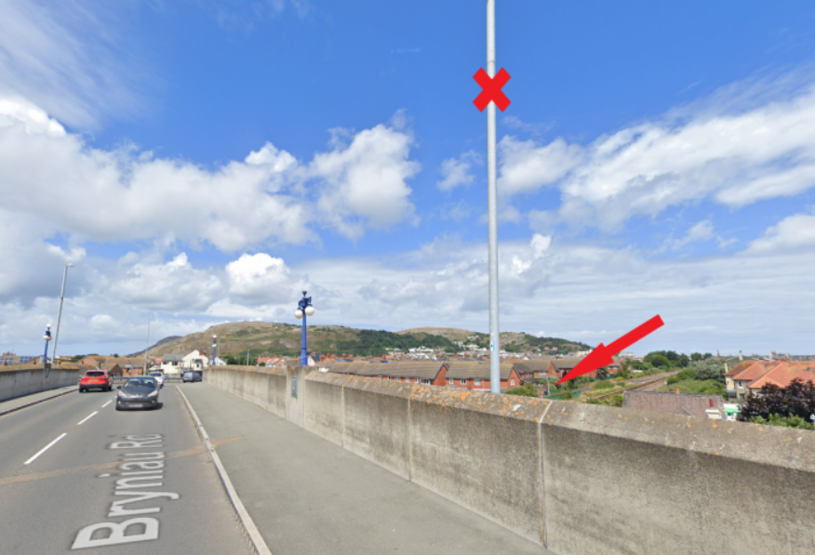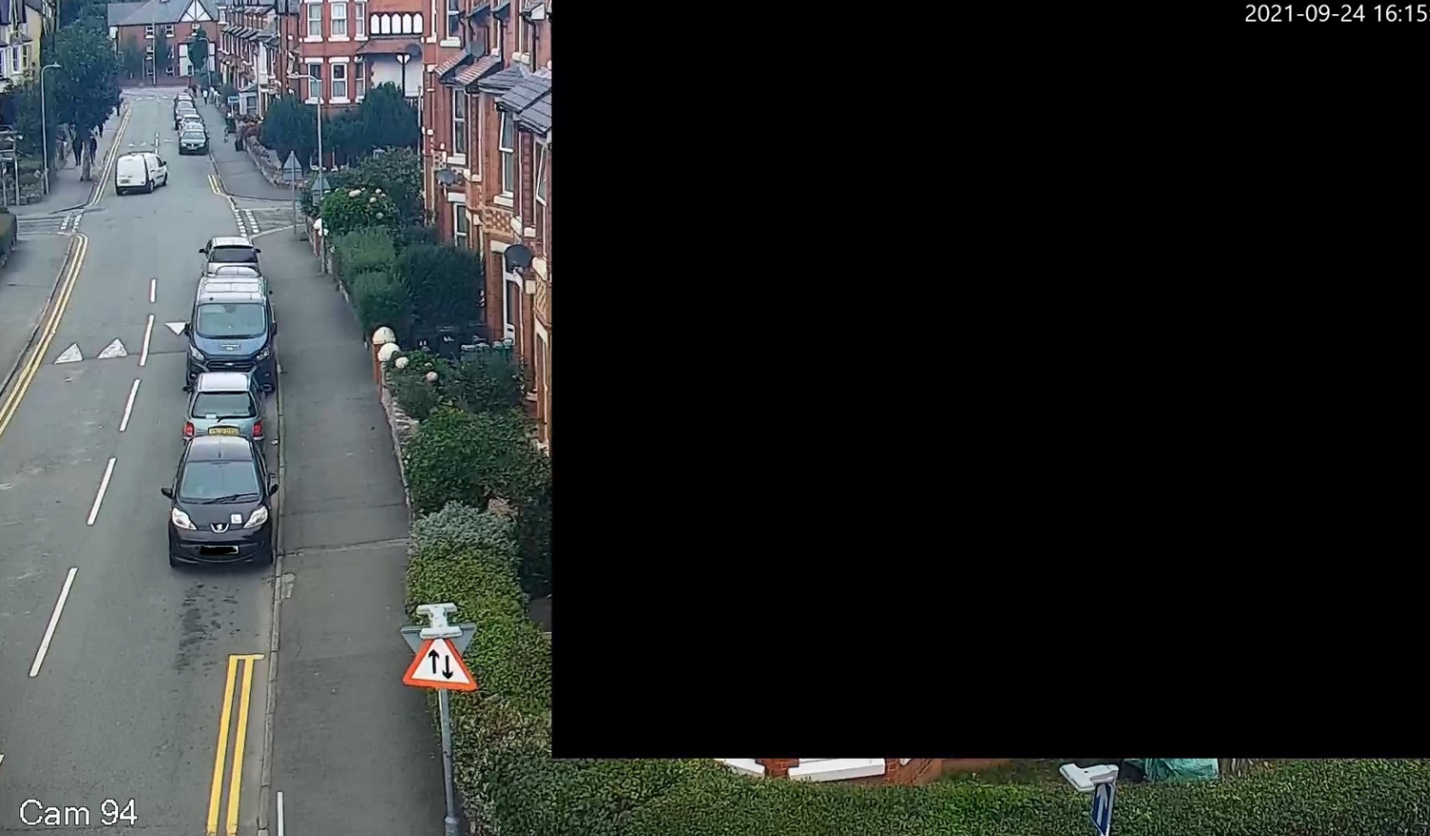

The installation of these cameras is being funded from a ‘Better Open Spaces Project’ which forms part of the government’s concerted action to improve local areas What is Levelling Up? - Levelling Up

As your home falls within the area of proposed camera we are giving you the opportunity to feed in your views please. We wish to reassure you that any windows of property directly adjacent to a CCTV camera will be screened by using privacy zones (black squares as in example above) making it impossible for any operator to breach your privacy. Conwy County Borough Council Full Privacy Notice

If you wish to comment in response to this consultation, please contact the Conwy CCTV Manager using the contact at the top of this letter.

