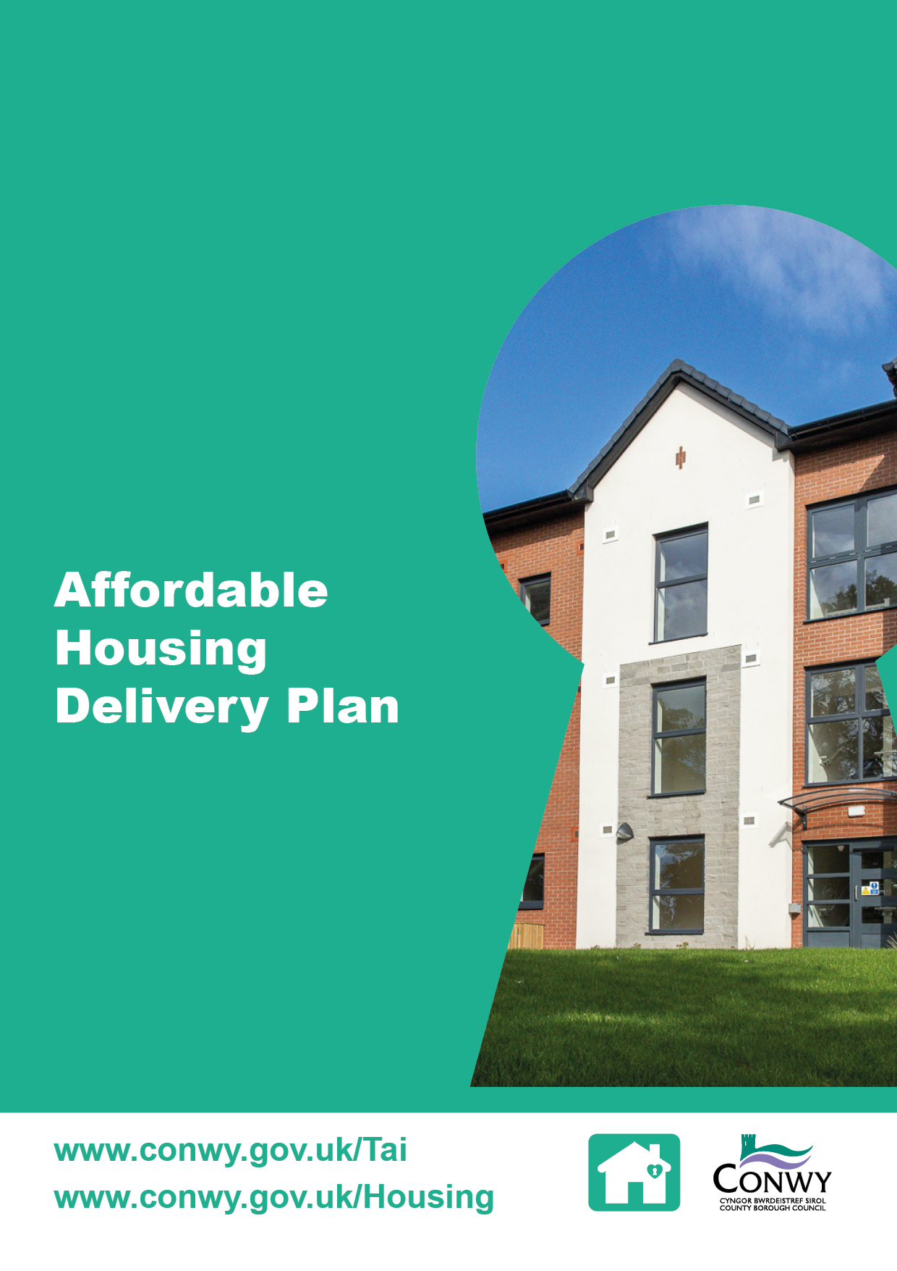

Contents

1 Introduction 1
2 Core Objectives by Focus Area 1
Focus area 1: Welsh Government Capital Grant Programme
(New Build and Existing Stock) 1
Focus area 2: Council Owned Sites 1
Focus area 3: Private Sector Accommodation 2
Focus area 4: Policy and Procedures 2
3 Resources 2
Staffing 2
Council Land 2
Welsh Government Leasing Scheme Wales 2
Partnership Working 2
4 Monitoring Success 3
Key Performance Indicators (KPIs) 3
Partnership Working 3
Communication 3
5 Implementation and Governance 4
Appendix 1 - Action Plan 5

1 Introduction

The Affordable Housing Delivery Plan (the Plan) sets out Conwy County Borough Council’s strategic approach to increasing the supply of affordable housing with a clear focus on collaboration and the provision of appropriate permanent social housing that meets the Welsh Government quality standards. It supports the delivery of the Local Housing and Homelessness Strategy, with the aim to ensure that the supply of affordable housing meets local housing need.

The Plan outlines key objectives design to ensure affordable housing in Conwy is delivered at pace and responds to the diverse needs of customers. It focuses on four core areas: the Welsh Government capital grant programme, council owned sites, the private sector and housing policy. Each area represents a key stakeholder group with unique challenges and opportunities. The Plan is designed to be a dynamic document, reviewed and updated annually to reflect progress, emerging challenges and evolving policy and legislation.

The Action Plan in Appendix 1 provides the detailed steps that will be taken to implement the Affordable Housing Delivery Plan. It outlines activities, responsible officers, timescales and expected outcomes for each of the four focus areas. The Action Plan serves as a practical tool to guide delivery, monitor progress and ensure accountability across all areas of work.

2 Core Objectives by Focus Area

Focus area 1: Welsh Government Capital Grant Programme (New Build and Existing Stock)

Objective: Maximise the use of all available Welsh Government capital grant funding, including regeneration, social housing and Transitional Accommodation Capital Programme, to increase the supply of new affordable housing and making best of existing stock, ensuring alignment with local housing needs, value for money and long-term sustainability

The demand for affordable housing has reached unprecedented levels in recent years and the demand for affordable housing far outstrips supply, highlighting the need for an increased supply of new affordable housing and interventions to make better use of existing homes.

This delivery area will focus on the following:

- Maximising capital grant and funding opportunities to accelerate supply of homes
- Monitoring housing need data and trends to project future service demand
- Aligning priorities with social landlord providers
- Redesignation and regeneration opportunities to align existing homes with presenting need.

Focus area 2: Council Owned Sites

Objective: Utilise surplus Council-owned land and assets for the delivery of affordable housing

The shortage of suitable land for housing development has been highlighted as a barrier to increasing the supply of affordable housing, with many sites unsuitable due to infrastructure constraints and challenging topography. This area reinforces the Council’s commitment to making best use of its assets to meet local housing needs and support sustainable communities.

Focus area 3: Private Sector Accommodation

Objective: Implement targeted initiatives that enable the use of private sector housing as affordable housing, expanding housing options for those in housing need

Access to affordable housing in the private sector remains a significant challenge across Conwy. According to the Local Housing Market Assessment 2025, market rents and house prices have continued to rise, placing considerable pressure on households seeking secure and affordable housing, particularly young people, single households and larger families. As a result, the Council recognises the need to explore and implement innovative approaches to bring private sector housing into use as affordable housing, helping bring the gap between housing supply and demand.

Focus area 4: Policy and Procedures

Objective: Ensure Conwy’s housing allocation policy is robust and effective, enabling fair, transparent and consistent access to affordable housing, prioritising those in greatest need and supporting the development of balanced, sustainable communities

The housing allocation policy requires review to ensure alignment with updated Welsh Government policy and legislation. This area will also focus on partnership working arrangements to create a modern, joined-up regional housing allocation scheme for North Wales. A system that provides an improved customer experience giving people more choice, consistency and control over their housing options. The partnership plan to deliver better value through strengthened regional arrangements, digital innovation and earlier intervention and prevention. The partnership will continue to monitor compliance and partner’s commitment to uphold consistent, fair access to affordable housing.

3 Resources

Staffing

This Plan will be delivered across three teams: Housing Strategy, Rapid Rehousing and Housing Partnerships.

Council Land

3 sites have been identified to come forward this financial year.

Welsh Government Leasing Scheme Wales

£185,000 grant is allocated to secure 37 properties to the Leasing Scheme Wales portfolio.

Partnership Working

The delivery of the Plan is underpinned by a commitment to collaboration and innovation.
Registered Social Landlords will be supported to access Welsh Government capital funding to refurbish existing stock, acquire and develop housing for use as social housing to meet specific housing needs as identified in the Housing Prospectus Conwy-Local-Housing-Prospectus-April-2025.

4 Monitoring Success

The success of the Plan will be measured through a combination of quantitative and qualitative indicators, aligned with the Welsh Government priorities and CCBC’s strategic objectives noted in section two.

Key Performance Indicators (KPIs)

Progress will be monitored against the following KPIs:

- Social Housing Grant claim
  - Target: full spend of allocation
- TACP Grant claim
  - Target: full spend of allocation
  - Target: Successful application for slippage
- Successful application for additional grant funding
- Leasing Scheme Wales Grant claim
  - Target: 37 properties
  - Target: Successful application for slippage
- Increase supply of affordable housing through Welsh Government grant schemes
  - Target: 173 social housing units
  - Target: 9 intermediate housing units
  - Target: 37 private sector leasing scheme units
- Compliance with the social housing allocation policy
  - Target: 100% of allocations made in line with the policy across all partner organisations
  - Target: 10% reduction in band 1
  - Target: 10% reduction in households on the housing waiting list.

KPIs will be used to benchmark performance against other local authorities and previous performance in Conwy.

Partnership Working

Effective collaboration is central to the Plan’s delivery. Success will be measured by:

- The number of active partnerships
- The impact of the partnership working
- Any lessons learnt.

Communication

Data will be captured to evaluate the accessibility of the service and will consider the digital and direct engagement.

- Digital engagement will be a review of website analytics including webpage views and online contact form submissions
- Direct engagement will be a review of telephone enquiries, written correspondence and in-person meetings.

5 Implementation and Governance

The successful delivery of the Affordable Housing Delivery Plan will be supported by the Affordable Housing Working Group, a partnership that brings together key stakeholders involved in housing, housing social care, planning and regeneration teams. The group will meet quarterly to coordinate activity, share best practice and monitor progress across the four focus areas.

To ensure transparency and accountability, progress against the Plan will be reported annually to the Housing and Homelessness Board. This will include updates on:

- Service key performance indicators
- Outcomes achieved within each focus area including partnership activity.

This governance structure ensures that the Plan is aligned with strategic priorities, is delivering measurable outcomes and value for money.

Appendix 1 - Action Plan

Area | Action | Output | Outcomes | Responsible Officer | Timescale
1 | Review and update the Local Housing Market Assessment to ensure it reflects current housing needs and complies with the latest Welsh Government guidance | Up-to-date Local Housing Market Assessment in place | Supports strategic housing planning and informs capital programmes | Affordable Housing Officer | 31st March 2027 for the 2–3-year review and the full rewrite deadline is 31st March 2029
1 | Review and update the Local Housing Prospectus to ensure it reflects current housing needs and strategic priorities | Up-to-date Local Housing Prospectus | Used by RSLs to bring forward housing schemes that meet local housing need | Affordable Housing Officer | May 2026
1 | In partnership with RSLs develop a pipeline of deliverable schemes ready for funding through the Social Housing Grant or other capital programmes | 6 weekly meetings with RSLs  Full spend of capital grant funding and ability to take up additional funding if it is available  Achieve target supply of affordable housing | Clear and regular communication with the RSL provides  Deliver meets housing need at pace | Housing Strategy Manager | Quarterly
1 | Establish a joint asset management forum with RSL partners to share data, priorities and planned investment programmes  RSLs to map existing stock and identify underused assets suitable for refurbishment or repurposing | Quarterly meetings with RSLs  Increased supply of affordable housing | Clear and regular communication with the RSL provides  Reduced VOID social housing properties, better use of existing housing stock and best use of available grant funding | Housing Services Manager | Quarterly
2 | Use the Affordable Housing Working Group to reduce the barriers to affordable housing developments progressing through Planning at pace | Quarterly meetings  Increased supply of affordable housing | Accelerate the delivery of affordable housing | Housing Strategy Manager | Quarterly
3 | Review the Leasing Scheme Wales delivery framework to ensure the correct internal procedures for property assessment, lease agreements and landlord engagement is in place | Full spend of Leasing Scheme Wales Grant  Achieve target of 37 new private sector leasing scheme units | Increased engagement with landlords | Housing Partnership Manager | May 2026
3 | Launch a targeted communications campaign to promote Leasing Scheme Wales and any other initiatives identified during the year | Updated Council web pages | Increased engagement with landlords | Housing Partnership Manager | May 2026
3 |  | Hold 2 x landlord and lettings agency forums | Increased engagement with landlords | Housing Partnership Manager | June 2026  December 2026
3 |  | Landlord bulletin | Increased engagement with landlords | Housing Partnership Manager | June 2026  December 2026
3 | Increase housing options for low-income households by developing new initiatives/ incentive schemes aim at landlords that improve affordability, security and support within the private rented sector  Monitor implementation of new schemes to ensure embed continuous learning | New tenancies in the private rented housing | Increased engagement with landlords | Housing Partnership Manager | Quarterly
4 | Use the findings from the housing allocation policy review to develop a new policy that aligns with the current legislation, takes into consideration best practice and meets local housing needs | Up-to-date housing allocation policy is in place | Housing allocations are compliance with relevant policy and legislation | Rapid Rehousing and Adaptations Manager | May 2026
 | Develop and implement a structured framework to regularly monitor and evaluation compliance to the housing allocation policy across all relevant teams and partners | 100% of allocations made in line with the policy across all partner organisations  10% reduction in band 1  10% reduction in households on the housing waiting list | Housing allocations are consistent and in line with agreed policy  Clear and regular communication with all relevant teams and partners | Rapid Rehousing and Adaptations Manager | Quarterly
 | Work with RSL partners to actively promote rightsizing opportunities for tenants under and over occupying properties | 10% reduction in band 1 | Making best use of existing housing stock and promote improved health and wellbeing | Rapid Rehousing and Adaptations Manager | Quarterly
 | Develop and implement a joint protocol with Children’s Services to consider access to suitable accommodation for young people leaving local authority care and unaccompanied asylum-seeking children | Protocol in place | Clear and regular communication with all relevant teams and partners | Rapid Rehousing and Adaptations Manager | June 2026

