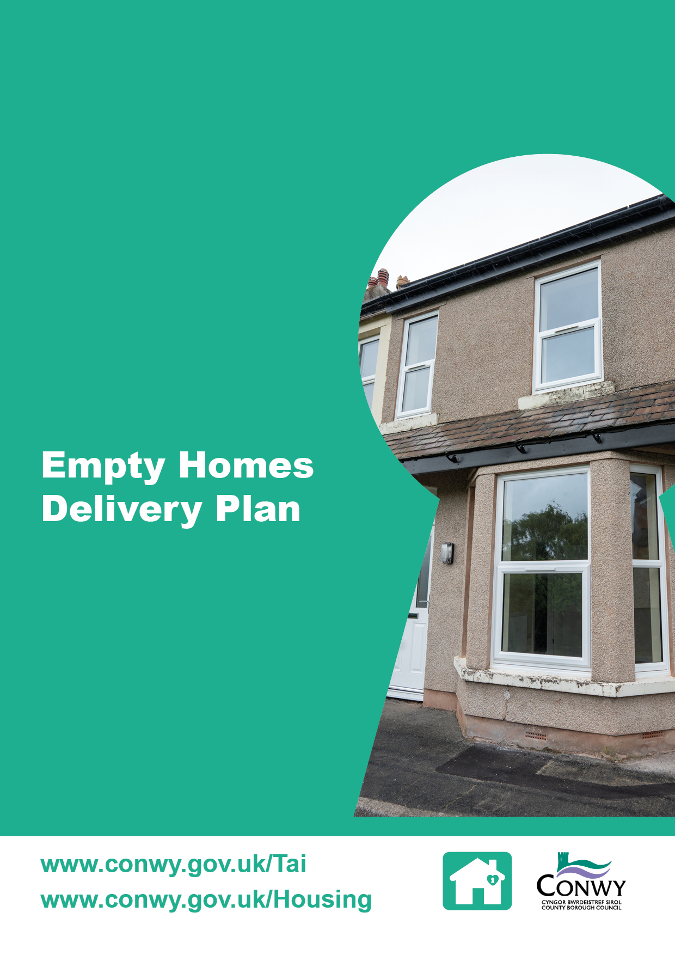

Contents

1 Introduction 1
2 Market Segmentation 1
Market 1: Empty Homeowners 1
Market 2: The Community 2
Market 3: Landlords 2
Market 4: Owner Occupiers 2
Market 5: Town Centre 2
3 Enforcement 2
4 Resources 3
Staffing 3
Grants 3
Loans 3
Partnership Working 3
5 Monitoring Success 4
Welsh Government Key Performance Indicators (KPIs) 4
Accessibility of the Empty Homes Service 4
Customer Satisfaction 4
Funding Success 4
6 Implementation and Governance 5
Appendix 1 - Action Plan 6

1 Introduction

The Empty Homes Delivery Plan (the Plan) sets out the strategic approach to addressing empty properties in Conwy County Borough, supporting the delivery of the Local Housing and Homelessness Strategy. The aim is to unlock the housing potential of empty homes and to promote sustainable communities.

The Plan outlines key objectives and partnerships aimed at bringing empty homes back into use, with a focus on proactive intervention and enforcement where necessary. It is designed to be a dynamic document, reviewed and updated annually to reflect progress, emerging challenges and evolving policy and legislation.

By aligning with the Local Housing and Homelessness Strategy, the Plan ensures that efforts to tackle empty homes contribute directly to wider housing objectives, including increasing the supply of affordable housing, improving housing quality and supporting town centre regeneration.

The Action Plan in Appendix 1 provides the detailed steps that will be taken to implement the Empty Homes Delivery Plan. It outlines activities, responsible officers, timescales and expected outcomes for each of the five empty homes service market segments noted in section 2. The Action Plan serves as a practical tool to guide delivery, monitor progress and ensure accountability across all areas of work.

2 Market Segmentation

To ensure a targeted and effective approach to bringing empty homes back into use, this Delivery Plan has been structured around five distinct market segments. Each segment represents a key stakeholder group with unique challenges and opportunities in relation to empty homes.

Market 1: Empty Homeowners

Objective: Empower empty homeowners to take action and bring their empty home back into use

The challenge identified is the lack of awareness among empty homeowners about the empty homes service.

This segment focuses on the following:

- Direct contact with property owners to offer tailored advice and guidance
- Raising awareness of financial support
- Promoting the benefits of bringing empty homes back into use including highlighting the impact of the Council Tax Premium for empty homeowners
- Ensuring the service is accessible
- Enforcement (see section 3).

Market 2: The Community

Objective: Empower local communities to lead initiatives that bring empty homes back into use and meet local housing needs

Each community has different challenges and often top-down solutions do not address some of the real issues. This segment promotes grassroots solutions by partnering with organisations such as Cwmpas, which will empower communities and provide tailored advice and support. This approach will enable residents to build the skills and knowledge needed to bring empty homes back into use, ensuring these properties meet the needs of their communities.

Market 3: Landlords

Objective: Provide flexible and tailored support, information and funding options to support new and existing landlords who purchase empty properties, bring them up to an acceptable standard and rent them to households
Landlords play a critical role in increasing the supply of affordable housing, however, the viability of providing quality accommodation at local housing allowance rate is challenging. This segment encourages ethical investment in empty homes.

Market 4: Owner Occupiers and Investors

Objective: Provide flexible and tailored support, information and funding options to support home buyers who purchase empty homes or owners of empty homes to improve the quality and condition

There is a significant number of empty homes that need investment to improve the quality and appearance, however, there are often affordability barriers. This segment encourages investment in empty homes and access to support and information to enable action to be taken to bring the property back in to use.

Market 5: Town Centre

Objective: Work in collaboration with key stakeholders to use a housing-led approach to regenerate town centres

There is a significant number of empty properties in town centres, which are often challenging to bring back into use due to the high cost and planning restrictions. These may include; space above shops, former commercial buildings, heritage sites and listed buildings which remain empty. This segment promotes strategic partnerships with Welsh Government, regeneration teams, planners and developers to revitalise town centres through housing-led initiatives.

3 Enforcement

While the Empty Homes service prioritises engagement and voluntary action, enforcement remains a necessary tool to address problematic long term empty homes where the owners are unwilling to cooperate.

Enforcement powers available to Conwy County Borough Council (CCBC) are detailed on the Council website [link here].

CCBC will continue to work in partnership with the Welsh Government when pursuing enforcement action. The Welsh Government will support the local authority with the cost of enforcement where it has been used as a last resort.

Enforcement will only be pursued after all reasonable efforts have been made to engage with the empty homeowner, including methods such as letters, phone calls and visits to the property.

4 Resources

To deliver the objectives of the Empty Homes Delivery Plan, the following resources are available:

Staffing

There are three full time equivalent Empty Homes Officers dedicated to the delivery of the Empty Homes Service. They are responsible for identifying empty homes, engaging with owners, coordinating activities and promoting funding opportunities.

Grants

This year, three separate budgets include provisions for Empty Homes Grants:

- £500,000 Empty Spaces into Living Places
- £185,000 Leasing Scheme Wales
- £92,761 Owner Occupier Grant.

Scheme details can be found on the Council website Empty homes: financial help for empty home owners - Conwy County Borough Council.

The Empty Homes team will continue to seek new funding opportunities to support the implementation of the Plan.

Loans

£352,572 is available to offer interest free loans of up to £35,000 for up to 5 years to help owners renovate an empty home for rent, or 2 years if the property is to be sold. This loan is called ‘Houses into Homes’.

Partnership Working

The delivery of the Plan is underpinned by a commitment to collaboration and innovation.

Registered Social Landlords will be supported to access Welsh Government capital funding to acquire and refurbish long-term empty properties for use as social housing to meet specific housing needs as identified in the Housing Prospectus Conwy-Local-Housing-Prospectus-April-2025.

5 Monitoring Success

The success of the Plan will be measured through a combination of quantitative and qualitative indicators, aligned with the Welsh Government priorities and CCBC’s strategic objectives noted in section two.

Welsh Government Key Performance Indicators (KPIs)

Progress will be monitored against the following KPIs:

- The number of empty homes brought back into use
  - Target: 75 properties
- The number of empty homes brought back into use as affordable housing
  - Target: 15 properties.

KPIs will be used to benchmark performance against other local authorities and previous performance in Conwy.

Accessibility of the Empty Homes Service

Data will be captured to evaluate the accessibility of the service and will consider the digital and direct engagement.

- Digital engagement will be a review of website analytics including webpage views and online contact form submissions
- Direct engagement will be a review of telephone enquiries, written correspondence and property visits.

Customer Satisfaction

Customer feedback will be gathered from individuals accessing the service to support CCBC’s commitment to delivering a service that meets the needs of customers and continuous service improvements. Success will be measured by:

- The quality and accessibility of support provided
- The impact of interventions on housing outcomes
- Concerns raised about the service
- Service improvements actions.

Funding Success

To ensure the Plan remains dynamic, the Empty Homes team will seek new funding opportunities. Success will be measured by:

- The number of grant applications submitted
- The total value of funding secured
- The impact of the funding
- Any lessons learnt.

6 Implementation and Governance

The successful delivery of the Empty Homes Plan will be supported by the Empty Homes Evaluation Group, a partnership that brings together key stakeholders involved in housing, regeneration, planning and community development. The group will meet quarterly to coordinate activity, share best practice and monitor progress across the five market segments.

To ensure transparency and accountability, progress against the Plan will be reported annually to the Housing and Homelessness Board. This will include updates on:

- Welsh Government key performance indicators
- Outcomes achieved within each market segment including partnership activity and funding success

The market segments are not mutually exclusive and therefore, outcomes will be reported based on the primary objective, for example, a landlord initiative set up to support town centre regeneration will be reported under market 5.

- Accessibility of the empty homes service
- Customer satisfaction and feedback.

This governance structure ensures that the Plan is aligned with strategic priorities, is delivering measurable outcomes and value for money.

Appendix 1 - Action Plan
Area | Action | Output | Outcomes | Responsible Officer | Timescale
1 | Identify empty properties and engage with owners to offer advice, support, signposting and financial support to bring properties back into use | Direct marketing of the service to empty homeowners via 3-step letter approach  Bespoke case advice and activity provided to owners | Building relationships with empty homeowners to enable more properties return to use  Increased awareness of the service and help available  Help to improve the quality and standard of accommodation in the County | Empty Homes Officer  Affordable Housing Officer | Quarterly
 | Promote the Empty Homes service | Carry out promotional activity in line with the Housing Services Communications Strategy 2025  Keep all service information up-to-date and available in a range of formats  Take opportunities to broaden communication methods  Arrange drop-in surgeries for face-to-face communication | Increased awareness of the service and help available  More take up of financial support | Empty Homes Officer | Quarterly
 | Identify and apply for funding opportunities to offer Grants/loans to empty property owners | Maximise funding opportunities to bring empty properties back into use in the Eryri National Park Area  Identify funding opportunities to develop new schemes to provide support the provision of affordable housing | Increased options for empty homeowners  Increased uptake of grants  Increased supply of affordable housing  More properties brought back into use | Empty Homes Officer  Housing Strategy Manager | Quarterly
 | Where positive engagement is not successful consider enforcement action to deal with problematic empty properties | Receive complaints about empty properties  Work in partnership with appropriate internal and external partners and co-ordinate multi-departmental response  Apply for funding opportunities to underwrite the risk of enforcement action | Increased community wellbeing and security  Increasing confidence and reputation of the Empty Homes Service  Reduce risks to the public  More properties brought back into use | Empty Homes Enforcement Working Group | Quarterly
2 | Engage with community groups and provide support with empty homes were requested | Attend community meetings as required  Provide advice about funding for community groups  Sign-post to support networks and information  Support village ‘walk-abouts’ with community members giving them the opportunity to point out empty properties | Building networks and strengthening relationships across all groups of people  More properties brought back into use  Increased community wellbeing | Empty Homes Officer  Affordable Housing Officer | Quarterly
3 | Assist empty property owners to let homes | Provide information and advice to comply with rented homes physical and managerial standards  Provide tenant matching/introductions to house households in need | Increase numbers of PRS accommodation, helping create movement in the PRS market  Help reduce the number of households registered on the social housing and affordable housing registers  Help with the rapid rehousing of homeless households  More properties brought back into use  Help improve the quality and standard of accommodation in the County | Empty Homes Officer | Quarterly
 | Assist empty property owners to lease homes | Encourage take up of leasing schemes to provide affordable housing options for people in housing need | Increased supply of affordable housing  More properties brought back into use  Help improve the quality and standard of accommodation in the County | Empty Homes Officer  Private Sector Access Officer | Quarterly
4 | Assist empty property owners to sell homes | Forge links with local estate agents, Auction Houses and signpost property owners accordingly  Link up property owners and private developers or RSLs who may wish to buy property | Increased supply of available housing  Increased supply of affordable housing  Increase market movement  More properties brought back into use | Empty Homes Officer | Quarterly
5 | Identify non-residential empty property in Town Centres that can be redeveloped as dwellings | Offer advice, support, signposting and financial incentives to bring property back into use | Increased supply of available housing  Assist with regeneration of Town Centres | Empty Homes Officer | Quarterly

