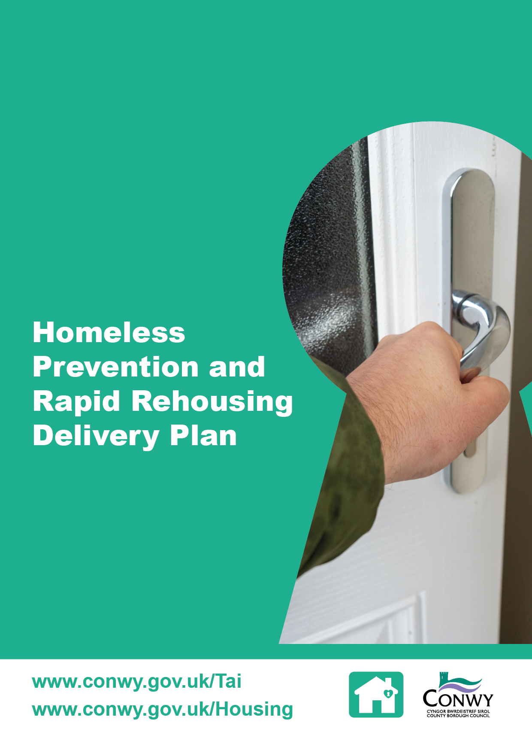

Contents

1 Introduction 1
2 Core Objectives by Focus Area 1
Focus area 1: Workforce 1
Focus area 2: Customers 2
Focus area 3: Partner Organisations 2
Focus area 4: Temporary Accommodation 2
3 Resources 3
Staffing 3
Partnership Working 3
4 Monitoring Success 3
Welsh Government Key Performance Indicators (KPIs) 3
Workforce 3
Temporary Accommodation 3
Accessibility of the Homelessness Service 4
Customer Satisfaction 4
Partnership Working 4
5 Implementation and Governance 4
Appendix 1 - Action Plan 6

1 Introduction

The Homeless Prevention and Rapid Rehousing Delivery Plan (the Plan) sets out Conwy County Borough Council’s strategic approach to tackling homelessness with a clear focus on prevention, collaboration and the right provision of quality temporary accommodation. It supports the delivery of the Local Housing and Homelessness Strategy, with the aim to ensure that homelessness is rare, brief and unrepeated.

The Plan outlines key objectives designed to ensure the homelessness service in Conwy is delivered effectively and responds to the diverse needs of customers. It focuses on four core areas: the workforce, customers, partner organisations and temporary accommodation. Each area represents a key stakeholder group with unique challenges and opportunities.

While the Plan addresses the temporary accommodation element of the housing pathway, it does not include the supply of permanent settled accommodation, this is covered separately within the Affordable Housing Delivery Plan. Additionally, the Plan does not cover access to wider support services as these are addressed through the Housing Support Programme Plan. This ensures that each plan remains focused and aligned with its specific strategic purpose, while collectively contributing to the broader goal of preventing and reducing homelessness in Conwy.

The Plan is designed to be a dynamic document, reviewed and updated annually to reflect progress, emerging challenges and evolving policy and legislation.

The Action Plan in Appendix 1 provides the detailed steps that will be taken to implement the Homeless Prevention and Rapid Rehousing Delivery Plan. It outlines activities, responsible officers, timescales and expected outcomes for each of the four focus areas noted in section 2. The Action Plan serves as a practical tool to guide delivery, monitor progress and ensure accountability across all areas of work.

2 Core Objectives by Focus Area

Focus area 1: Workforce

Objective: Ensure an adequately resourced and skilled workforce is in place to deliver high quality homelessness prevention services, while embedding continuous service improvement to improve customer outcomes

The demand for homelessness services has reached unprecedented levels in recent years and it has been challenging to adapt the workforce to meet the needs of the service, highlighting the need for strategic workforce planning.

This area will focus on the following:

- Workforce capacity and resilience
- Skills development and training
- Recruitment and retention
- Monitoring future trends in service demand
- Risk management plans to respond to sudden changes in demand.

Focus area 2: Customers

Objective: Empower individuals who are homeless or at risk of homelessness to access timely, person-centred support in a psychologically informed environment, enabling prevention, informed decision-making and improved long-term outcomes

The challenge identified is the lack of awareness among individuals about the support available to prevent homelessness. Addressing this issue is essential to ensuring that people can access help before reaching crisis.

This area will focus on the following:

- Raising awareness of the homelessness prevention services and available support
- Ensuring the service is accessible, inclusive, trauma informed and easy to navigate
- Strengthening referral pathways to enable timely and coordinated access to support across agencies.

Focus area 3: Partner Organisations

Objective: Strengthen multi-agency collaboration to embed homelessness prevention across all services, ensuring coordinated support and shared responsibility for early intervention and prevention

There is a recognised need to improve awareness and understanding among internal teams and external partner agencies about their role and responsibilities in supporting the delivery of the homelessness service. Strengthening this awareness is essential to fostering more effective collaboration and coordinated prevention efforts.

This area will focus on the following:

- Communication and information sharing
- Training
- Engagement
- Formalised partnership structures.

Focus area 4: Temporary Accommodation

Objective: Maintain a sufficient and flexible supply of quality temporary accommodation that meets diverse needs and delivers value for money

The increased demand for homelessness services in recent years has previously led to an increased reliance on emergency accommodation. With fluctuating demand for temporary accommodation, the challenge is the availability of diverse temporary accommodation options that are of high quality and appropriate to the varied needs of those accessing the accommodation.

This area will focus on the following:

- Developing alternative models of temporary accommodation
- Increasing capacity within the temporary accommodation portfolio
- Strengthening move on support
- Monitoring trends in future service demand
- Developing a risk management plan to respond to sudden changes in demand.

3 Resources

Staffing

This Plan will be delivered across three teams: Rapid Rehousing and Adaptations, Housing Solutions and Housing Partnerships teams.

Partnership Working

The delivery of the Plan is underpinned by a commitment to collaboration and innovation.

4 Monitoring Success

The success of the Plan will be measured through a combination of quantitative and qualitative indicators, aligned with the Welsh Government priorities and CCBC’s strategic objectives noted in section two.

Welsh Government Key Performance Indicators (KPIs)

Progress will be monitored against the following KPIs:

- Homelessness successfully prevented
  - Target 70%
- Homelessness successfully relieved
  - Target 25%
- Homelessness successfully discharged
  - Target: 70%.

KPIs will be used to benchmark performance against other local authorities and previous performance in Conwy.

Workforce

Progress will be monitored against the following service KPIs:

- Sickness Absence
  - Target: Achieve a 10% reduction
- Case loads
  - Target: 30 cases per officer.

Temporary Accommodation

Progress will be monitored against the following service KPIs:

- A reduction in emergency temporary accommodation length of stay
  - Target: No longer than 6 weeks
- The number of out of county placements
  - Target: Achieve on average through the year 0
- A percentage reduction in temporary accommodation spends
  - Target: Achieve a 50% reduction.

Accessibility of the Homelessness Service

Data will be captured to evaluate the accessibility of the service and will consider the digital and direct engagement.

- Digital engagement will be a review of website analytics including webpage views and online contact form submissions
- Direct engagement will be a review of telephone enquiries, written correspondence and in-person meetings.

Customer Satisfaction

Customer feedback will be gathered from individuals accessing the service to support CCBC’s commitment to delivering a service that meets the needs of customers and continuous service improvements. Success will be measured by:

- The quality and accessibility of support provided
- The impact of interventions on housing outcomes
- Concerns raised about the service
- Service improvements actions.

Partnership Working

Effective collaboration is central to the Plan’s delivery. Success will be measured by:

- The number of active partnerships
- The impact of the partnership working
- Any lessons learnt.

5 Implementation and Governance

The successful delivery of the Homeless Prevention and Rapid Rehousing Delivery Plan will be supported by the Rapid Rehousing Working Group, a partnership that brings together key stakeholders involved in housing, housing related support services, social care, human resources, community development, health and other public services. The group will meet quarterly to coordinate activity, share best practice and monitor progress across the four focus areas.

To ensure transparency and accountability, progress against the Plan will be reported annually to the Housing and Homelessness Board. This will include updates on:

- Welsh Government key performance indicators
- Conwy homelessness service key performance indicators
- Outcomes achieved within each focus area including partnership activity
- Accessibility of the homelessness service
- Customer satisfaction and feedback.

This governance structure ensures that the Plan is aligned with strategic priorities, is delivering measurable outcomes and value for money.

Appendix 1 - Action Plan
Area | Action | Output | Outcomes | Responsible Officer | Timescale
1 | Conduct a comprehensive assessment of current staffing levels, roles and workloads across homelessness services to identify gaps and future resource needs | Findings used to inform workforce planning and recruitment plans | A clear understanding of staffing requirements and a proactive plan to ensure services are adequately resourced | Housing Services Manager | June 2026
 | Design a structured training and development programme tailored to homelessness service delivery including trauma informed proactive, legal frameworks, safeguarding and customer service excellence. Consider opportunities for collaboration regionally | Sickness: Achieve a 10% reduction  Caseloads: x cases per officer | A skilled, confident workforce equipped to deliver high-quality, person-centred support | Housing Services Manager | June 2026
 | Facilitate regular team-based reflective practice sessions to share experience, challenges and best practices | Staff attendance at meetings and feedback forms | Improved staff morale, shared learning and enhanced service delivery | Housing Solutions Manager | Quarterly
 | Develop a dashboard to track service performance | Performance dashboard created and regularly updated | Data can be used to inform service improvements | Housing Services Manager | June 2026
2 | Review the customer journey in partnership with key stakeholders and ensure the pathway to housing services is accessible | Customer journey map and stakeholder feedback | Improved access to services that empowers individuals to make informed decisions and achieve positive outcomes | Housing Services Manager | March 2026
 | Review the prevention service delivery framework to ensure the correct internal procedures are in place to identify individuals at risk of homelessness early and offer targeted support before crisis occurs | Updated prevention framework and procedures | Increased prevention and reduced homelessness presentations | Housing Solutions Manager | March 2026
 | Develop clear, accessible materials outlining the homelessness service, including how the service works with other partners | Updated Council web pages  Online forms  One stop shop  Outreach services  In person contact | Service is accessible to meet the needs of a variety of people | Housing Services Manager | Quarterly
 | Develop and implement a method to monitor customer satisfaction with homelessness services | Satisfaction reports | Improved understanding of the customer experience and areas for improvement | Housing Solutions Manager | Quarterly
3 | Establish a multi-agency homelessness prevention forum to share information on homelessness service developments (including new legislation and rapid rehousing principles), priorities, prevention approaches and referral processes.  Use forums as an opportunity for partners to provide feedback and contribute to service improvements | Forum established and meeting minutes recorded | Improved collaboration, shared learning and service alignment  Services are shared by multi-agency input | Housing Solutions Manager | Bi-annually
 | Establish focus groups to formalise partnership working arrangements in the following areas: Vulnerable People, Young People, Care Leavers and Foster Families | Focus groups established and meeting minutes recorded | Services are shaped by multi-agency input | Housing Services Manager | Quarterly
 | Explore the potential to include homelessness awareness in induction programmes for staff across partner organisations | Induction materials developed and shared | Increased awareness and early intervention across services | Housing Solutions Manager | May 2026
4 | Review current and projected demand for temporary accommodation, considering household types, support needs, accessibility requirements and geographical distribution and use findings to develop a property acquisition plan that considers alternative models to current temporary accommodation units and contingency arrangements for sudden increases in demand | Demand analysis report  Property acquisition plan developed | A clear understanding of the number, size and type of temporary accommodation needed.  A flexible supply of temporary accommodation that meets the changing demand | Housing Partnerships Manager and Housing Support Grant Manager | May 2026

