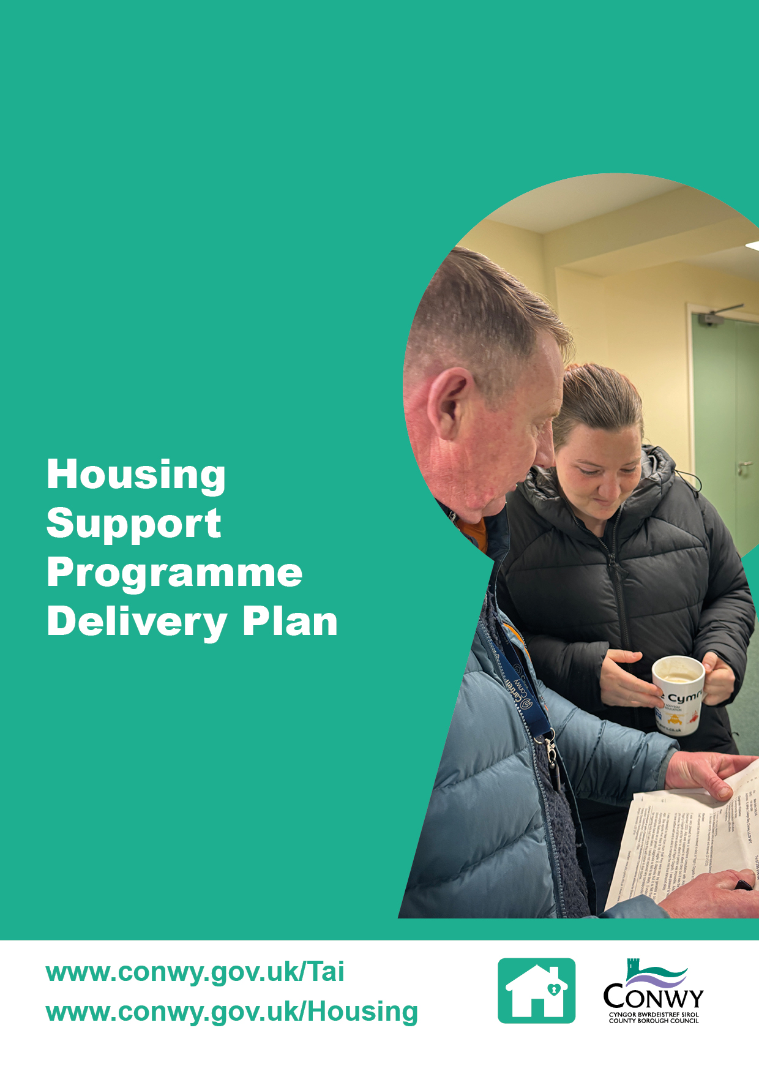

Contents

1 Introduction 1
2 Core Objectives by Focus Area 1
Focus area 1: Welsh Government Grant Programme 1
Focus area 2: Partner Working 1
Focus area 3: Lived Experience Co-production 2
3 Resources 2
Staffing 2
Housing Support Grant 2
Partnership working 2
4 Monitoring Success 2
Welsh Government Key Performance Indicators (KPIs) 2
Customer satisfaction 3
Partnership working 3
5 Implementation and Governance 3
Appendix 1 - Action Plan 4

1 Introduction

The Housing Support Programme Delivery Plan (the Plan) sets out Conwy County Borough Council’s strategic approach to delivering housing support that is targeted and responsive to local needs with a clear focus on multi-agency collaboration. It supports the delivery of the Local Housing and Homelessness Strategy, with the aim to ensure support is available at the right time to address inequity and prevent homelessness.

The Plan outlines key objectives designed to ensure the housing support service in Conwy is delivered effectively and responds to the diverse needs of customers. It focuses on three core areas: the Welsh Government grant, partnership working and lived experience co-production. Each area represents a key stakeholder group with unique challenges and opportunities. The Plan is designed to be a dynamic document, reviewed and updated annually to reflect progress, emerging challenges and evolving policy and legislation.

The Action Plan in Appendix 1 provides the detailed steps that will be taken to implement the Housing Support Programme Delivery Plan. It outlines activities, responsible officers, timescales and expected outcomes for each of the three focus areas. The Action Plan serves as a practical tool to guide delivery, monitor progress and ensure accountability across all areas of work.

2 Core Objectives by Focus Area

Focus area 1: Welsh Government Grant Programme

Objective: Utilise the Welsh Government Housing Support Grant to deliver high quality housing related support services through a coordinated multi-agency approach that is fully aligned with the local Housing Needs Assessment

The demand for homelessness services has reached unprecedented levels in recent years, alongside a growing need for housing related support. Over the years, the needs of households have changed, and it has been challenging to adapt the Housing Support Grant programme at pace.

This area will focus on transforming the service to ensure it is targeted, preventative and person-centred, delivering value for money and improved outcomes in a psychologically informed environment. To support this work, a comprehensive needs assessment was undertaken in November 2025, in partnership with key stakeholders, and will be used to target the Housing Support Grant. A summary of the key findings is presented in the Statement of Need [link here].

Focus area 2: Partner Working

Objective: Strengthen multi-agency collaboration to develop clear, coordinated pathways into a broad range of services, beyond housing related support ensuring individuals receive the right support at the right time

Often individuals and households require support from multiple services, however, due to unprecedented levels of demand in recent years, access to multiple services at the right time has been challenging, leading to missed opportunities for early and effective interventions.

This area will focus on ensuring all partners including health, third sector organisations, police and probation services, education and social care are engaged and integrated working collectively to deliver the right support at the right time, avoiding duplication and responding to the needs of local people.

Focus area 3: Lived Experience Co-production

Objective: Place people with lived experience at the heart of the Housing Support Grant Programme by actively engaging them in the design, development and evaluation of services

Previously, support services have been developed without fully understanding the complexities of people’s needs and/or the barriers they face, which can lead to people choosing to not access the service.

This area will focus on ensuring support is shaped to meet the needs of those who will be accessing the service and promote improved engagement.

We want to move from engaging people with lived experience to co-producing services with those affected by homelessness.

3 Resources

Staffing

The Housing Support Programme is led by the Housing Support Grant Manager, who is responsible for coordinating the design, commissioning and review of existing services. The HSG Manager is supported by three Contract and Reviewing Officers, responsible for monitoring and reviewing HSG commissioned services and a Single Pathway Officer, responsible for processing and coordinating referrals.

Housing Support Grant

Conwy County Borough Council has been allocated £10,593,142.88 Housing Support Grant in 2025/26.

Partnership working

The delivery of the Plan is underpinned by a commitment to collaboration and innovation. A multi-agency group including social care, health, probation and a provider representative will provide oversight of the programme.

4 Monitoring Success

The success of the Plan will be measured through a combination of quantitative and qualitative indicators, aligned with the Welsh Government priorities and CCBC’s strategic objectives noted in section two.

Welsh Government Key Performance Indicators (KPIs)

Progress will be monitored against the following KPIs:

- HSG outcomes.

housing-support-grant-outcomes-framework (2).pdf

KPIs will be used to benchmark performance against other local authorities and previous performance in Conwy.

- Reduction in repeat homelessness
- Positive resolution rate for homelessness prevention cases
- No evictions from supported accommodation projects
- Continuity of support for people in their own accommodation to ensure long term stability and independence.

Customer satisfaction

Customer feedback will be gathered from individuals accessing the service to support CCBC’s commitment to delivering a service that meets the needs of customers and continuous service improvements. Success will be measured by:

- The quality and accessibility of support provided
- The impact of interventions on housing outcomes
- Concerns raised about the service
- Service improvements actions
- Effective homelessness interventions.

Partnership working

Effective collaboration is central to the Plan’s delivery. Success will be measured by:

- The number of active partnerships
- The impact of the partnership working
- Any lessons learnt.

5 Implementation and Governance

The successful delivery of the Housing Support Programme Delivery Plan will be supported by the Housing Support Grant Working Group, a partnership that brings together people with lived experience and key partners involved in housing related support services. The group will meet quarterly to coordinate activity, share best practice and monitor progress across the three focus areas.

To ensure transparency and accountability, progress against the Plan will be reported annually to the Housing and Homelessness Board. This will include updates on:

- Welsh Government key performance indicators
- Outcomes achieved within each focus area including partnership activity
- Customer satisfaction and feedback.

This governance structure ensures that the Plan is aligned with strategic priorities, is delivering measurable outcomes and value for money.

Appendix 1 - Action Plan

Area | Action | Output | Outcomes | Responsible Officer | Timescale
1 | Review the Needs Assessment to identify priority areas and ensure HSG funded services are commissioned to meet identified gaps | Delivery plan in line with WG requirements | Grant is used to fund services that meet local needs | Housing Support Grant Manager | February 2026
 | Encourage providers to develop flexible services to adapt to the changing needs of individuals | Service specifications and contracts reflect flexibility and person-centred approaches | Services are responsive to changing needs and improve individual outcomes | Housing Support Grant Manager | Quarterly
 | Establish a Strategic Planning group with representatives from housing, health, social care and the third sector to oversee the delivery of the HSG programme | Terms of reference and regular meetings scheduled | Improved collaboration, shared accountability and integrated service delivery | Housing Support Grant Manager | May 2026
 | Use the Welsh Government outcomes framework to monitor success of the HSG programme | Regular performance reports aligned to WG framework | Evidence of impact and continuous service improvements | Housing Support Grant Manager | Bi-annually
2 | Conduct a review of current services and referral pathways across agencies, identify gaps and opportunities to strengthen partnerships | Mapping report of existing services and referral pathways with recommendations | Improved coordination and reduced duplication of services | Housing Support Grant Manager | June 2026
 | Use the Housing Support Grant Provider forum to share information on HSG service developments, priorities, prevention approaches and referral processes.  Use forums as an opportunity for partners to provide feedback and contribute to service improvements | Forum minutes and shared resources  Feedback reports and action plans | Increased awareness and alignment of services across providers  Services are continuously improved based on stakeholder input | Housing Support Grant Manager | Quarterly
 | Facilitate workshops where key stakeholders can codesign new or improve existing services | Workshop outputs including service design proposals | Services better reflect local needs and stakeholder expertise | Housing Support Grant Manager | Ongoing
3 | Establish a lived experience advisory panel to contribute to the design, development and evaluation of services  Involve the panel in commissioning processes and service reviews  Provide training and support to panel members to enable meaningful participation | Terms of reference, meeting schedule and feedback reports from the panel  Co-produced commissioning documents and review findings  Training material and attendance records | Services are shaped to meet the needs of people accessing the service  Empowered individuals with lived experience contributing to service development | Housing Support Grant Manager | June 2026

