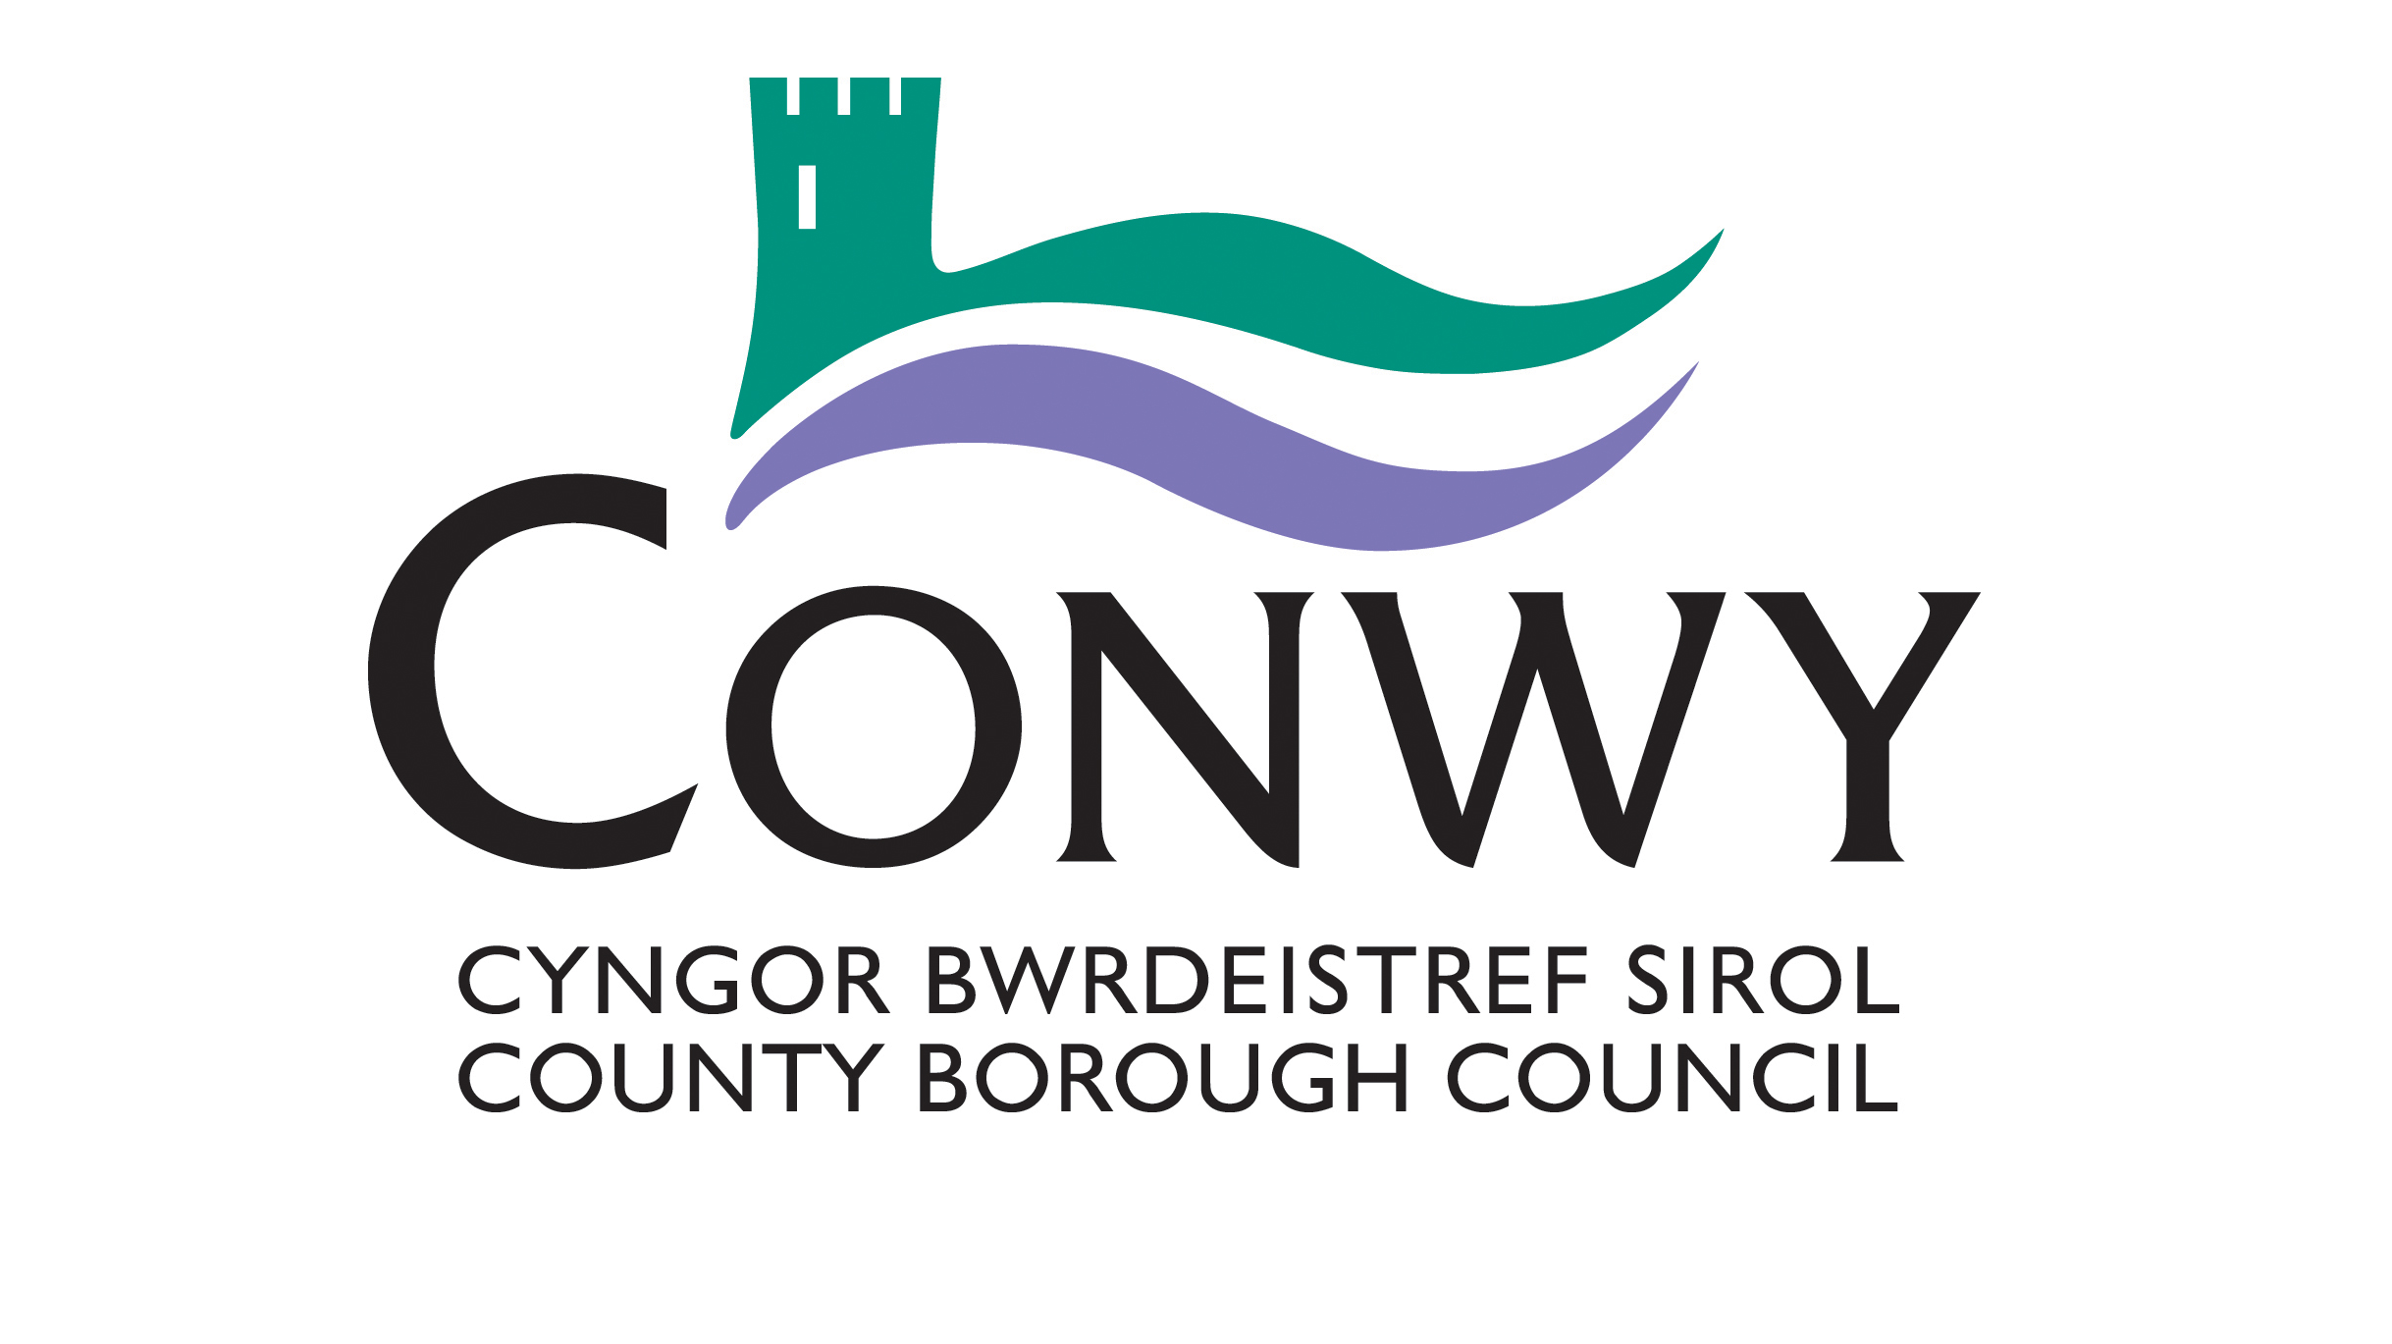

Blue Badge Application Form
This form should be completed by applicants who are applying under the following criteria, which will be fast tracked through the application process.
This applies to people who:
a. have a terminal condition and have a mobility impairment; and
b. have an original DS 1500 form, supporting letter from their McMillan nurse or other relevant health specialist.
Further guidance can be found in the accompanying guidance notes.
Please complete section 1 below and sign the declarations at the last page. You will also need to supply the appropriate documents to confirm your address and identity.
If you are completing the form on behalf of an applicant who is under 16 or who is unable to complete the form themselves, please provide their details in appropriate sections and sign the form on their behalf.

For Office use only
Seen by:
Proof of ID:
Proof of Address:
Other Documentation:

Date:

Section 1 – Information about the applicant
Title (Please Select) | Mr / Mrs / Miss / Ms |  | Other
First name
Surname
Surname at Birth
(if different)
Date of Birth (DD/MM/YYYY)
Place of Birth | Town
 | Country
National Insurance Number
Current address
Postcode
Contact details | Home
 | Mobile
 | Email
Previous address, if different in the last three years
Postcode
For enforcement purposes please nominate the vehicle registration number(s) for the main cars in which you intend to use the Blue Badge. (Up to three registration numbers should be nominated, but please remember that other vehicles can be used).

Declarations and signatures
Mandatory declarations about the information you have provided and the application process
- Please read the following declarations thoroughly.
- Please tick all relevant boxes to indicate that you have read and understood each declaration.
- Failure to tick one of these declarations may mean we are unable to consider your application.
- Providing fraudulent information may result in prosecution and a fine.
All documents relating to this application will be dealt with in line with the Data Protection Act 1998 and may be shared within the local authority, with other local authorities, the police and parking enforcement officers to detect and prevent fraud. Any medical information that you have supplied to support this application is deemed, under the Data Protection Act, to be “sensitive personal data” and will only be disclosed to third parties as necessary for the operation and administration of the Blue Badge scheme, and to other Government Departments or agencies, to validate proof of entitlement or as otherwise required by law.
Declarations to be completed by ALL applicants, parent or carer.
I confirm that, as far as I know, the details provided are complete and accurate. I realise that you may take action against me if false information has been provided in this application form.
I give consent to the local authority to check my personal details on the local authority’s Council Tax database so that I do not need to submit proof of my address.
I understand that I must promptly inform my local authority of any changes that may affect my entitlement to a badge.
I understand that, if my application is successful, I must not allow any other person to use the badge for their benefit and that I must only use the badge in accordance with the rules of the scheme as set out in “The Blue Badge Scheme – Rights and Responsibilities in Wales” leaflet which will be sent to me with the badge. Fraudulent applications or misuse of a badge may result in a fine of £1,000 and/or forfeit of the badge.
I understand that I must not hold more than one valid Blue Badge at any time.
I confirm that I do not currently hold a Blue Disabled Person’s Parking Badge that has been issued by a different local authority.
I understand that you will deal with all documents relating to this application in line with the Data Protection Act 1998, and you may share them with other local authorities, the police and parking enforcement officers to detect and prevent fraud.

Checklist of documents you may need to enclose
We have provided a checklist below to help remind you of what information you need to enclose. You will need to check with your local authority whether they require original documents or certified copies.
Proof of your address, dated within the last 12 months.
(If you have not given consent for us to check Council Tax/electoral register/school records.)
Proof of your identity.
A passport-style photograph of yourself with your name on the back (if possible).
Your signature against the declarations
Your signature
Print name
Date of application
If you are applying on behalf of another person, please indicate your relationship.
Relationship
Official Guardian
Power of Attorney
Parental Responsibility
Other (Please describe)
Where you have applied for a Blue Badge on behalf of another person you must be aware that using the Blue Badge contrary to the rules governing the scheme may result in prosecution, a fine and the withdrawal of the Blue Badge.
When completed please send this form to-

Conwy County Borough Council
Blue Badge Dept
PO Box 1
Conwy
LL30 9GN

Should you have any queries please call - 01492 577800 email:bluebadge@conwy.gov.uk
Guidance notes
Your application will be verified by your local authority, who will process a fast track request for a badge, providing you have included the correct information to support your application. The declarations include a section for you to check this.
Proof of your identity
We need to check your identity to reduce the potential for fraudulent applications for a Blue Badge. You must attach a certified photocopy of one of the following as proof of your identity:
• Birth certificate/adoption certificate
• Marriage/Divorce certificate
• Civil Partnership/Dissolution certificate
• Passport
• Valid driving licence
• Current Blue Badge
• Concessionary Travel Card
Identification documents that include a photograph are preferable but please check with your local authority if you are unable to provide one of the above.
Address
Proof of address should be in the form of an original Council Tax bill bearing your name and address. The original must be submitted with your application and will be returned at the end of the application process.
Please note that you will not need to submit your Council Tax bill if you have ticked the appropriate box in the declarations, which gives your consent for the local authority to check your address on their Council Tax records or electoral register.
If you are completing the application form on behalf of someone under the age of 16, you should give your consent for the local authority to check school records to confirm their address.
Blue Badge Issue Fee
There is no charge to the Blue Badge holder upon first issue of a badge, however, a fee of up to £10 may be charged for badges issued as replacements in the case where a badge has been lost, stolen or damaged to an extent it cannot be read by people who will be checking the badge when used for parking or other concessions.
Other information
You should also provide the Vehicle Registration Numbers of up to three vehicles in which you are most likely to use a Blue Badge, if your application is successful. This information helps local authorities with their enforcement of the Blue Badge scheme rules, but please note that you can use a Blue Badge in other vehicles.

