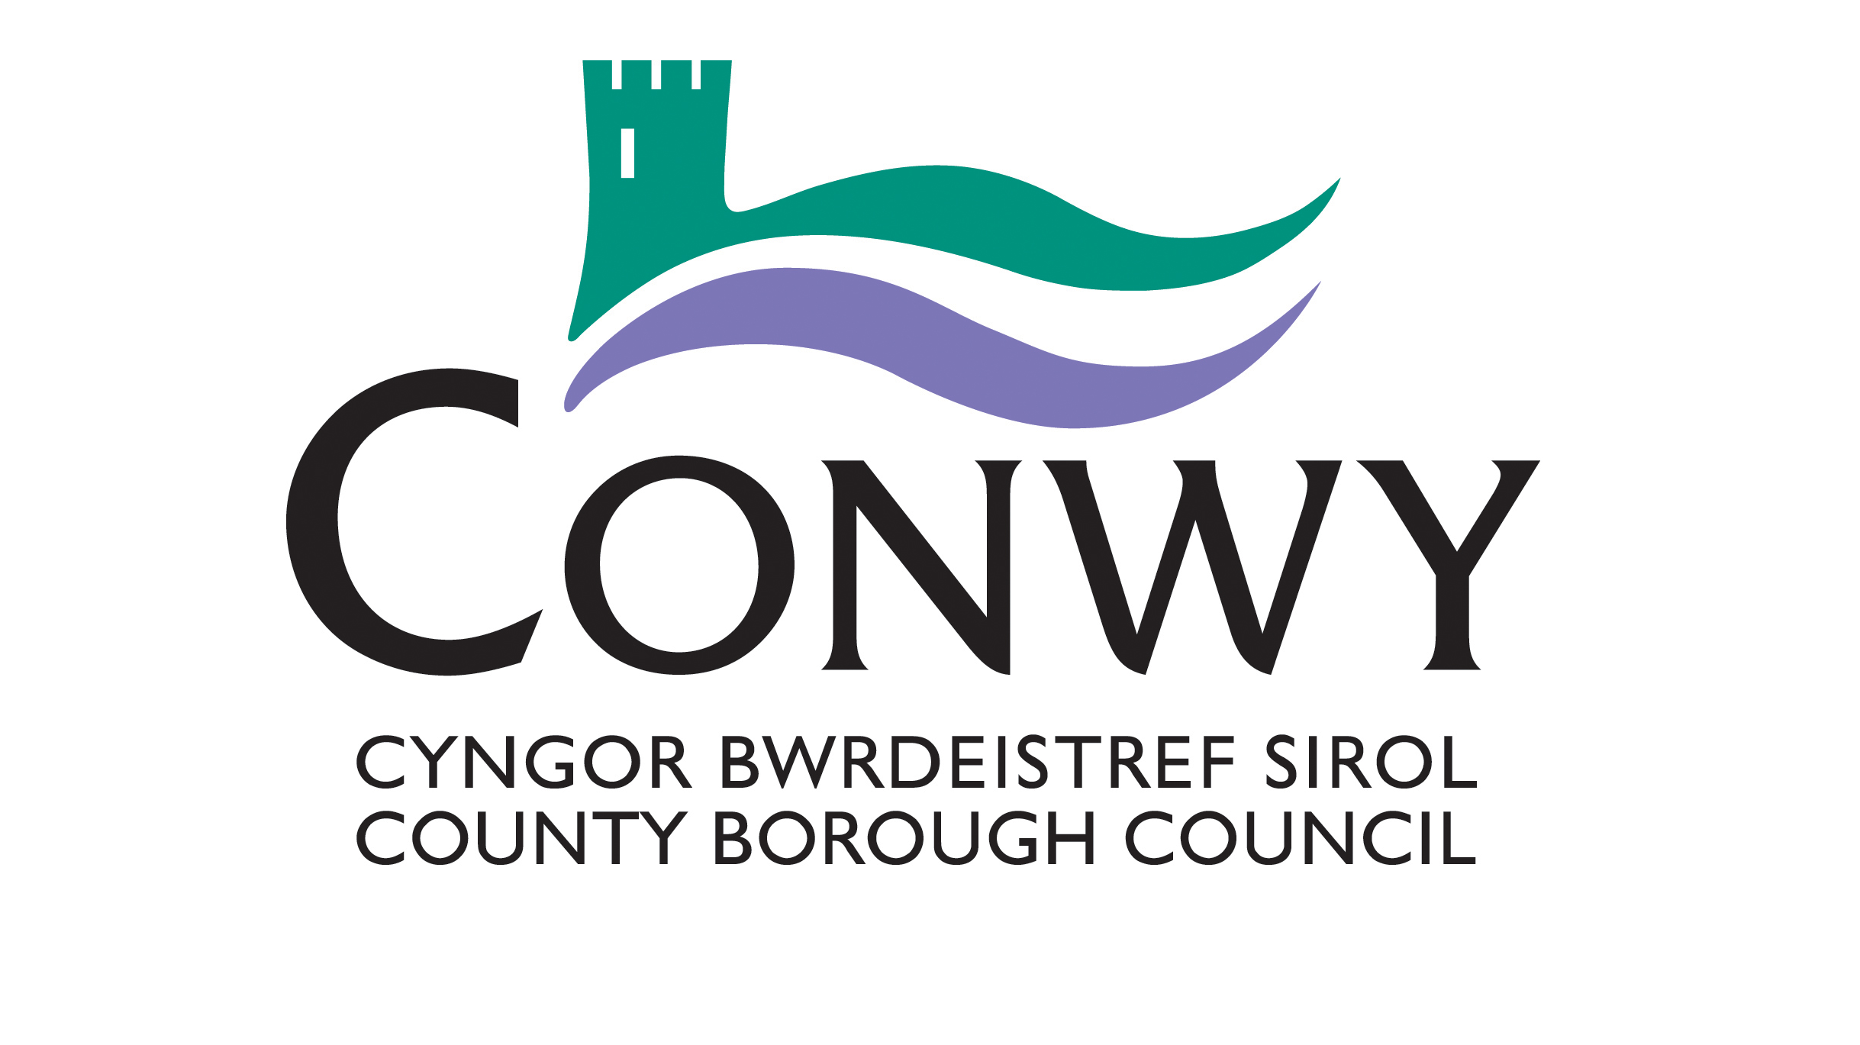

Blue Badge Application Form – Organisational
Please complete all sections of the application form and supply the appropriate documents to confirm your address and evidence of eligibility.
When completing this form you may find the accompanying guidance notes are helpful.
Section 1 – Applying for an Organisational Blue Badge
These questions are intended for organisations involved in the care of disabled people who are seeking a Blue Badge for a vehicle/vehicles (e.g. minibus, or specially adapted commercial vehicle) which is/are to be used to carry disabled people who would themselves qualify for an individual Blue Badge. Please see accompanying guidance note for a list of the eligibility criteria prescribed in the regulations that govern the scheme. One application form can be used to apply for more than one Organisational Blue Badge.
An ‘organisation’ is defined in legislation as meaning an organisation concerned with the care of disabled persons to which a disabled person’s badge may be issued.
Organisational badges will therefore only be issued to an organisation which:
- Cares for and transports disabled people who would meet one or more of the eligibility criteria for a individual Blue Badge; and
- Has a clear need for an organisational badge rather than using the individual Blue Badges of people it is transporting.
Organisational badges should only be used when transporting disabled people in their care who meet one or more of the eligibility criteria for a badge – and must not be used for the employee’s benefit when they are carrying out other business on behalf of the organisation. Such use may result in prosecution, a fine and the withdrawal of the Blue Badge.
It is unlikely that taxi or private hire operators and community transport operators would be eligible for an organisational Blue Badge as they are not usually concerned with the care of disabled people who would meet one or more of the eligibility criteria for a badge.
If you are unsure about how to answer these questions, then please read the guidance notes enclosed with this application form. Further information can be obtained from your local authority.

Name of organisation (maximum of 30 characters)
Main contact name
Role in Organisation
Address
Postcode
Telephone
Email
Does your organisation care for disabled people who would themselves qualify for an individual Blue Badge? See accompanying guidance note for a list of the eligibility criteria. |  |  | Yes |  | No
If YES, please give details:
As part of that care, does your organisation provide them with transportation? |  |  | Yes |  | No
If YES, please give details of the types of vehicles in which you wish to use the badge, their vehicle registration number and how often they are used to transport disabled people:
Type of vehicle | Vehicle Registration Number | Frequency used to transport  disabled people
Are any of your vehicles licensed under the Disabled Passenger Vehicle (DPV) taxation class? |  |  | Yes |  |  | No
If YES, please give details and attach a photocopy of the tax disc(s) to this application:
How many disabled people are in the care of your organisation?
How many of these people are already in receipt of a Blue Badge as individuals?
How many of these people do you estimate would be eligible to receive a Blue Badge if they applied as individuals (see description of eligible disabled people in the accompanying guidance note)?
Charity Number of your organisation (if applicable)
Please describe why your organisation is applying for a Blue Badge and the types of trips it will be used for:
How often do you envisage your organisation will use the Blue Badge?
If you already have an organisational Blue Badge:
What is the serial number and expiry dates on the current badge(s)?
How many organisational badges are you applying for?
(Please note that your organisation will be required to pay the badge issue fee for each Organisational Badge that is issued.)
Why do you require more than one Blue Badge?
Badge issue fee
The local authority will need to insert details of local payment options for successful Blue Badge applicants, where the fee is collected.
See accompanying Guidance Note
Payment will only be taken if your organisation’s application for a Blue Badge is successful. Your organisation will only be issued with a Blue Badge once your payment has been received.

Section 2 – Declarations and signatures
These questions need to be answered to ensure your application is processed.
2a) Mandatory declarations about the information you have provided and the application process
- Please read the following declarations thoroughly.
- Please tick all relevant boxes to indicate that you have read and understood each declaration.
- Not ticking one of these declarations may mean we are unable to issue you with a Blue Badge.
- Providing fraudulent information may result in prosecution and a fine.
All documents relating to this application will be dealt with in line with the Data Protection Act 1998 and may be shared within the local authority, with other local authorities, the police and parking enforcement officers to detect and prevent fraud. Any medical information that you have supplied to support this application is deemed, under the Data Protection Act, to be “sensitive personal data” and will only be disclosed to third parties as necessary for the operation and administration of the Blue Badge scheme, and to other Government Departments or agencies, to validate proof of entitlement or as otherwise required by law.
Declarations to be completed by applicants.
I confirm that, as far as I know, the details I have provided are complete and accurate. I realise that you may take action against me if I have provided false information in this application form.
I understand that I must promptly inform my local authority of any changes that may affect entitlement to a badge.
I confirm that I am authorised to represent the organisation and that the organisation is concerned with the care of disabled people.
I understand that, if the application is successful, the badge(s) will only be used when transporting disabled people and that the organisation must use the badge(s) in accordance with the rules of the scheme.
2b) Your consent to use your information to improve the service you receive
Please read and tick the following optional declarations that you consent to. Ticking these boxes will help to improve the service we can offer you.
I consent to the local authority checking any information already held by the local authority on the basis that:
• It can help determine eligibility for a Blue Badge;
• It may speed up the processing of my application;
I agree to the disclosure of the information included in this form to other local authority departments/service providers so that I can be informed about other local authority services that may be of benefit to me.
2c) Checklist of documents you may need to enclose
Please ensure you have enclosed all of the relevant documents for the sections of this application form that you have completed. We have provided a checklist below to help remind you of what you need to enclose.
Section 1 – Information about you
Proof of your address, dated within the last 12 months.
A copy of your organisational logo if appropriate.
A photocopy of the tax discs for any vehicles registered under the Disabled Passenger Vehicle (DPV) class.
Your signature against the declarations in Section 2a and 2b
Your signature

Your role or position in the organisation
Date of application (DD/MM/YYYY) | / /
Please print your name here

When completed please send this form to-

Conwy County Borough Council,
Blue Badge Department
PO Box 1
Conwy
LL30 9GN

Or email to – bluebadge@conwy.gov.uk
Should you have any queries please call - 01492 577800

