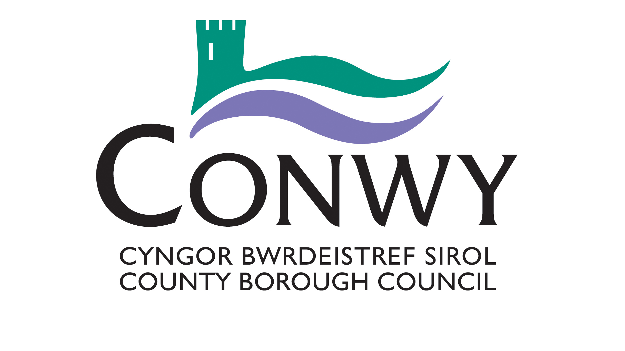

Blue Badge Application Form
This form should be completed by applicants who are applying under the following criteria.
People who:
a. have a cognitive impairment; and
b. are unable to plan or follow any journey, to such an extent that you/they require constant supervision
Further guidance on this criteria can be found in the accompanying guidance notes.
Please complete section 1 below and sign the declarations at the last page. You will also need to supply the appropriate documents to confirm your address and identity.
If you are completing the form on behalf of an applicant who is under 16 or who is unable to complete the form themselves, please provide their details in appropriate sections and sign the form on their behalf.

Site Name-
Seen by-
Job Title-
Documents-
Date -
For Office use only

Section 1 – Information about the applicant
Title (Please Select) |  | Mr / Mrs / Miss / Ms |  |  | Other
First name
Surname
Surname at Birth
(if different)
Date of Birth (DD/MM/YYYY)
Place of Birth |  | Town
 |  | Country
National Insurance Number
Current address
Postcode
Contact details |  | Home
 |  | Mobile
 |  | Email
Previous address, if different in the last three years
Postcode
For enforcement purposes please nominate the vehicle registration number(s) for the main cars in which you intend to use the Blue Badge. (Up to three registration numbers should be nominated, but please remember that other vehicles can be used).
If you know them please state the medical terms for the condition/impairment that you have been diagnosed with:
Please provide details and letters from any relevant health specialists you have seen in the last 12 months who would be able to support your claim:
Name | Job title |  | Hospital/Health Centre |  |  |  | Telephone Number | Date last seen
Are you on the Local Authority Learning Disability Register? Please state which:
Do you attend a Memory Clinic? Please provide an appointment card or letter to support your application.

Declarations and signatures
Mandatory declarations about the information you have provided and the application process
- Please read the following declarations thoroughly.
- Please tick all relevant boxes to indicate that you have read and understood each declaration.
- Failure to tick one of these declarations may mean we are unable to consider your application.
- Providing fraudulent information may result in prosecution and a fine.
All documents relating to this application will be dealt with in line with the Data Protection Act 1998 and may be shared within the local authority, with other local authorities, the police and parking enforcement officers to detect and prevent fraud. Any medical information that you have supplied to support this application is deemed, under the Data Protection Act, to be “sensitive personal data” and will only be disclosed to third parties as necessary for the operation and administration of the Blue Badge scheme, and to other Government Departments or agencies, to validate proof of entitlement or as otherwise required by law.
Declarations to be completed by ALL applicants or nominee.
I confirm that, as far as I know, the details provided are complete and accurate. I realise that you may take action against me if false information has been provided in this application form.
I understand that I must promptly inform my local authority of any changes that may affect my entitlement to a badge.
I confirm that the photograph I have submitted with the application is a true likeness.
I understand that, if my application is successful, I must not allow any other person to use the badge for their benefit and that I must only use the badge in accordance with the rules of the scheme as set out in “The Blue Badge Scheme - Rights and Responsibilities in Wales” leaflet which will be sent to me with the badge. Fraudulent applications or misuse of a badge may result in a fine of £1,000 and/or forfeit of the badge.
I understand that I must not hold more than one valid Blue Badge at any time.
I confirm that I do not currently hold a Blue Disabled Person’s Parking Badge that has been issued by a different local authority.
I understand that you will deal with all documents relating to this application in line with the Data Protection Act 1998, and you may share them with other local authorities, the police and parking enforcement officers to detect and prevent fraud.
I understand that you may need to contact an accredited professional within the health, social care or education services for the purpose of obtaining further information in support of this application.
Where further information is required, I understand that I may be required to undertake a face to face interview with a member of the Blue Badge team, in order to determine my eligibility for a Blue Badge.
Checklist of documents you may need to enclose
We have provided a checklist below to help remind you of what information you need to enclose. You will need to check with your local authority whether they require original documents or certified copies.
Proof of your address, dated within the last 12 months.
(If you have not given consent for us to check Council Tax/electoral register/school records).
Proof of your identity.
A passport-style photograph of yourself with your name on the back.
Your signature against the declarations
Your signature
Print name
Date of application
If you are applying on behalf of another person, please indicate your relationship.
Relationship
Official Guardian
Power of Attorney
Parental Responsibility
Other (Please describe)
Where you have applied for a Blue Badge on behalf of another person you must be aware that using the Blue Badge contrary to the rules governing the scheme may result in prosecution and a fine and the withdrawal of the Blue Badge.
When completed please send this form to- Conwy County Borough Council, Blue Badge Dept, PO Box 1, Conwy LL30 9GN
Should you have any queries please call - 01492 577800
Guidance notes
Your application will be verified by the local authority, and an accredited professional within the health, social care or education services may be contacted to obtain further information in support of this application.
The declarations include a section for you to agree to this.
Proof of your identity
We need to check your identity to reduce the potential for fraudulent applications for a Blue Badge. You must attach a certified photocopy of one of the following as proof of your identity:
• Birth certificate/Adoption certificate
• Marriage/Divorce certificate
• Civil Partnership/Dissolution certificate
• Passport
• Valid driving licence

Identification documents that include a photograph are preferable but please check with your local authority if you are unable to provide one of the above.
A certified photocopy is a photocopy of a document that has been verified as being true by a person, other than your partner or family member, who has known you for a minimum of two years and is 18 years or over.
The individual certifying the documents should include the text: “This copy is a true likeness of the original” alongside their signature. They should also print their name, contact details and occupation alongside this information. The local authority may contact them separately to verify your identity.
These are examples of the type of person that would be suitable:
accountant Justice of the Peace police officer
bank/building society official licensee of public house social worker
barrister local government officer solicitor
councillor (local or county) nurse (RGN and RMN) surveyor
civil servant officer of the armed services teacher, lecturer
dentist optician trade union officer
fire service official pharmacist
Photo
The photograph can be provided electronically to the local authority in the form of a jpg. The photograph must have a strong definition between face and background and must, as far as practicable, be;

- in colour;
- 45 millimetres in height and 35 millimetres in width (passport size);
- taken within a month prior to the date of the application;
- against a light grey or cream background;
- undamaged;
- free from “red eye”, shadows, reflection or glare from spectacles;
- of the full head of the holder (without any other person visible or any covering, unless it is worn for religious beliefs or medical reasons);
- facing forward;
- with nothing covering the face;
- looking straight at the camera;
- with a neutral expression and mouth closed;
- with eyes open and clearly visible (without sunglasses or tinted spectacles and without hair or spectacle frames obscuring the eyes);
- in sharp focus and clear;
- printed professionally or in digital format;
- a true likeness, without amendment.
Address
Proof of address should be in the form of an original Council Tax bill bearing your name and address. The original must be submitted with your application and will be returned at the end of the application process.
You will not need to submit your Council Tax bill if you have ticked the appropriate box in Section 1, which gives your consent for the local authority to check your address on their Council Tax records or electoral register.
If you are completing the application form on behalf of someone under the age of 16, you should give your consent for the local authority to check school records to confirm their address.
Blue Badge Issue Fee
There is no charge to the Blue Badge holder upon first issue of a badge, however, a fee of up to £10 may be charged for badges issued as replacements in the case where a badge has been lost, stolen or damaged to an extent it cannot be read by people who will be checking the badge when used for parking or other concessions.

Your local authority may request that credit/debit card details and/or a cheque are included with the application form in readiness for payment to be taken if your application is successful. Your local authority will only issue successful applicants with a Blue Badge once payment of the required fee has been received.
Other information
You should also provide the Vehicle Registration Numbers of up to three vehicles in which you are most likely to use a Blue Badge if your application is successful. This information helps local authorities with their enforcement of the Blue Badge scheme rules, but please note that you can use a Blue Badge in other vehicles too.

