Handy Tips for Sleep during the Coronavirus lockdown (Adults and Children)
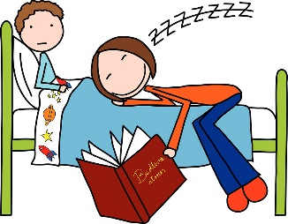
Since the Coronavirus lockdown, many of us have had some sleep difficulties. This is understandable for both parents, guardians and for children. The good news is, we can put things in place to help with this.

Routine - This is the most important factor in getting a good sleep, but this has been turned upside down during the recent lockdown. Keep your old routines going both day and night.

Consistency - Keep bed and wake times consistent, eating at similar times also helps with our internal body clock. This is key to success. Having a regular bedtime routine is important.

Exercise - Get outdoors for your daily exercise. Our eyes need to see the sun because of our sleep hormone (melatonin). It regulates our sleep and wake cycle. If you can, get out at the same time every day. Exercise reduces our stress hormone (but not too close to bedtime) and improves our sleep quality.

Bedtime Routine - At least an hour before bed, turn off you TV, ipads, tablets, mobile phones, Xbox, and Play Stations. The ‘blue’ light they give off blocks our sleep hormone. Dim the lights and have some quiet play or do relaxing activities.
Have a short bath/shower/wash and then go straight to bed. This begins to cool the body down and stimulates melatonin production. Comforters, such as teddies and blankets, can help children to settle

Bedroom - Keep it as dark as possible to help with our melatonin production. Remove any distractions (toys, mobiles, TV etc.). Keep it cool and quiet. Very dim plug in night lights can be useful if children are fearful of the dark.
Keep the bed for sleep, and if you have to sit on it during the day to play or do homework, throw a cover over it to change the appearance. It helps if the brain associates the bed with sleep.

Drinks - Avoid drinks with caffeine in (tea, coffee, hot chocolate, coca cola, energy drinks such as Lucozade). Caffeine stops us from going to sleep and reduces our sleep quality. Stop caffeine by mid-afternoon as it stays in the body for many hours.
Avoid excessive alcohol as this too disrupts sleep by changing the structure and the quality.

Be a role model - Children copy the most important people in their lives – us as parents (or carers). By having our own bedtime routine in place, and stopping our electronic gadgets an hour before bed, we can show them that we take sleep seriously.

If you are worried about your child’s sleep, please contact your School Nurse or Family Centre, who can refer you to the sleep clinic for further help and support.

